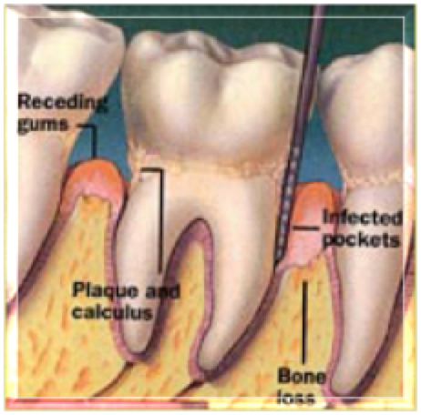

KING SAUD UNIVERSITY

College of Dentistry

Department of Periodontic and Community Dentistry

DIVISION OF PERIODONTICS

Advanced Periodontal Therapy

Student Name

Computer Number: Student Number

Serial Number: Attendance sheet

Cubical Number:

✹

## Academic Year 1433/1434 H (2012/2013) G

✹