Chapter: 3
Supply Analysis

Meaning:
- Supply of a commodity means quantity of the commodity which is actually offered for sale at a given price during some particular time.

- It is the quantity of a commodity that a seller is prepared (or willing) to sell in the market at a given price and at a given period of time.

- Supply refers to a schedule showing various quantities of a commodity that the producers are willing to sell at different possible prices of that commodity at a given time.

- Like demand, supply definition is complete when it has the following elements:
- Quantity of a commodity that the producer is willing to offer for sale;
- Price of the commodity;
- Time during which commodity is offered for sale.
Supply is Different from Stock:
- Supply and stock are different from each other.
- Stock of a commodity refers to the quantity of commodity available with the seller at a point of time.
- Supply is that part of the stock which is offered for sale corresponding to different possible prices of the commodity.
Law of Supply:
- Other things remaining the same, quantity supplied of a commodity is directly related to the price of the commodity. When price of a commodity increases, its quantity supplied increases and when the price falls, quantity supplied also falls.
Sx = f (Px), ceteris peribus

Example: Supply of Sugar and its Price
Price (SR/Kg) | Qty Supplied (Kg) | Ref. points
1 | 5 | A
2 | 10 | B
3 | 15 | C
4 | 20 | D
5 | 25 | E

- Supply curve shows graphically the relationship between quantity supplied of a commodity to its price.
- Supply curve slopes upwards from left to right.
Individual Supply
- It refers to supply of a commodity by an individual firm in the market.
Market Supply
- It refers to supply of a commodity by all the firms in the market. If there are only two firms in the market and one of them is selling 50 units and the other is selling 70 units at a given price, the market supply at this given price will be 120 units.
Individual Supply Curve
- Supply curve is a graphic presentation of supply schedule showing positive relationship between price of a commodity and its quantity supplied.
Price (SR) Quantity Supplied (Units)  1 0  2 5  3 10  4 15  5 20 | 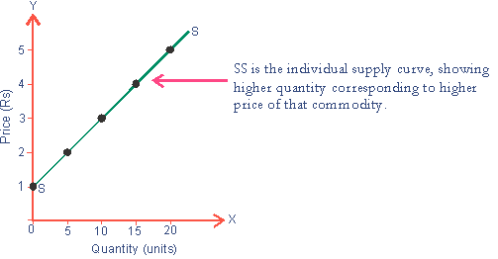

Market Supply Schedule
- Market supply schedule is the supply schedule of all the firms in the market producing a particular commodity.
Price (SR) | Quantity supplied by Firm A (in Units) | Quantity supplied by Firm B (in Units) | Market Supply
1 | 0 | 5 | 5
2 | 5 | 10 | 15
3 | 10 | 15 | 25
4 | 15 | 20 | 35
5 | 20 | 25 | 45

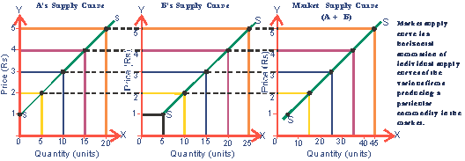
- Note the Difference between Supply and Quantity Supplied:
Supply refers to the entire supply schedule showing various quantities of a commodity offered for sale corresponding to different possible prices of that commodity, at a given time. On the other hand, quantity supplied refers to a specific quantity (like 15 units) offered for sale against a specific price (SR 4).
Reasons behind Upward Sloping Supply Curve:
- Law of diminishing marginal productivity;
- Goals of profit maximization.
Factors Determining Supply:
- Price of the Commodity: Price is the prime determinant of supply. As stated earlier, higher the price, higher the quantity supplied and lower the price, lower the quantity supplied.
- Price of Related Goods: Supply of a commodity is also affected by price of related goods. An increase in the price of a related good induces a firm to adjust its supplies. Example: If price of cars rises, supply of 2-wheeler is expected to be restricted. Implying that the firms will now sell 2-wheelers only at a higher price.
- Number of Firms: Larger the number of firms, greater the quantity supplied and vice versa. Thus, under conditions of perfect competition, supply of a commodity is generally higher than under monopoly.
- Goal of the Firm: Supply of a good also depends upon goal of the firm. Generally, a sales maximizing firm offers a higher quantity of the good for sale than a profit-maximizing firm.
- Price of Factor Inputs: The price of inputs (such as labour, raw material) determines the cost of production. If input price rises, cost of production increases and profits are reduced. This will cause supply to fall at the given price.
- Technology: Technological improvement reduces cost of production. It induces the producers to produce more and increase the supply of a commodity. More is offered for sale at a given price.
- Government Policy: Changes in taxation and subsidy policy of the government also affects the market supply of a commodity. Higher tax burden on the firms restricts the supply, while subsidies are an inducement to increase the supply of a commodity.
- Producers’ Expectations: Generally, supply is restricted if the producers expect that price of a commodity to rise in the near future, and vice versa.
Supply Function:
Sx = f (Px, Py, T, C, Gp)
Where Sx = Supply of commodity x;
F = function of
Px = Price of commodity x;
Py = Price of commodity y;
T = Technological changes
C = Cost of production or price of inputs;
Gp = Government policy or excise tax rate.
Change in Quantity Supplied (Movement) Vs Change in Supply (Shift):
Change in quantity supplied (movement- expansion or contraction):
- A movement along the supply curve is caused by changes in the price of the good, other things remaining constant.
- It is also called change in quantity supplied of the commodity.
- In a movement, no new supply curve is drawn.
- Movement along the supply curve can be of two types:
- Expansion or extension of supply; and
- Contraction of supply.
- Expansion or extension of supply refers to rise in supply due to rise in price of the good.
- Contraction of supply refers to fall in supply due to fall in the price of good.
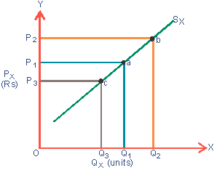
Moving from point a to b shows increase in quantity supplied from Q₁ to Q₂ in response to increase in price (from P₁ to P₂) It is called extension of supply. Likewise, moving from point a to c shows decrease in quantity supplied (from Q₁ to Q₃) in response to decrease in price (from P₁ to P₃) It is called contraction of supply.
Extension of Supply  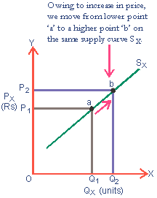 | Contraction of Supply  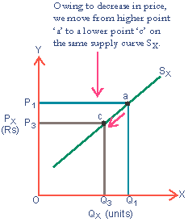

Change in Supply (Shift- Increase or Decrease):
- A shift in supply curve is caused by changes in factors other than the price of the good. These factors are-
- Price of the other commodity;
- State of technology;
- Cost of production;
- Government policy, etc.
- A change in any of these above factors causes shift in the supply curve. It is also called change in supply.
- In a shift, a new supply curve is drawn.
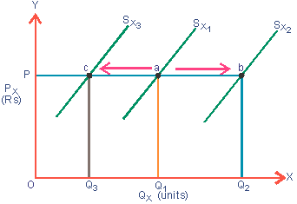
- A shift of the supply curve can be of two types:
- Increase in supply; and
- Decrease in supply.
- Increase in supply: when supply of a commodity rises due to favourable changes in factors other than price of the commodity, it is called increase in supply. This is due to-
- Improvement in technique of production;
- Fall in the price of related goods;
- Fall in the cost of production;
- Fall in excise tax.
- Increase means more supply at the same price, or same supply at a lower price.
- Decrease in supply: when supply of a commodity falls due to unfavorable changes in factors other than its price, it is called decrease in supply. The main reasons of decrease in supply are-
- Obsolete technique of production;
- Increase in the price of related goods;
- Increase in the cost of production;
- Rise in excise tax.
- Decrease means same quantity supplied at higher price or less quantity supplied at the same price.

Shift in Supply Curve
It is a situation when quantity supplied of a commodity (Q_{x}) increases or decreases, due to change in any other determinant of supply, other than price of that commodity.
Forward Shift in  Supply Curve  - It is a situation when more is supplied at the existing price, owing to change in other determinants of supply, other than price (P_{x}).  - It is also known as increase in supply.  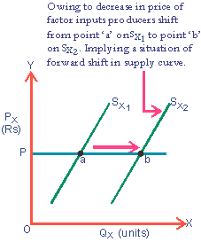 | Backward Shift in  Supply Curve  - It is a situation when less is supplied at the existing price, owing to change in other determinants of supply, other than price (P_{x}).  - It is also known as decrease in supply.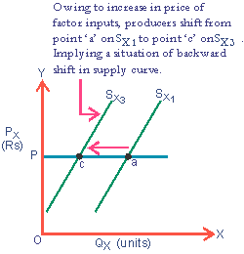

Review Questions
I. Multiple Choice Questions:
1. The relationship between quantity supplied and its price is-
a. directly related | b. inversely related
c. no relation | d. none is correct.
2. The supply curve slopes-
a. downward to the right | b. upward to the right
c. horizontal straight line | d. vertical straight line
3. What is/are the following reason/ reasons for upward sloping supply curve?
a. Law of diminishing marginal productivity | b. Goals of profit maximization
c. (a+b) both is the reason. | d. none is the reason.
4. Factors that determine supply of a commodity-
a. Price of the commodity; | b. New technology;
c. Price of substitutes; | d. Discoveries;
e. Changes in input supply | f. All

5. Change in quantity supplied takes place-
a. same supply curve; | b. new supply curve;
c. both may be possible; | d. none is possible.
6. Change in supply takes place-
a. on the same supply curve; | b. on new supply curve;
c. both may be possible; | d. none is possible.

Ques: | 1 | 2 | 3 | 4 | 5 | 6
Ans: | a | b | c | f | a | b

II. True/ False Statement:
1. In case of change in quantity supplied, new supply curve is drawn.
2. Law of supply states that higher the price lower the quantity supplied and lower the price higher the quantity supplied, other things remaining the same.
Ques: | 1 | 2
Ans: | F | F

III. Match the following:
Match- I | Match- II
A. Change in supply will take place | a. On the same supply curve
B. Change in quantity supplied will take place | b. On new supply curve
C. Increase in supply | c. Rightward shift in supply curve
D. Decrease in supply | d. Leftward shift in supply curve

Match- I | A | B | C | D
Match- II | b | a | c | d

IV. Questions with Answer:
Ques: What is law of supply?
Ans: Other things remaining the same, quantity supplied of a commodity is directly related to the price of the commodity. When price of a commodity increases, its quantity supplied increases and when the price falls, quantity supplied also falls.
Sx = f (Px), ceteris peribus

Example: Supply of Sugar and its Price
Price (SR/Kg) | Qty Supplied (Kg) | Ref. points
1 | 5 | A
2 | 10 | B
3 | 15 | C
4 | 20 | D
5 | 25 | E

Supply curve shows graphically the relationship between quantities supplied of a commodity to its price. Supply curve slopes upwards from left to right.
Ques: What are the reasons behind Upward Sloping Supply Curve?
Ans: There are two following reasons:
1. Law of diminishing marginal productivity;
2. Goals of profit maximization.
Ques: What are the factors that determine supply of a commodity?
Ans: The factors that determine supply of a commodity:-
- Price of the commodity;
- Discoveries;
- New technology;
- Weather conditions;
- Price of substitutes;
- Changes in input supply, etc.

Ques: What do you understand by the term extension of supply and contraction of supply?
Ans: Expansion or extension of supply refers to rise in supply due to rise in price of the good.
Contraction of supply refers to fall in supply due to fall in the price of good.
Ques: What do you mean by increase in supply and decrease in supply?
Ans: Increase in supply: when supply of a commodity rises due to favourable changes in factors other than price of the commodity, it is called increase in supply.
Decrease in supply: when supply of a commodity falls due to unfavorable changes in factors other than its price, it is called decrease in supply.
Ques: What are the main differences between expansion in supply and increase in supply curve?
Ans:
Expansion in supply | Increase in supply
1. Expansion or extension of supply refers to rise in supply due to rise in the price of the good. | 1. Increase in supply refers to more supply at a given price or same supply at a higher price.
2. This occurs on the same supply curve. | 2. It occurs on the new supply curve.
3. The reason of extension or expansion in supply is decrease in price of the good only. | 3. The reasons for increase in supply are other than the price of good.

*****

