BCH 333
Lab Sheet #3

Salting out and dialysis:

Materials:

Chemicals: chicken skeletal muscle, homogenizing buffer, ammonium sulfate, bovine serum albumin (5g/l)"as standard protein", biuret reagent.

Glassware: 8 test tubes, 8 plastic cuvettes, centrifuge tubes, measuring cylinder, pipettes[1ml,2ml,5 ml], beakers and dialysis bag.

Instruments: Vortex, centrifuge device, blender, and spectrophotometer.

A-Salting out:

Method:

(2)
Centrifuge the homogenate
at 3000 rpm, for 10 min. at 4˚C.
(1)
Cut skeletal muscle (100g) into small pieces and homogenize it for 10 minutes in 300 ml of homogenizing buffer (pH 6) in a blender.

(4)
Measure the volume of the "supernatant".

-The volume of the supernatant is = ……………… ml.

(3)
Discard the residue (palette) and adjust the pH of supernatant to (pH6.0).

(5)
-Calculate the required amount of ammonium sulfate salt needed to saturate the solution 40% using ammonium sulfate in grams.
…………………………………………………………………………………………………………………………………………………………………………
…………………………………………………………………………………………………………………………………………………………………………
-Amount of ammonium sulfate salt needed to saturate the solution with 40% is
= ……………………….g.

(7)
After the addition is completed and the salt is completely dissolved, centrifuge at 3500 rpm for 10 min.
(6)
Add the required salt to the solution slowly with small quantities and mix well continuously after each addition.

(8)
Discard the pellet and measure the volume of the supernatant.
-The volume of the supernatant is= ……………………….

(9)
-Calculate the required amount of ammonium sulfate salt needed to saturate the solution 60% using ammonium sulfate in grams.
…………………………………………………………………………………………………………………………………………………………………………
…………………………………………………………………………………………………………………………………………………………………………
-Amount of ammonium sulfate salt needed to saturate the solution with 60% is = ………………………..

(11)

Centrifuge for 10 min.
at 3500 rpm.
(10)
Add the required salt to the solution slowly with small quantities and mix well continuously after each addition.

(12)
Dissolve the pellet in 10 ml homogenizing buffer and place it and the supernatant in separated dialysis bag for 30 min.

Step (B-Dialysis)

- salt's fractionation table; indicate the grams of the salts to be added to one liter of solution.

Desired salts concentration
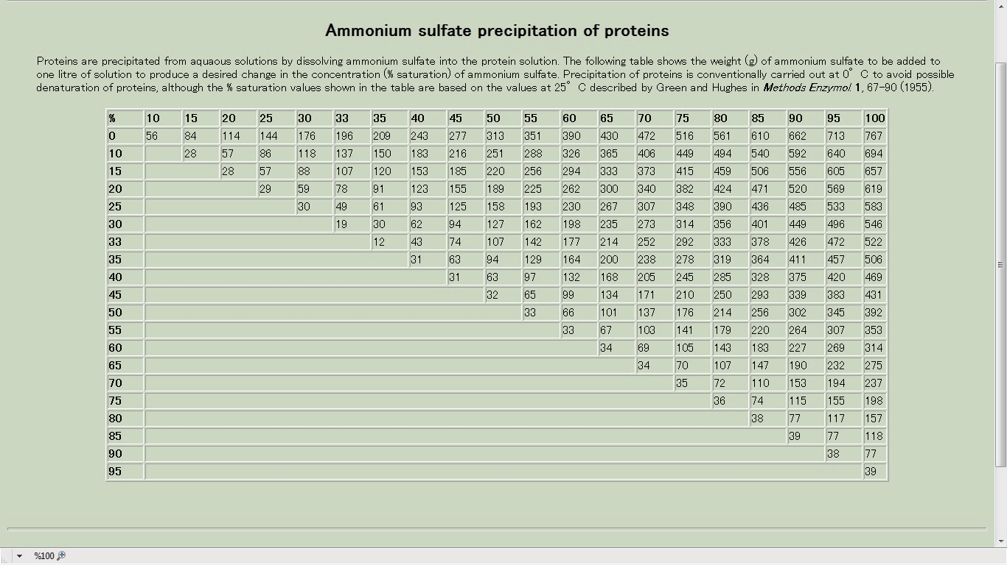
Initial salts concentration

C-Determination of protein by Biuret Method:
Standard stock of bovine serum albumin[BSA]=5g/l.

Tube No. | d.H2O | Std. of BSA  [5g/l] | Sample with unknown concentration | Biuret reagent | Incubate for 10 mins.
Blank | 1 | - |  | 4 ml
1 | 0.9 | 0.1
2 | 0.8 | 0.2
3 | 0.6 | 0.4
4 | 0.4 | 0.6
5 | 0.2 | 0.8
6 | 0 | 1
7 (supernatant) |  |  | 1 | 4 ml
8 (resuspended pellet) |  |  | 1 | 4 ml

- read at 540 nm.
-Prepare a standard graph using BSA[5g/l].

-Calculate the protein concentration of tube 7 and 8 from the standard graph, after determine the concentrations of slandered solution.
Tube No. | Absorbance at 540 nm | Conc. of BSA [g/l]
1
2
3
4
5
6
7 |  | ……….?
8 |  | ……….?

