KING SAUD UNIVERSITY
COLLEGE OF COMPUTER AND INFORMATION SCIENCES
COMPUTER SCIENCE DEPARTMENT
CSC215 | Lab3  C Basics | 2nd Semester 1436-1437

Program 1: Write a C program which will take 2 inputs (Base and Exponents) and calculate the power of the exponents from it base value. The program should ask for these 2 inputs and give the results. Please check the results with different no.s for base and exponent.

Sample run:

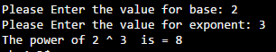

Program 2: Factorial program in C programming using For Loop
The factorial function (symbol: !) means to multiply a series of descending natural numbers.
Ex: 4! = 4*3*2*1 = 24
5! = 5&4*3*2*1 = 120
Sample run:

Program 3: Write a program that reads the size of a two dimensional array of int from the user, and reads its elements, then it subtracts the diagonal element from each element in the row and prints the array after subtraction.
Note: if the array is not a square array, print a warning message “The array is not a square array!!”
Array = 2 4
3 1
Array After the Subtraction =
- 2
2 0

For example:

Name your file using the following naming convention:
- “Lab3_YourFirstName_YourLastName.c"
- Don’t forget to move to your own directory
- Compile your code and execute it.
- Show the program to your lab instructor before you leave.

Answer:
Program 1:
********************************************************************
C program to find power of any number using for loop
*****************************************************************

#include <stdio.h>
int main()
{
int base, exponent, i, power = 1;
/*
* Reads base and exponent from user
*/
printf("Please Enter the value for base: ");
scanf("%d", &base);
printf("Please Enter the value for exponent: ");
scanf("%d", &exponent);

/*
* Calculates the Power using the loop and run till the exponent is reached
*/
for(i=1; i<=exponent; i++)
{
power = power * base;
}
printf("The power of %d ^ %d is = %d\n", base, exponent, power);
return 0;
}
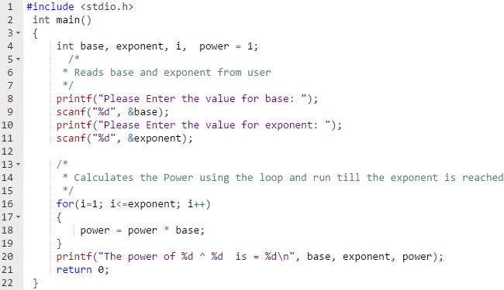

Program 2:
#include <stdio.h>
int main()
{
int c, n, fact = 1;
printf("Enter a number to calculate it's factorial :");
scanf("%d", &n);
/* C is the no. for which we can calculating the factorial*/
for (c = 1; c <= n; c++)
fact = fact * c;

printf("Factorial of number %d! = %d\n", n, fact);

return 0;
}

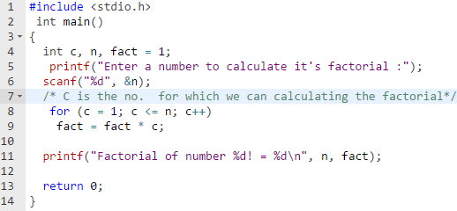
Program 3:
#include<stdio.h>
int main()
{
int size1, size2;
int i,j,x,y;
int diagonal;
printf("Enter the size of your 2 dimensional array:");
scanf("%d %d", &size1, &size2);
if(size1 != size2)
{
printf("The array is not a square array");
}
else
{
int array[size1][size2];
printf("Please enter the array elements row by row");
for(i=0; i<size1; i++)
{
for(j=0; j<size2; j++)
scanf("%d", &array[i][j]);
}
for(x=0; x<size1; x++)
{
diagonal = array[x][x];
for(y=0; y<size2; y++)
{
array[x][y]= array[x][y]- diagonal;
printf("%d \t", array[x][y]);
}
printf("\n");
}
}//end else
return 0;
}//end main

