Chromatography

Chromatography is the collective term for a set of laboratory techniques for the separation of mixtures. The mixture is dissolved in a fluid called the "mobile phase", which carries it through a structure holding another material called the "stationary phase". The various constituents of the mixture travel at different speeds, causing them to separate. The separation is based on differential partitioning between the mobile and stationary phases.
Chromatography techniques:
- Column chromatography
- Liquid chromatography (LC)
- Gas chromatography (GC)
- Paper chromatography
- Thin layer chromatography (TLC)

Ion exchange chromatography
The applications of these techniques are wide reaching and cross many disciplines including biology, biochemistry, microbiology and medicine.

Column chromatography
Column chromatography is a method used to separate and purify individual chemical compounds from mixtures of compounds. Chromatography involves a sample being dissolved in a mobile phase. The mobile phase is then forced through an immobile, immiscible stationary phase. The phases are chosen such that components of the sample have differing solubilities in each phase. A component which is quite soluble in the stationary phase will take longer to travel through it than a component which is not very soluble in the stationary phase but very soluble in the mobile phase. As a result of these differences in mobilities, sample components will become separated from each other as they travel through the stationary phase.
The distribution of analytes between phases can often be described quite simply. An analyte is in equilibrium between the two phases;
A_{mobile} A_{stationary}
The equilibrium constant, K, is termed the partition coefficient; defined as the molar concentration of analyte in the stationary phase divided by the molar concentration of the analyte in the mobile phase.

The mobile phase is either a pure solvent or a mixture of different solvents. By changing the solvent, or perhaps using a mixture, the separation of components can be adjusted. Usually begins by using less polar mobile phase and then the polarity is increased by mixing more than one solvent or replacing the solvent by another one.

Table 1: Polarity index
Solvents | Polarity
Heptane | 0.0
Hexane | 0.0
Toluene | 2.4
Benzene | 2.7
Diethyl Ether | 2.8
Dichloromethane | 3.1
Tetrahydrofuran | 4
Chloroform | 4.1
Acetone | 5.1
Methanol | 5.1
Ethanol | 5.2
Acetic Acid | 6.2
Water | 9

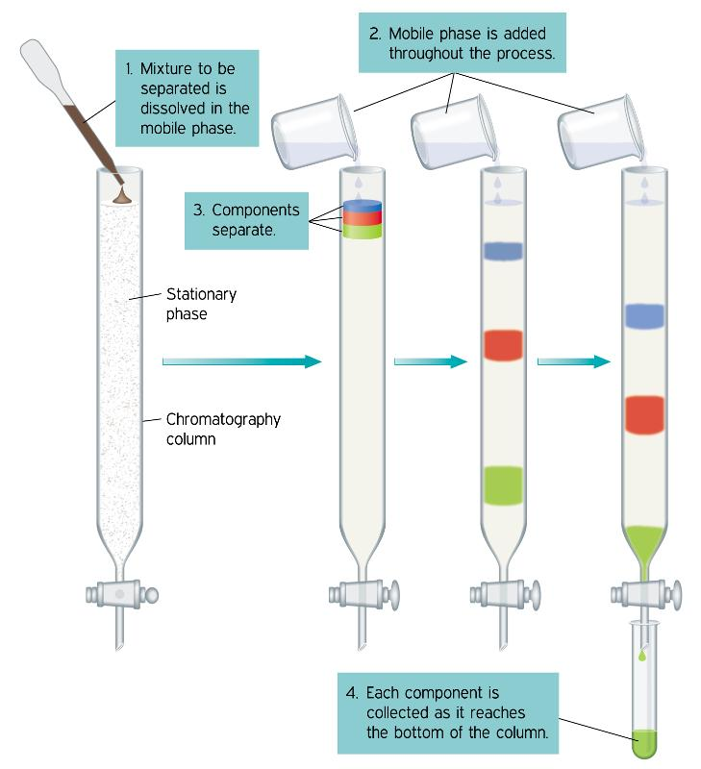

Figure1: Column chromatography

(4): Separation of colored compounds by column chromatography

Purpose:
Separation of mixture of potassium permanganate and potassium dichromate by column chromatography.
Tools and materials used:
Separation column, conical flask, pipettes 1ml, burette, graduated pipette.
Silica gel, mixture of potassium permanganate and potassium dichromate, Distilled water, sulfuric acid, oxalic acid.
Procedure:
- Wash the column with distilled water.
- Place a cotton plug or glass wool at the end of the column.
- Mount the column on the stand.
- Put about 40 gm of silica gel in flask 250 ml and add some of distilled water (the solvent).
- Prepare the separation column from silica gel the length of column 30-40 cm until the water level slightly above the surface of the silica and then close the tap separation column.
- Pipette 0.5 ml from the mixture of potassium permanganate and potassium dichromate into the solvent layer above the silica gel in the packed column.
- Open the tap and continue filling the column with distilled water and elute it until the permanganate layer runs down the column.
- Pipette 5 ml from potassium permanganate into a conical flask and add 2 ml from sulfuric acid (2 M) and heat it in a water bath before reaching its boiling point.
- Titrate with hot oxalic acid until the color of potassium permanganate disappears.
- Calculate the concentration.

