Chapter- 7
Theory of Production
Introduction:
- Production is a process by which goods and services are made available to the consumer.
- Production process simply means the physical relationship between inputs (labour, materials, capital, etc) used and the resulting output.
- The supply of product depends upon its cost of production, which in turn depends upon- (a) the physical relationship between inputs and output (production function), and (b) the price of inputs.
Production function:
- The production function is a purely technical relationship between inputs and output (products).
- Production function represents the technology of a firm of an industry.
- The theory of production is the study of production function.
- The general mathematical form of the production function is-
Q = f (L, K, R, S, υ, γ)
Where Q = output (product)
L = labour input
K = capital input
R = raw materials
S = land input
υ = return to scale
γ = efficiency parameter.

- Production function can provide measurements of-
- The marginal productivity of the factors of production;
- The marginal rate of substitution and the elasticity of substitution;
- Factor intensity;
- The efficiency of production;
- The return to scale.
Types of production function:
- Production function is of two types-
- Short- run production function (Law of Variable Proportions)- Q = f (Land, Labour); and
- Long- run production function (Return to Scale) Q = f (Land, Labour).
- Short- run is a period in which firms can adjust production by changing variable factors such as materials and labour but cannot change quantities of one or more fixed factors such as capital, land etc.
- The long- run is a period long enough to permit changes in all the factors of production.
Production with one variable input: total, marginal and average products-
Total product (TP):
- TP is defined as the total quantity of goods produced by a firm during a specific period of time.
- TP can be increased by employing more and more of the variable factor labour.
- In figure, TP_{L} curve starts from the origin, increases at an increasing rate, then increases at decreasing rate, reaches a maximum and then starts falling.
Marginal product (MP):
- MP is defined as the change in TP resulting from the employment of an additional unit of a variable factor (labour).
- MP_{L} can be written as-
- MP_{L} = $\frac{Change in Total Output}{Change in Labour Input}$ = $\frac{∆TP}{∆L}$
- MP_{L} can be calculated as-
- MP_{L} for n^{th} unit = TP_{n} – TP_{n-1}
Average product (AP):
- AP is defined as the amount of output per unit of the variable factor employed, i.e.,
AP_{L} = $\frac{Total Output}{Labour Input}$ = $\frac{TP}{L}$

Example:
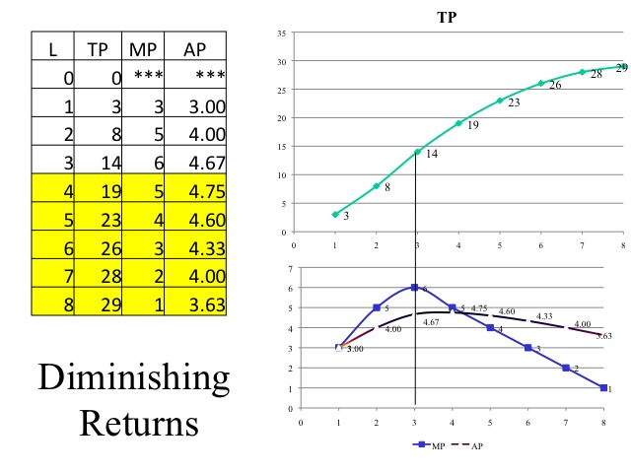
Relationship between TP_{L}, MP_{L} and AP_{L} Curves:
- The AP_{L} and MP_{L} curves are derived from the TP_{L} curve given in the figure-
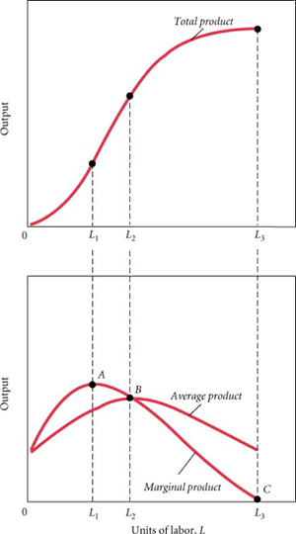
Relationship between TP_{L} and AP_{L} Curves
- AP_{L} at any point on the TP_{L} curve is the slope of the straight line from the origin to that point on the TP_{L} curve. The value of slope rises and declines thereafter.
- AP_{L} initially rises, reaches a maximum and then falls.
- As long as TP_{L} is positive, AP_{L} is positive.
- AP_{L} is inverted- U shaped.
Relationship between TP_{L} and MP_{L} Curves
- MP_{L} at any point on the TP_{L} curve is the slope of the TP_{L} curve at that point. The slope rises then falls till TP_{L} is maximum. At that point slope is zero and beyond that it is negative.
- MP_{L} rises initially, reaches at maximum when the slope of the tangent is steepest and then declines.
- When TP_{L} is maximum, MP_{L} is zero.
- When TP_{L} falls, MP_{L} is negative.
- TP_{L} is the area under the MP_{L} curve.
- The falling portion of the MP_{L} curve shows the law of variable proportions.
- MP_{L} is positive as long as TP_{L} is increasing, but becomes negative when output (TP_{L}) is decreasing.
Relationship between AP_{L} and MP_{L} Curves
The relationships between AP_{L} and MP_{L} Curves are as follows:
- Initially when both AP_{L} and MP_{L} curves are rising, MP_{L} curve rises at a faster rate than the AP_{L} curve. Both AP_{L} and MP_{L} curves rise till the fixed factor (L) is under-utilized.
- When both AP_{L} and MP_{L} curves are falling, MP_{L} curve falls at a faster rate than the AP_{L} curve. Both AP_{L} and MP_{L} curves start falling once the fixed factor (L) is fully utilized.
- When AP_{L} curve neither rising nor falling, MP_{L} = AP_{L}.
- There is a range where even through the MP_{L} curve is falling AP_{L} curve continues to rise.
Short- Run Production Function: Law of Variable Proportions
- It is a short- run production function.
- It takes place when production is increased by using one of the variable factors while keeping all other factors fixed.
- It states that when total output or production of a commodity is increased by adding units of a variable input, while the quantities of other inputs are held constant, the increase in total production becomes, after some point, smaller and smaller.
- The law operates when both AP_{L} and MP_{L} begins to diminish.
- The law operates under these assumptions:
- State of production or technology remains unchanged;
- All units of variable factor, labour, are homogeneous or of same quality; and
- There must always be some fixed input.
Stages of Production:
- The law of variable proportion can be divided into three phases/stages-
- Stage I: Stage of increasing Returns
- Stage II: Stage of Diminishing Returns
- Stage III: Stage of Negative Returns
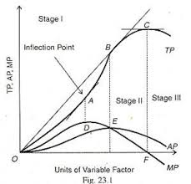
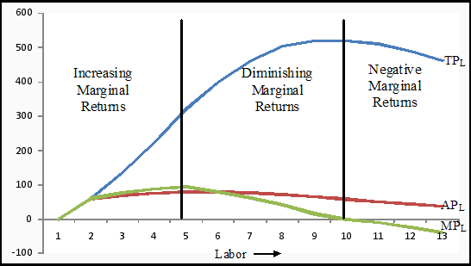
Stage I: Stage of increasing Returns
- Stage I goes from origin to the point where the AP_{L} is maximum (i.e., from origin to point b).
- In this stage, TP_{L} is initially increasing at an increasing rate and then starts increasing at decreasing rate from the point of inflexion (point c) onwards.
- AP_{L} rises throughout in this stage.
- MP_{L} rises initially and then starts falling.
- Increasing returns are due to indivisibility of factors and specialization of labour.
- A rational producer will not operate in this stage because the producer always has an incentive to expand through Stage I of labour because rising AP_{L} means the average cost decreases as output is increased.
Stage II: Stage of Diminishing Returns
- This stage of production ranges from the point where AP_{L} is maximum to the point where MP_{L} is zero (i.e., from point b to d).
- In this stage both AP_{L} and MP_{L} are positive but declining.
- A rational producer will always operate in this Stage because he wants to maximize efficiency of scarce factor, labour.
- The law of diminishing returns operates in this Stage II.
- It is the most fundamental law of production.
Stage III: Stage of Negative Returns
- Stage III covers the entire range over which MP_{L} is negative.
- A rational producer will not operate in this stage.
Long- Run Production Function: Return to Scale
- In the long- run, all factors of production are variable.
- If the firm has two inputs- labour and capital- both of which are variable then the long- run production function will be-
Q = f (L, K)
- The long- run production function can be represented graphically by Iso- quant or Iso- product curves.
Iso- quant:
- An isoquant shows the different combinations of labour and capital with which a firm can produce a specific quantity of output.
- It is defined as the locus of all the technically efficient combinations of inputs which yield a given amount of output.
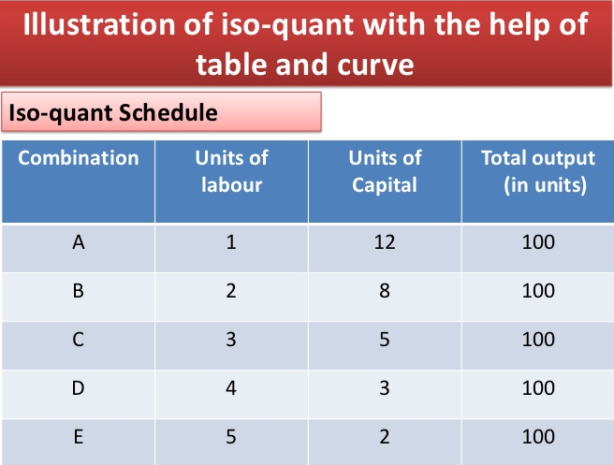 | 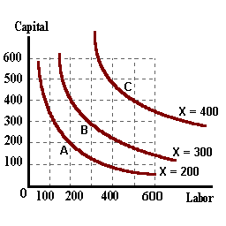
Features of Isoquants:
- In the relevant range, isoquants are downward sloping.
- A downward sloping isoquant means that if a firm wants to use more of labour then it must use less of capital to produce the same level of output or remain on the same isoquant.
- Ridge lines are loci of points on isoquants where the marginal product of the factors is zero.
- Along the upper ridge line, MP_{K} = 0. It means capital is used to its intensive margin. The MRTS_{LK} is infinite, i.e., MRTS is undefined at this point.
- Along the lower ridge line, MP_{L} = 0. It shows intensive margin for labour. Thereby, MRTS_{LK} is zero. At this point labour has been substituted for capital to the maximum extent.
- Inside the ridge lines, the techniques of production are efficient.
- The relevant range represents stage II of production where MP of each factor declines continuously but do not reach zero.
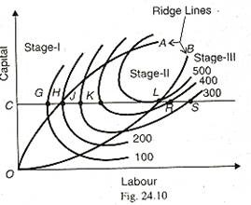
- Isoquants are convex to the origin: Diminishing MRTS
- Convexity implies diminishing slope.
- The slope of an isoquant is called marginal rate of technical substitution of labour for capital (MRTS_{LK}). It is the rate of trade- off of one factor for the other.
- The slope measures the degree of substitutability of the factors.
Slope of an isoquant = $\frac{∂K}{∂L}$ = MRTS_{LK} = $\frac{MPL}{MPK}$
- MRTS_{LK} is defined as the amount of capital that the firm is willing to give up in exchange for labour, so that output remains constant.
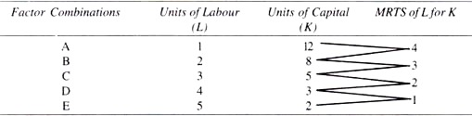 | 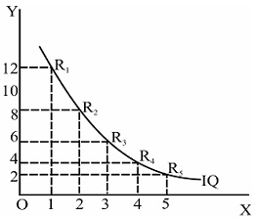

- Isoquants Never Cross Each Other.
Iso- cost Line:
- An isocost line shows the different combinations of labour and capital that a firm can buy, given total outlay (TO) and the prices of the factors.
- An isocost equation is given as:
TO = P_{L}.L + P_{K}.K
Slope of Isocost = $\frac{OA}{OB }$ = $\frac{TO/PK}{TO/PL }$ $=(-)\frac{PL}{PK }$

Producer’s Equilibrium:
- There are two cases of producer’s equilibrium-
- Case I: Maximize Output Subject to a Cost Constraint; and
- Case II: Minimize Cost Subject to an Output Constraint.
Case I: Maximize Output Subject to a Cost Constraint
- If cost is a constraint then the producer maximizes his output subject to a single isocost line (AB). The producer’s equilibrium is shown in this fig.-
- At point Q, the isocost line is tangent to the highest possible isoquant at production level of 100.  - At the point of tangency, the absolute slope of an isoquant is equal to the absolute slope of the isocost line.  - Thus, the conditions of producer’s equilibrium are-  - Slope of isoquant = slope of isocost line, i.e.,  MRTS_{LK} = P_{L}/P_{K}  MP_{L}/MP_{K} = P_{L}/P_{K}  MP_{L}/P_{L} = MP_{K}/P_{K}  - Isoquants must be convex to the origin. | 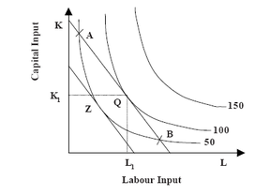
Case II: Minimize Cost Subject to an Output Constraint
- If output is given, then the producer will aim to minimize his cost subject to a single isoquant, I as shown in the following fig.
- Point E is the point of producer’s equilibrium.
- It shows the minimum cost of producing the given output.
- At point E, the given isoquant (I) is tangent to the lowest possible isocost line.
- At this point of tangency, the absolute slope of isoquant is equal to the absolute slope of isocost line.
- Thus, the conditions of producer’s equilibrium are the same-
- Slope of isoquant = slope of isocost line, i.e.,
MRTS_{LK} = P_{L}/P_{K}
MP_{L}/MP_{K} = P_{L}/P_{K}
MP_{L}/P_{L} = MP_{K}/P_{K}
- Isoquants must be convex to the origin.
Expansion Path:
- If the firm increases its total outlay, then there will be parallel outwars shifts of the isocost lines (prices of factors remain constant).  - These different isocost lines will be tangent to different isoquants, thus giving different equilibrium points.  - By joining these points of producer’s equilibrium, the firm’s expansion path is obtained. | 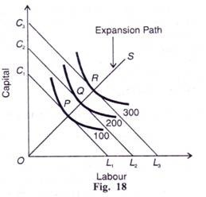

Cobb- Douglas Production Function:
- Cobb- Douglas production function is a linearly homogeneous production function of the form-
Q = AL^{α}K^{β}
Where Q = Output
L = Labour input
K = Capital input
A = Efficiency parameter, technology
α = Output elasticity of labour
β = Output elasticity of capital
- In Cobb- Douglas production function, elasticity of substitution (e_{s} or σ) is equal to unity.
- In Cobb- Douglas production function, the sum of its exponents measures returns to scale-
If α + β = 1=> Constant Return to Scale;
If α + β > 1=> Increasing Return to Scale;
If α + β < 1=> Diminishing Return to Scale;
- Cobb- Douglas production function shows constant return to scale.
Elasticity of Substitution:
- Elasticity of substitution (e_{s}) between two factors labour and capital measures the ease with which one factor can be substituted for the other.
- It is defined as the proportionate change in the ratio between the two factors divided by the proportionate change in their MRTS. i.e.,
e_{s} = $\frac{\% Change in K/L}{\% Change in MRTSLK}$ = $\frac{∆K/L}{∆MRTSLK}$. $\frac{MRTSLK}{K/L}$
- The value of e_{s} varies from zero to infinity.
Returns to Scale:
- In the long run output (production) may be increased by changing all factors by the same proportion, or by different proportions.
- The term ‘returns to scale’ refers to the changes in output as all factors change by the same proportion.
- There are three types of returns to scale-
- Increasing Returns to Scale;
- Constant Returns to Scale; and
- Decreasing Returns to Scale.
Increasing Returns to Scale:
- When the increase in output is more than proportional to the increase in inputs, it is called increasing returns to scale.
- Increasing Returns to scale implies decreasing costs and decreasing costs are due to economies of large- scale production, which takes place by increasing the scale of operation.
- In terms of isoquant map, the distance between successive isoquants decreases.
Constant Returns to Scale
- When the increase in output is proportional to the increase in inputs, it is called constant returns to scale.
- In terms of isoquant map, the distance between successive isoquants remains the same.
Diminishing Returns to Scale
- When the increase in output is less than proportional to the increase in inputs, it is called diminishing returns to scale.
- Diminishing returns to scale implies increasing costs and increasing costs are due to diseconomies of large- scale production, which takes place by excessive increasing the scale of operation.
- In this case, there is managerial inefficiency caused by scarce supply of factors of production and imperfect substitution.
- The manager is overburdened and faces the problems of control and coordination.
- In terms of isoquant map, the distance between successive isoquants increases.

Reasons behind Returns to Scale: Economies and Diseconomies of Scale

Questions for Review
- Write T for True and F for False against each statement:
- Production is a process by which goods and services are made available to the consumer.
- The production function is a purely technical relationship between inputs and output (products).
- Short- run is a period in which firms can adjust production by changing all factors of production.
- TP_{L} curve starts from the origin, increases at an increasing rate, then increases at decreasing rate, reaches a maximum and then starts falling.
- Marginal product is defined as the change in TP resulting from the employment of an additional unit of a variable factor.
- AP_{L} is U- shaped.
- Short- run production function is also known as law of returns to scale.
- Long- run production function is also known as law of variable proportion.
- A rational producer will always operate in diminishing returns (Stage II).
- Iso- quants are convex to the origin because of diminishing marginal rate of technical substitution (MRTS).
Ques | 1 | 2 | 3 | 4 | 5 | 6 | 7 | 8 | 9 | 10
Ans | T | T | F | T | T | F | F | F | T | T
- Matching Test:

Match- I |  |  | Match- II
- Short- run production function: |  |  | - Returns to Scale
- Long- run production function: |  |  | - Law of variable proportions
- The different combinations of labour and capital with which a firm can produce a specific quantity of output is known as: |  |  | - Iso- quant
- The different combinations of labour and capital that a firm can buy, given total outlay (TO) and the prices of the factors. |  |  | - Iso- cost line
I | A | B |  | C | D
II | b | a |  | c | d
- Multiple Choice Questions:
- Production function provides measurements of-
- The marginal productivity of the factors of production;
- The marginal rate of substitution and the elasticity of substitution;
- The return to scale;
- Factor intensity;
- All of the above.
- Which is/ are true about iso- quants-
- It is convex to the origin;
- The slope of an isoquant is called marginal rate of technical substitution of labour for capital (MRTS_{LK});
- Iso- quants never cross each other;
- All are true.
- The conditions of producer’s equilibrium are-
- Slope of isoquant = slope of iso- cost line;
- Iso- quants must be convex to the origin;
- a+ b
- None of these.
- In Cobb- Douglas production function, elasticity of substitution (e_{s} or σ) is equal to-
- unity | - zero
- infinity | - None of these.

- In Cobb- Douglas production function, the sum of its exponents measures-
- Returns to Scale; | - Factors intensity;
- Marginal productivity of factors; | - Elasticity of substitution
- Slope of an iso- quant is-
- MRTS; | - Marginal productivity of factors;
- Elasticity of substitution; | - Factors intensity.
- A rational producer will always operate in-
- Stage I; | - Stage II;
- Stage III | - None of these.
- Which of the following stage is known as law of diminishing returns-
- Stage I; | - Stage II;
- Stage III | - None of these.
- The most fundamental law of production is-
- Stage I; | - Stage II;
- Stage III | - None of these.
- MP_{L} for n^{th} unit is equal to-
- TP_{n} – TP_{n-1} | - TP_{n} – TP_{n+1}
- AP_{n} – AP_{n-1} | - TP_{n} + TP_{n-1}

Ques | 1 | 2 | 3 | 4 | 5 | 6 | 7 | 8 | 9 | 10
Ans | e | d | c | a | a | a | b | b | b | a

- Very Short Questions:
Ques: What is production?
Ans: Production is a process by which goods and services are made available to the consumer.
Ques: What is production function?
Ans: The production function is a purely technical relationship between inputs and output (products). It represents the technology of a firm of an industry.
Ques: What is iso- quant?
Ans: An isoquant shows the different combinations of labour and capital with which a firm can produce a specific quantity of output. It is defined as the locus of all the technically efficient combinations of inputs which yield a given amount of output.
Ques: What do you understand by iso- cost line?
Ans: An isocost line shows the different combinations of labour and capital that a firm can buy, given total outlay (TO) and the prices of the factors.
Ques: What are the main features of iso- quants?
Ans: The main features of iso- quants are:
- In the relevant range, isoquants are downward sloping;
- Isoquants are convex to the origin: Diminishing MRTS;
- Isoquants Never Cross Each Other.
Ques: How many types of production functions are there in theory of production?
Ans: There are two types of production functions:
- Short- run production function; and
- Long- run production function.
Ques: What is short- run production function?
Ans: Short- run production function is that production function in which firms can adjust production by changing variable factors such as materials and labour but cannot change quantities of one or more fixed factors such as capital, land etc. it is also known as law of variable proportion.
Ques: What is long- run production function?
Ans: The long- run production function is that production function in which all the factors of production can be changed. It is also known as laws of returns to scale.

Ques: Define total product, average product and marginal product.
Ans: Total Product (TP): It is defined as the total quantity of goods produced by a firm during a specific period of time. TP can be increased by employing more and more of the variable factor labour.
Average Product (AP): AP is defined as the amount of output per unit of the variable factor employed, i.e.,
AP_{L} = $\frac{Total Output}{Labour Input}$ = $\frac{TP}{L}$
Marginal Product (MP): MP is defined as the change in TP resulting from the employment of an additional unit of a variable factor (labour). MP_{L} can be written as-
MP_{L} = $\frac{Change in Total Output}{Change in Labour Input}$ = $\frac{∆TP}{∆L}$
MP_{L} can be calculated as-
MP_{L} for n^{th} unit = TP_{n} – TP_{n-1}
Ques: What are laws of variable proportions?
Ans: Short- run production function is known as law of variable proportions in which firms can adjust production by changing variable factors such as materials and labour but cannot change quantities of one or more fixed factors such as capital, land etc.
Ques: What are the three stages of production? Or,
Ques: How many types of laws of variable proportions are there in the short run production function?
Ans: There are three stages of production or the law of variable proportion can be divided into three phases/stages-
- Stage I: Stage of increasing Returns;
- Stage II: Stage of Diminishing Returns; and
- Stage III: Stage of Negative Returns

Ques: What do you understand by first stage of product or law of increasing returns?
Ans: In the first stage, TP_{L} is initially increasing at an increasing rate and then starts increasing at decreasing rate from the point of inflexion onwards. AP_{L} rises throughout in this stage. MP_{L} rises initially and then starts falling. Increasing returns are due to indivisibility of factors and specialization of labour. A rational producer will not operate in this stage because the producer always has an incentive to expand through Stage I of labour because rising AP_{L} means the average cost decreases as output is increased.
Ques: What do you understand by second stage of product or law of diminishing returns?
Ans: The second stage of production ranges from the point where AP_{L} is maximum to the point where MP_{L} is zero. In this stage both AP_{L} and MP_{L} are positive but declining. A rational producer will always operate in this Stage because he wants to maximize efficiency of scarce factor, labour. The law of diminishing returns operates in this Stage II. It is the most fundamental law of production.
Ques: What do you understand by third stage of product or law of negative returns?
Ans: Stage III covers the entire range over which MP_{L} is negative. A rational producer will not operate in this stage.
Ques: What do you understand by the term returns to scale?
Ans: In the long run output (production) may be increased by changing all factors by the same proportion, or by different proportions. The term ‘returns to scale’ refers to the changes in output as all factors change by the same proportion.
Ques: How many types of returns to scale are there?
Ans: There are three types of returns to scale-
- Increasing Returns to Scale;
- Constant Returns to Scale; and
- Decreasing Returns to Scale.

Ques: What is increasing returns to scale?
Ans: When the increase in output is more than proportional to the increase in inputs, it is called increasing returns to scale.
Ques: What is constant returns to scale?
Ans: When the increase in output is proportional to the increase in inputs, it is called constant returns to scale.
Ques: What is diminishing returns to scale?
Ans: When the increase in output is less than proportional to the increase in inputs, it is called diminishing returns to scale.
Question: What are the relationships between TP_{L} and AP_{L} Curves?
Answer: The relationships between TP_{L} and AP_{L} Curves are as follows:
- AP_{L} at any point on the TP_{L} curve is the slope of the straight line from the origin to that point on the TP_{L} curve. The value of slope rises and declines thereafter.
- AP_{L} initially rises, reaches a maximum and then falls.
- As long as TP_{L} is positive, AP_{L} is positive.
- AP_{L} is inverted- U shaped.
Question: What are the relationships between TP_{L} and MP_{L} Curves?
Answer: The relationships between TP_{L} and MP_{L} Curves are as follows:
- MP_{L} at any point on the TP_{L} curve is the slope of the TP_{L} curve at that point. The slope rises then falls till TP_{L} is maximum. At that point slope is zero and beyond that it is negative.
- MP_{L} rises initially, reaches at maximum when the slope of the tangent is steepest and then declines.
- When TP_{L} is maximum, MP_{L} is zero.
- When TP_{L} falls, MP_{L} is negative.
- TP_{L} is the area under the MP_{L} curve.
- The falling portion of the MP_{L} curve shows the law of variable proportions.
- MP_{L} is positive as long as TP_{L} is increasing, but becomes negative when output (TP_{L}) is decreasing.
Question: What are the relationships between AP_{L} and MP_{L} Curves?
Answer: The relationships between AP_{L} and MP_{L} Curves are as follows:
- Initially when both AP_{L} and MP_{L} curves are rising, MP_{L} curve rises at a faster rate than the AP_{L} curve. Both AP_{L} and MP_{L} curves rise till the fixed factor (L) is under-utilized.
- When both AP_{L} and MP_{L} curves are falling, MP_{L} curve falls at a faster rate than the AP_{L} curve. Both AP_{L} and MP_{L} curves start falling once the fixed factor (L) is fully utilized.
- When AP_{L} curve neither rising nor falling, MP_{L} = AP_{L}.
- There is a range where even through the MP_{L} curve is falling AP_{L} curve continues to rise.
Ques: What are the conditions of producers’ equilibrium?
Ans: There are two conditions for producer’s equilibrium-
- Slope of isoquant = slope of isocost line, i.e.,
- Isoquants must be convex to the origin.
Ques: What is Cobb- Douglas production function? Write down its main features.
Ans: Cobb- Douglas production function is a linearly homogeneous production function of the form-
Q = AL^{α}K^{β}
Where Q = Output
L = Labour input
K = Capital input
A = Efficiency parameter, technology
α = Output elasticity of labour
β = Output elasticity of capital
Cobb- Douglas production function shows constant return to scale. In Cobb- Douglas production function, elasticity of substitution (e_{s} or σ) is equal to unity and the sum of its exponents measures returns to scale-
If α + β = 1=> Constant Return to Scale;
If α + β > 1=> Increasing Return to Scale;
If α + β < 1=> Diminishing Return to Scale;

*****

