Chapter- 8
Cost of Production
Introduction:
- The production function is one important determinant of cost of a commodity.
- The other determinant of cost is the price of inputs.
- Production function together with the price of inputs determines the cost of a commodity.
- The cost of a commodity with a profit margin determines the price of the commodity.
- When the supply curve interacts with demand curve, the point of intersection gives the equilibrium price and quantity.
The Cost Function:
- Cost is defined as the payment made to the factors of production used in the production of the commodity.
- Cost functions are derived from production function.
- Cost is a multivariate function, i.e., it shows relationship between total cost and its determinants.
- The long run cost function is given as:
C = f (Q, T, P_{f})
- The short- run cost function is:
C = f (Q, T, P_{f}, K)
Where
C = Total cost
Q = Output
T = Technology
P_{f} = Price of factors
K = Fixed factor(s)
Different Cost Concepts:
- Opportunity/ alternative Cost:
- The cost of alternative opportunity sacrificed or given up.
- At any given time, resources can be put to only one use.
- For example, a piece of land may be used either for building a residential flat or for constructing a hospital. If the land is used for constructing a hospital then its opportunity cost is the cost of residential flat foregone.
- It is also known as transfer earnings.
Explicit Cost Vs Implicit Cost:
- Explicit cost-
- Explicit cost, direct cost, accounting cost or money cost is the same thing.
- The actual expenditure incurred by a firm to purchase or hire the inputs it needs in the production process is called explicit cost.
- These include wages, rent, interest payment for power, insurance, advertising, etc.
- Implicit cost-
- Implicit cost or imputed cost is the cost of inputs owned by the firm and used by the firm in its own production process.
- It includes payment for owned premises, self- invested capital and depreciation of capital equipment.
- Total cost of producing a commodity consists of both implicit and explicit costs.
Private Cost Vs Social Cost:
- Private Cost-
- Private cost is the money cost incurred by a firm in producing a commodity.
- Social Cost-
- It is the cost of producing a commodity to the society as a whole.
- It includes real cost which is cost borne by the society, directly or indirectly, due to the produced commodity.
Fixed Cost Vs Variable Cost:
- Fixed Cost-
- Fixed cost, overhead cost or supplementary cost is the cost that does not change with change in output.
- Variable Cost-
- Variable cost is that costs which vary/change with the quantity of output produced.
- It is also called prime cost.
Economic Cost Vs Accounting Cost:
- Economic Cost-
- Economic cost is the cost to a firm of utilizing economic resources in production, including opportunity cost.
- Accounting Cost-
- Accounting cost is the actual expense plus depreciation charges for capital equipment.
Short- run Vs Long- run Cost:
- Short- run Cost-
- Short- run costs are the costs over a period during which some factors are in fixed supply, like plant, machinery, etc.

- Long- run Cost-
- Long- run costs are the costs over a period long enough to permit changes in all factors of production.
Sunk cost:
- Sunk cost is the expenditure that has been incurred and cannot be recovered.
Costs in the Short- Run: Total Cost, Average Cost and Marginal Cost
- Total Cost-
- The total cost of production is divided into two parts- total fixed cost (TFC) and total variable cost (TVC)-
TC = TFC + TVC
Total Fixed Cost (TFC)-
- It is defined as that cost which does not vary with the output.
- TFC curve is a straight line parallel to x- axis.
Total Variable Cost (TVC)-
- Variable cost is the cost that varies with the quantity of output produced.
- Total variable cost (TVC) curve is inverse- S shaped starting from the origin.

Total Cost (TC) = TFC + TVC
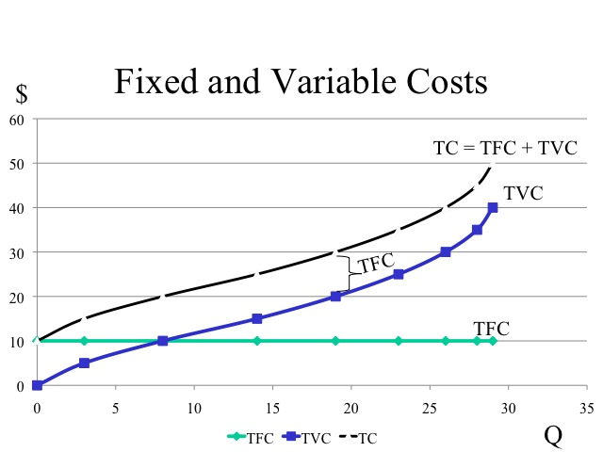

- Average Cost (AC):
- Average cost is found by dividing total cost (TC) by the level of output, i.e.,
TC = TFC + TVC; $\frac{TC}{Q}= \frac{TFC}{Q}$ + $\frac{TVC}{Q};$AC = AFC + AVC
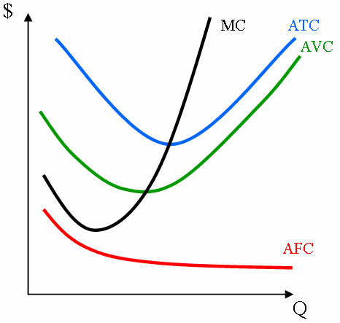
- Relationship between TFC and AFC:
- AFC at any point on the TFC curve is the slope of the straight line from the origin to that point.
- To a horizontal line of TFC, showing fixed cost, AFC is a rectangular hyperbola showing decreasing fixed cost per unit as output increases.

- Relationship between TVC and AVC:
- AVC at any point on the TVC curve is the slope of the straight line from the origin to that point on the TVC curve.
- As output expands, the value of slope falls continuously until maximum point of AP_{L} and beyond that the value of slope rises.
- The reason behind the shape of both TVC and AVC curves is the law of variable proportions.
- To an inverse – S shape of TVC curve, AVC is U- shaped.

- Relationship between AC and AVC:
- AVC is part of AC given that AC = AFC + AVC.
- Both AVC and AC are U- shaped, reflecting the law of variable proportions.
- The minimum point of AC occurs to the right of the minimum point of the AVC.

- Marginal Cost (MC):
- An addition made to the TC or TVC as output is increased by one more units, i.e.,
MC = $\frac{∂TC}{∂X}$ = $\frac{∂TVC}{∂X}$

- Relationship between TC or TVC and MC:
- MC at any level of output is given by the slope of either the TC or the TVC curve at that level of output.
- As output expands the value of slope declines continuously and then rises thereafter.
- The reason behind the shape of the MC curve is the law of variable proportions.
- To an inverse – S shape of TC or TVC curve, MC is U- shaped.

- Relationship between AC and MC:
- When MC is falling, MC is below AC.
- When AC is rising, then MC is above AC.
- When AC is neither falling nor rising, MC is equal to AC.
- There is a range over which AC is falling but MC is rising.
- MC curve cuts AC curve at its minimum point.

- Relationship between MC and AVC:
- MC and AVC are the same at the first unit of output.
- MC curve passes through the minimum point of both the AVC and the AC curves.
- The area under the MC curve gives the TVC.

- The Long- run Cost Curve:
- Long- run average cost curve is U- shaped envelope curve.
- The reason behind the U- shape of the LAC is the laws of returns to scale.
- The reason of the LAC curve is an envelope curve is that there is no reserve capacity. It means, each plant size can produce optimally a single level of output.
- LAC and LTC are planning curves.
- The LTC curve is inverse- S shaped starting from origin.
- The LTC curve is an envelope and continuous curve.

- Relationship between Production Functions and Cost Curves:
- The AVC curve is the monetized mirror image of the AP_{L} curve and the MC curve is the monetized mirror image of the MP_{L}.
- When AP_{L} curve rises, AVC curve falls. When AP_{L} curve is maximum, AVC curve is minimum. When AP_{L} curve falls, AVC curve rises.
- When MP_{L} curve rises, MC curve falls. When MP_{L} curve is maximum, MC curve is minimum. When MP_{L} curve falls, MC curve rises.
- Stage II of production- the stage of diminishing returns- begins where MP_{L} is eventually declining and MC is rising.

- Shifts in Cost Curves:
- Change in input supply; and
- Change in technology.

- Learning Curve:
- Learning curve shows that a firm learns overtime to absorb new technological information which enhances its efficiency and reduces its cost of production.
- Both management and workers gain experience and are able to lower their cost for these reasons:-
- Speed of workers increases with time;
- Efficiency of managers in scheduling the production process rises with time;
- Experience of engineers helps to make cost saving product designs;
- Better and more specialized tools and plant organization reduces cost;
- Effective raw material processing by supplier reduces input cost.
Review Questions
- Write T for True and F for False against each statement:
- The cost of a commodity is determined by production function and the price of inputs.
- Cost function shows relationship between total cost and its determinants.
- The actual expenditure incurred by a firm to purchase or hire the inputs it needs in the production process is called implicit cost.
- Sunk cost is the expenditure that has been incurred and cannot be recovered.
- TFC curve is a straight line parallel to x- axis.
- Total variable cost (TVC) curve is inverse- S shaped starting from the origin.
- AFC is a rectangular hyperbola showing decreasing fixed cost per unit as output increases.
- The minimum point of AC occurs to the left of the minimum point of the AVC.
- MC curve cuts AC curve at its minimum point.
- LAC and LTC are planning curves.
Ques | 1 | 2 | 3 | 4 | 5 | 6 | 7 | 8 | 9 | 10
Ans | T | T | F | T | T | T | T | F | T | T

- Matching Test:

- The actual expenditure incurred by a firm to purchase or hire the inputs: |  |  |  | - Variable cost
- The cost of inputs owned by the firm and used by the firm in its own production process: |  |  |  | - Fixed cost
- The cost that does not change with change in output: |  |  |  | - Implicit cost
- The costs which vary/change with the quantity of output: |  |  |  | - Explicit cost
I | A | B | C |  | D
II | 4 | 3 | 2 |  | 1

- Multiple Choice Questions:
- Cost functions are derived from-
- Production function; | - Demand function;
- Supply function; | - None of these.
- Total cost (TC) is equal to-
- TFC + TVC | - MC + AC
- TFC + MC | - TFC + AC
- Which of the following is rectangular hyperbola-
- TFC | - TVC
- AFC | - AVC
- An addition made to the TC or TVC as output is increased by one more units is called:
- AC | - MC
- AVC | - AFC
- When MC is falling, MC is-
- Below AC | - Above AC
- Equal to AC | - All may be possible.
- MC curve cuts AC curve at its-
- minimum point; | - Maximum point.
- Any point; | - Never cuts.
- Shift in cost curves is/are due to–
 | - Change in input supply; |  |  |  | - Change in technology;
 | - a + b |  |  |  | - None of these.
Ques | 1 | 2 | 3 | 4 |  | 5 | 6 | 7
Ans | a | a | c | b |  | a | a | c

- Questions with Answer:
Ques: What is cost?
Ans: Cost is defined as the payment made to the factors of production used in the production of the commodity.

Ques: What do you mean by opportunity cost?
Ans: The cost of alternative opportunity sacrificed or given up is known as opportunity cost. For example, a piece of land may be used either for building a residential flat or for constructing a hospital. If the land is used for constructing a hospital then its opportunity cost is the cost of residential flat foregone. It is also known as transfer earnings.
Ques: Differentiate between explicit cost and implicit cost.
Ans: The differences between these costs are as follow:
Explicit Cost | Implicit Cost
The actual expenditure incurred by a firm to purchase or hire the inputs it needs in the production process is called explicit cost. | Implicit cost or imputed cost is the cost of inputs owned by the firm and used by the firm in its own production process.
These include wages, rent, interest payment for power, insurance, advertising, etc. | It includes payment for owned premises, self- invested capital and depreciation of capital equipment.

Ques: What are fixed cost and variable cost?
Ans: Fixed Cost- Fixed cost, overhead cost or supplementary cost is the cost that does not change with change in output.
Variable Cost- Variable cost is that costs which vary/change with the quantity of output produced. It is also called prime cost.
Ques: What is marginal cost?
Ans: An addition made to the TC or TVC as output is increased by one more units, i.e.,
MC = $\frac{∂TC}{∂X}$ = $\frac{∂TVC}{∂X}$
Ques: What are the relationships between AC and MC?
Ans: The relationships between AC and MC are as follows:
- When MC is falling, MC is below AC.  - When AC is rising, then MC is above AC.  - When AC is neither falling nor rising, MC is equal to AC.  - There is a range over which AC is falling but MC is rising.  - MC curve cuts AC curve at its minimum point. | 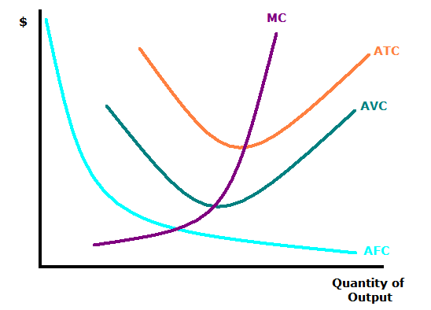

Ques: What are the relationships between MC and AVC or ATC?
Ans: The relationships between MC and AVC or ATC are as follows:
- MC and AVC are the same at the first unit of output.
- MC curve passes through the minimum point of both the AVC and the AC curves.
- The area under the MC curve gives the TVC.
Ques: Fill up the following costs from the given table-
Units | TFC | TVC | TC | MC | AFC | AVC | ATC
1 | 100 | 50 | 150 | ---- | 100 | 50 | 150
2 | 100 | 80 | 180 | 30 | 50 | 40 | 90
3 | 100 | 110 | 210 | 30 | 33.3 | 36.6 | 69.9
4 | 100 | 170 | 270 | 60 | 25 | 42.5 | 67.5
5 | 100 | 250 | 350 | 80 | 20 | 50 | 70
*****

