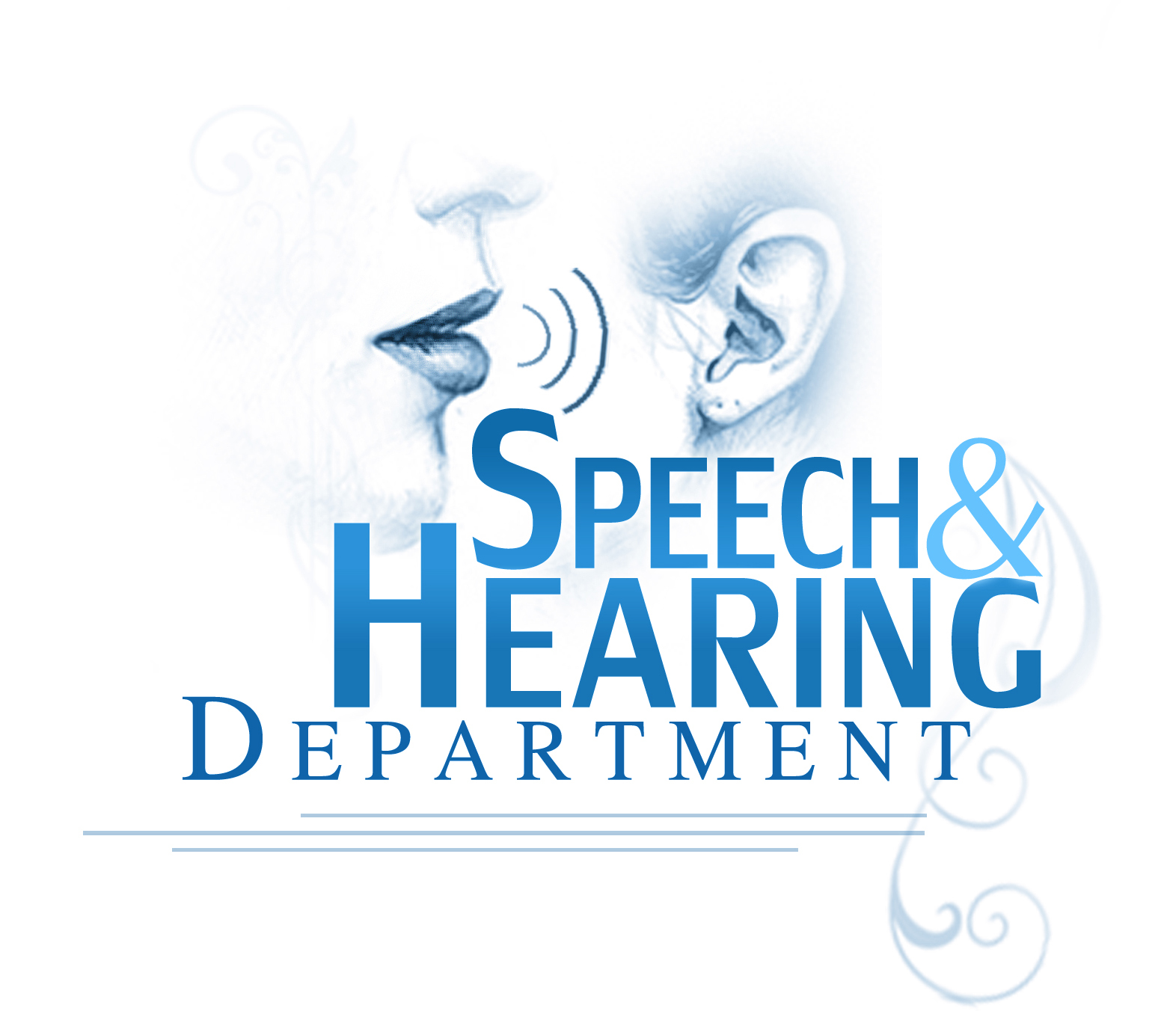
King Saud University
Applied Medical Science
Rehabilitation Department
Speech and Hearing Program
First Mid-Term
10th of March 2012
9:30 a.m. – 10:30 a.m.
Clinical procedures / RHS 378
Name: I.D. #: .
Answer Key Sheet (A)
Question 1: Matching:
Q | 1 | 2 | 3 | 4 | 5 | 6 | 7 | 8 | 9 | 10
Letter | I | J | A | B | M | D | G | E | C | H

Question 2: True or False:
Q | T/F | Correction/Reason
1 | F | - An SLP could refer the patient to any healthcare provider. As long as, the patient doesn’t have any record of being to that particular healthcare provider.  - Recommend that the patient be referred/ assessed.
2 | F | - The chart provides complete information about the patient’s condition.  - Partial.
3 | F | - When administering oral stimulation always begin with outer body parts and move in toward midline (work from the cheeks to the tongue to the lips)  - Work from the cheeks to lips to tongue.
4 | F | - The Diadochokinetic Test uses rapid alternating movements, basically, to assess the Articulators motor skill.  - To assess the motor skill, coordination, and neuromotor integration of the articulators.
5 | T
6 | T
7 | F | - An SLP or an Audiologist may provide consultation to the parents and children regarding speech and language disorders.  - Counseling.
8 | T
9 | F | - Baseline is when you assess the clients’ speech production while giving feedback.  - Without giving feedback.
10 | T

Question 3: Multiple Choices:
Q | 1 | 2 | 3 | 4 | 5 | 6 | 7 | 8 | 9 | 10
Letter | C | F | B | D | A | B | A | C | A | A

GOOD LUCK

