CLS 321

GENERAL PATHOLOGY

Lab Manual

Done by:
Danah Al-Turbak

All the projector slides are seen by a data show projector in a power point slides and the pictures are now with Danah Al-Turbak the Demonstrator of this course, and for the Glass slides it’s in Histology lab and we can see these slides under light microscopes in histology lab or by the screen which connected to a light microscope “ all slides are seen at low power”.
This lab have 20% of the 321 course marks, we divide it as 5% for the QUIZ in the mid of the term and 15% for the FINAL practical exam.

lab 1: INFLAMMATION " part one":
General introduction to inflammation.

* Projector slides:

1- Chronic inflammatory cells. 3 slides
2- Langerhan's specific Giant cell.
3- Foreign body. 2 slides
4- Acute inflammatory cells.
5- Margination of WBC's.
6- Immigration of WBC's.
7- Inflammatory reaction.

*Microscopic slides:

1- Chronic inflammatory cells from nasal polyps 2 slides.

Examples of projector slides:
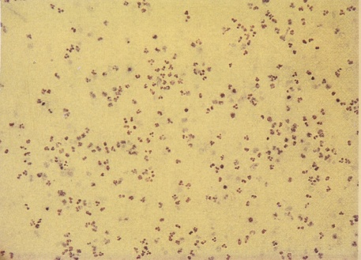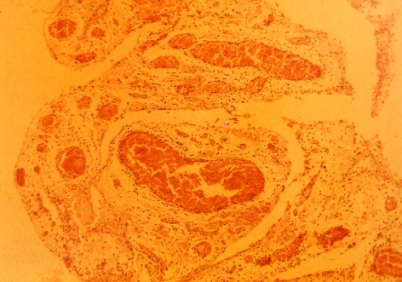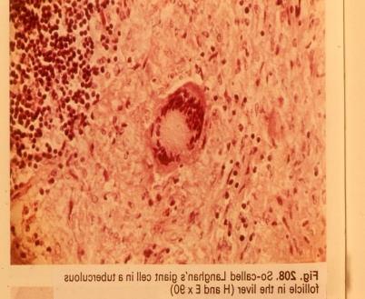
Lab 2: Continue in inflammation:
Types of inflammation, and sub-types of each type.

*Projector Slides:

1- Serofibrinous peritonitis in liver.
2- Acute diffuse suppurative appendicitis. 2 pictures 1-gross and 1- microscopic.
3- Severe acute cystitis.
4- Stomach Ulcer.

*Glass Slides:

1- Acute diffuse suppurative appendicitis.
2- Chronic marked fibrosis in spleen.

Examples of projector slides:
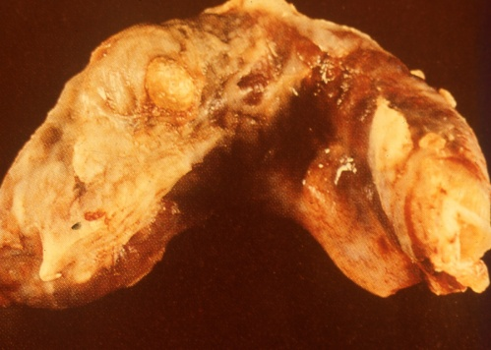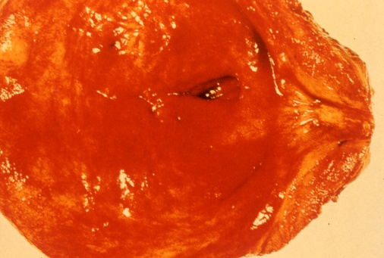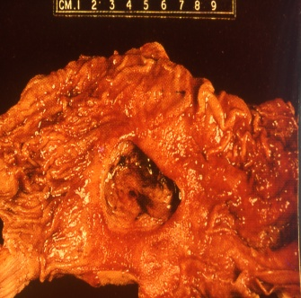
Lab 3: GRANULOMA “continue in inflammation”

Brief introduction in granuloma causes and how it appears.

*Projector Slides:

1- Early T.B in lymph node.
2- Casieating T.B in lymph node.
3- Chronic fibrocasious T.B in lung.
4- Belharziasis in Rectum.
5- Belharziasis in Urinary Bladder.
6- Belharziasis in Liver.

*Glass Slides:

1- Early T.B in Lymph node.
2- T.B in Lymph node.
3- Belharziasis in liver.
4- belharziasis in colon.

Examples of projector slides:
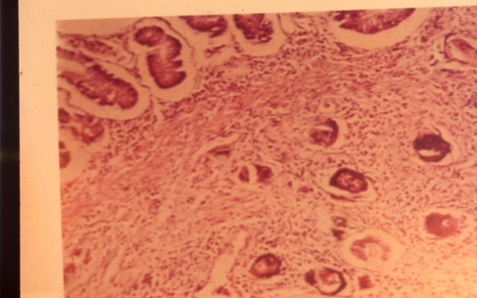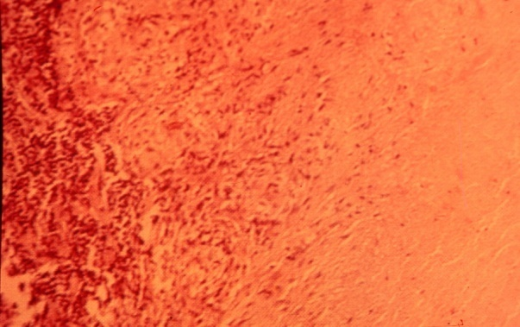

Lab 4: DEGENERATION:

Introduction of degeneration and types.

*Projector Slides:

1- Cloudy swelling in kidney. 2 slides 1-Gross and 1- Microscopic.
2- Fatty degeneration in liver. 2 slides 1- Gross and 1- Microscopic.
3- Amyloid degeneration in liver.
4- Amyloid degeneration in kidney. 3 slides 1- Gross and 2- Microscopic : Early and advanced stage.
5- Hyaline degeneration in spleen.

*Glass Slides:

1- Cloudy swelling in kidney. 2 slides.
2- Fatty degeneration in liver.
3- Amyloid degeneration in kidney 2 slides.
4- Amyloid degeneration in liver.
5- Amyloid degeneration in spleen.

Examples of projector slides:
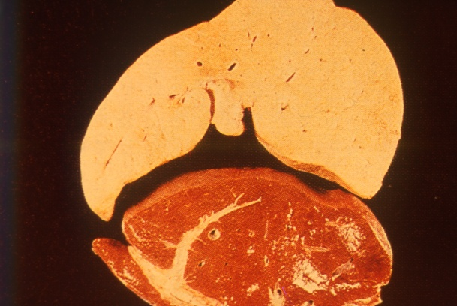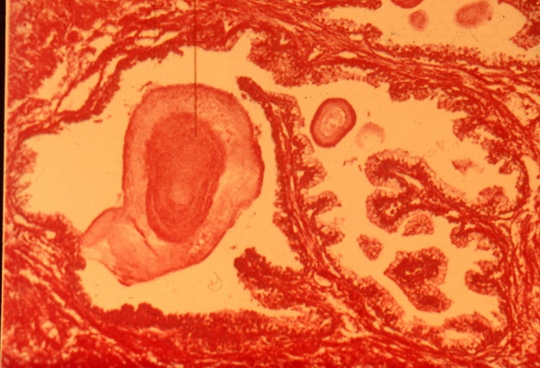

Lab 5: GANGRENE AND HEALING:

Definition and types of gangrene, definition and mechanism of healing.

*Projector Slides:

1- Dry gangrene.
2- Granulation tissue 2 slides.
3- Primary union.
4- Secondary union.
5- Myocardial Scaring.
6- Repair after myocardial infarction.

*Glass Slides:

1- Granulation tissue.

Examples of projector slides:
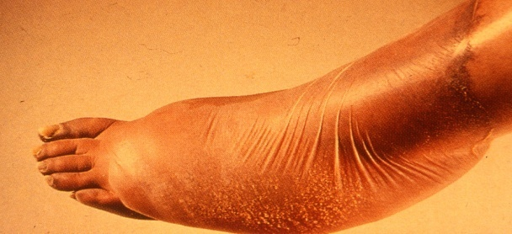
Lab 6: GROWTH DISTURBANCE:

Introduction and definitions to growth disturbance types.

*Projector slides:

1- Brown atrophy in heart 2 slides 1- Gross and 1- Microscopic
2- Hyper atrophy and normal heart.
3- Left ventricle hyper atrophy.
4- Atrophy and hyper atrophic cardiac muscles.
5- Senile hyperplasia in prostatic gland.

Here we have no Glass slides until now.

Examples of projector slides:
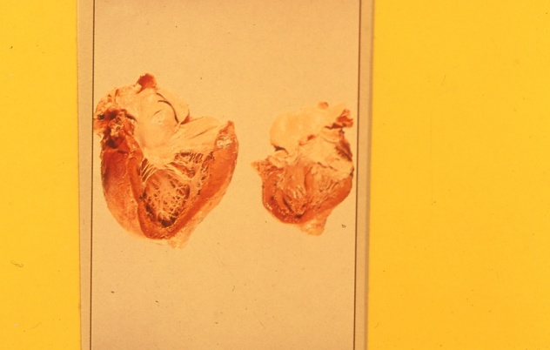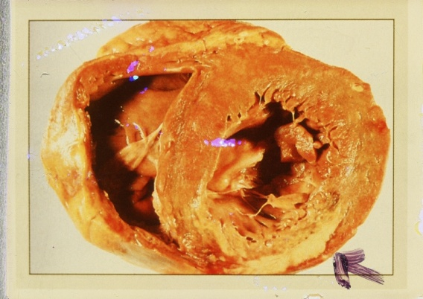

Lab 7: CIRCULATORY DISTURBANCE:

Types and causes of circulatory disturbance.

*Projector Slides:

1- Chronic venous congestion in lung.
2- Chronic venous congestion in liver.
3- Cerebral hemorrhage.
4- Cerebral Hematoma.
5- Thrombosis in the out flow of the heart.
6- Recent thrombus Gross and Microscopic in same picture.
7- Pulmonary embolism and infarction.
8- Pulmonary infarction.
9- Infarction in the kidney.
10- Atherosclerosis with lipid foam cells.
11- Atheroma in the heart.
12- Atheroma and Aneurysm in Aorta.
13- Aneurysm in the abdominal artery.
14- Renal Atherosclerosis 2 slides 1- Low magnification and 1- High

*Glass Slides:

1- Chronic venous congestion in lung 2 slides.
2- Chronic venous congestion in liver.
3- Infarction in lung.
4- Infarction and congestion in lung.
5- Infarction and normal kidney.

Examples of projector slides:
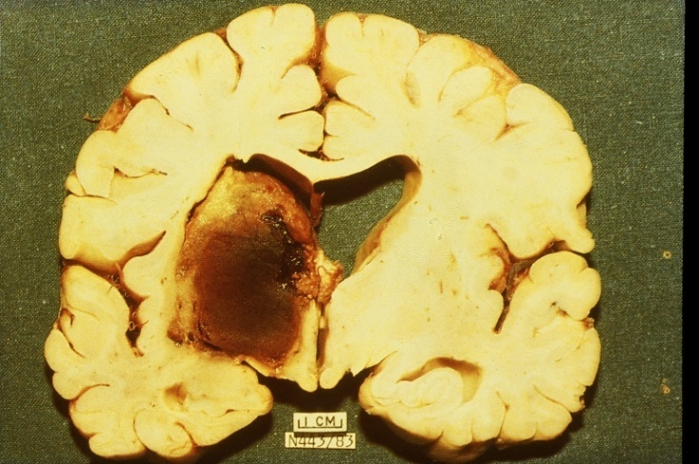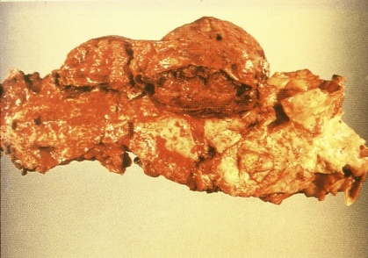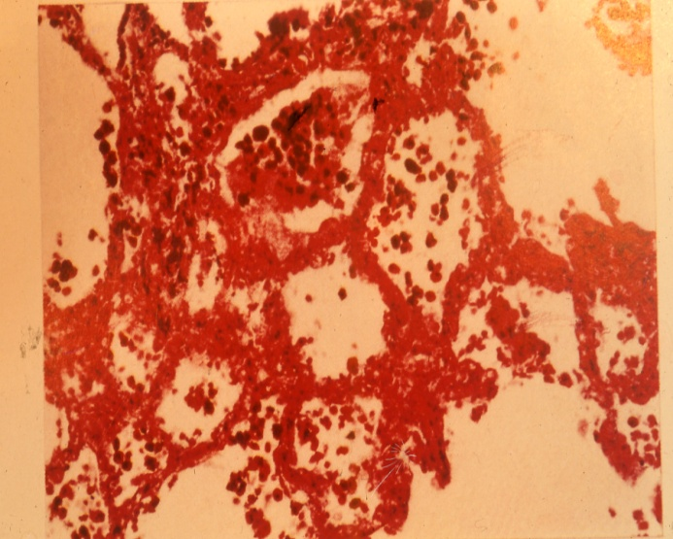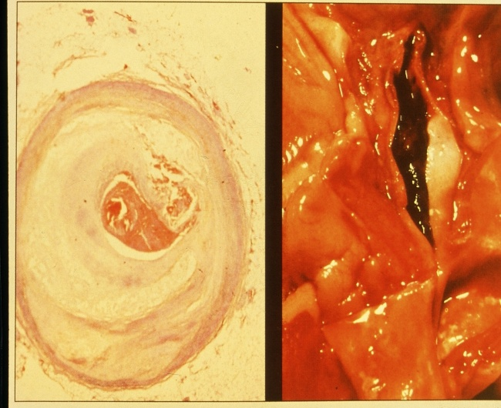
Lab 8: BENIGN TUMORS:

Short introduction to tumors as growth disturbance and difference between benign and malignant tumors, and common terminology.

*Projector Slides:

1- Adenoma in colon.
2- Adenoma in the intestine.
3- Pericanalicular fibroadenoma in breast.
4- Fibroma.
5- Fibromyoma.
6- Schwanomma, neurolemmoma.
7- Benign Melanoma in skin.

*Glass Slides:

1- Adenoma in intestine.
2- Fibroma.
3- Fibromyoma.
4- Schwanomma.
5- Pericanalicular fibroadenoma in breast.
6- Intracanalicular fibroadenoma in breast.
7- Lipoma.
8- Cavernous hemangioma.

Examples of projector slides:
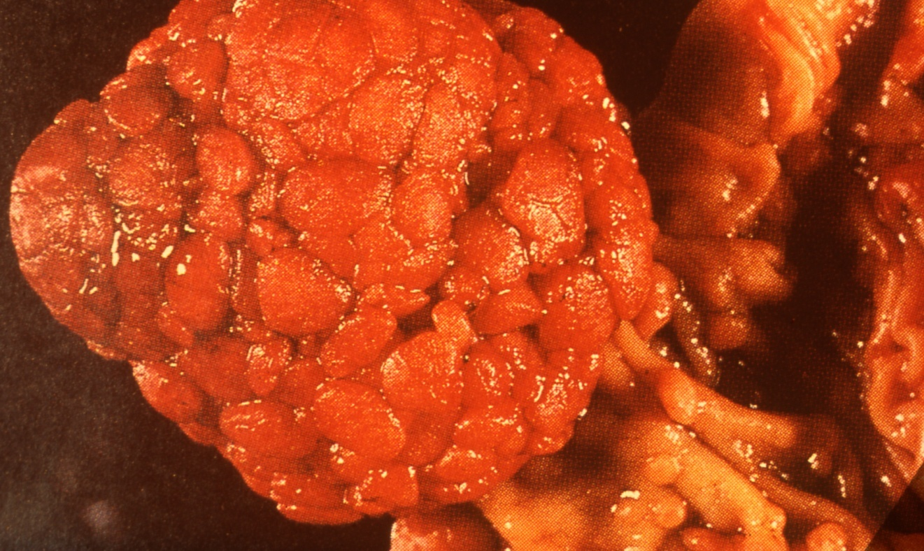

Lab 9: MALIGNANT TUMORS:

Terminology.

*Projector Slides:

1- Osteoclastoma Giant cell Tumor.
2- Osteosarcoma 2 slides 1- Gross and 1- Microscopic.
3- Squamous cell carcinoma.
4- Basal cell carcinoma.
5- Mucoid cell carcinoma.
6- Adenocarcinoma in colon.
7- Metastatic malignant melanoma in liver and eye ball.

*Glass Slides:

1- Osteocalstoma.
2- Osteosarcoma.
3- Squamous cell carcinoma.
4- Adenocarcinoma in intestine.

Examples of projector slides:
