King Saud University
College of Applied Studies &Community Services Program: Computer Science and Engineering

First Semester: 1445
DEVELOPMENT OF INTERNET APPLICATIONS (1) CT 1452

Instructor: Maram Aldakheel

Email: amaram@ksu.edu.sa

Course goal:

You will learn the fundamentals of the Internet and WWW including HTML, URL and HTTP. Also, other relevant concepts and technologies such as CSS, and JavaScript.

Textbook:

Internet & World Wide Web How to Program (5th edition)
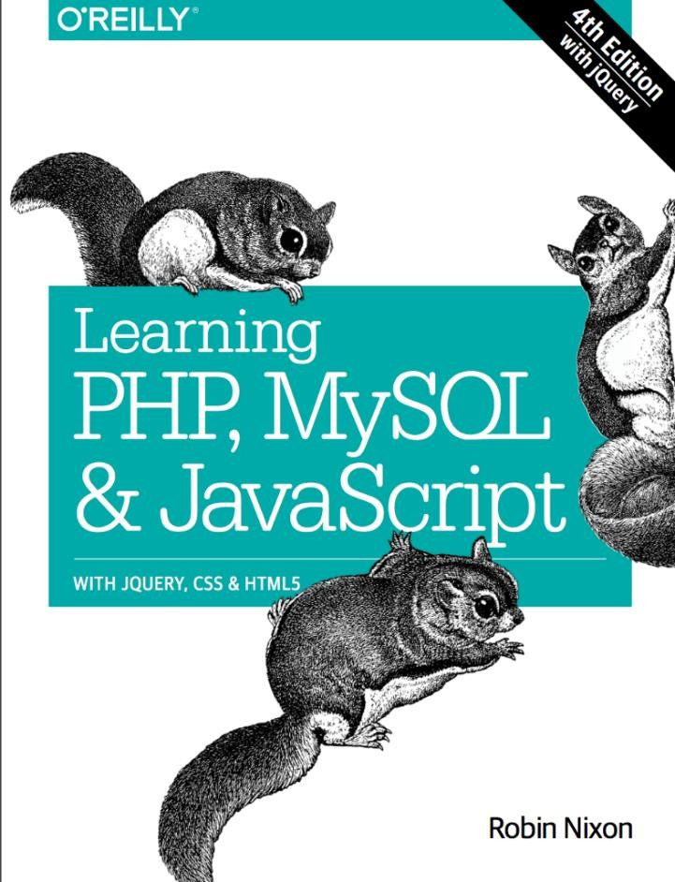

Reference:

Slides, lecture notes and the textbook

Assessment Plan for the Course:

Mid 25%

Class Quizzes 20%
Lab Evaluations 10%

Assignments ) project ) 5%
Final 40%

Notes:

- Late assignment submission will be not accepted.
- Students are encouraged to discuss assignments but not copy.
- If you miss an assignment, or lab evaluation, you will get on a zero.
- Missed exams can be made up in cases of extreme circumstances and it covers all chapters.
- Attendance is very important if you absent more than 25% you will be forbidden to enter the final exam.

