Crate two tables (Student, Lecturer) in the database university.
Data Base Name University:
Student:
Columns:
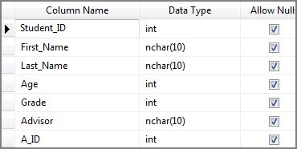
Data:
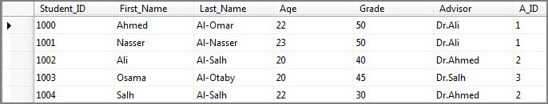

Lecturer:
Columns:
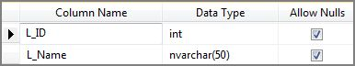
Data:
