Neurophysiology 346 RHS

Organization of the Nervous system.
Nervous system is composed of 2 divisons:
- Central Nervous system(CNS): Brain & Spinal cord

- Peripheral Nervous system(PNS): Sensory receptors, sensory nerves, & ganglia.

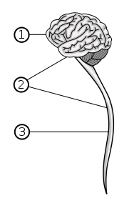 The central nervous system (2) is a combination of the brain (1) and the spinal cord Brain
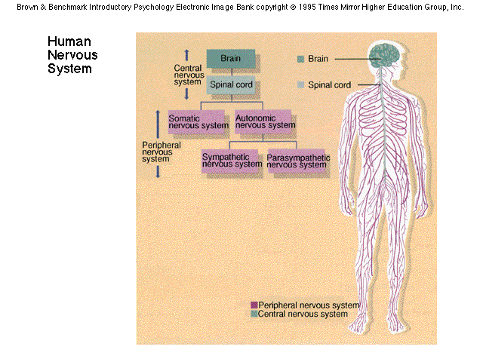

Central  nervous  system | Brain | Prosencephalon | Telencephalon | Rhinencephalon, Amygdala, Hippocampus, Neocortex,Basal ganglia, Lateral ventricles
 |  |  | Diencephalon | Epithalamus, Thalamus, Hypothalamus, Subthalamus,Pituitary gland, Pineal gland, Third ventricle
 |  | Brain stem | Mesencephalon | Tectum, Cerebral peduncle, Pretectum,Mesencephalic duct
 |  |  | Rhombencephalon | Metencephalon | Pons, Cerebellum
 |  |  |  | Myelencephalon | Medulla oblongata
 | Spinal cord

Nervous system
1) Sensory or Afferent division 2) Motor or Efferent division 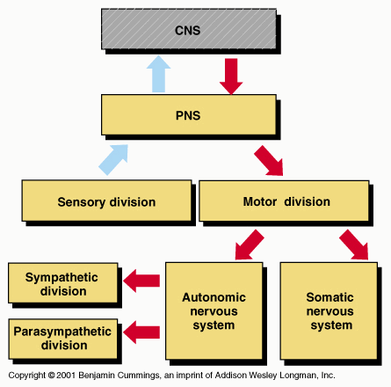

Brain:
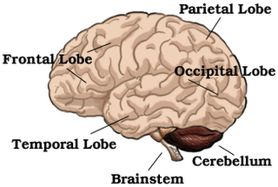

Spinal cord: spinal cord is segmented and contains 31 pairs of spinal nerves, which contains both sensory and motor nerves. 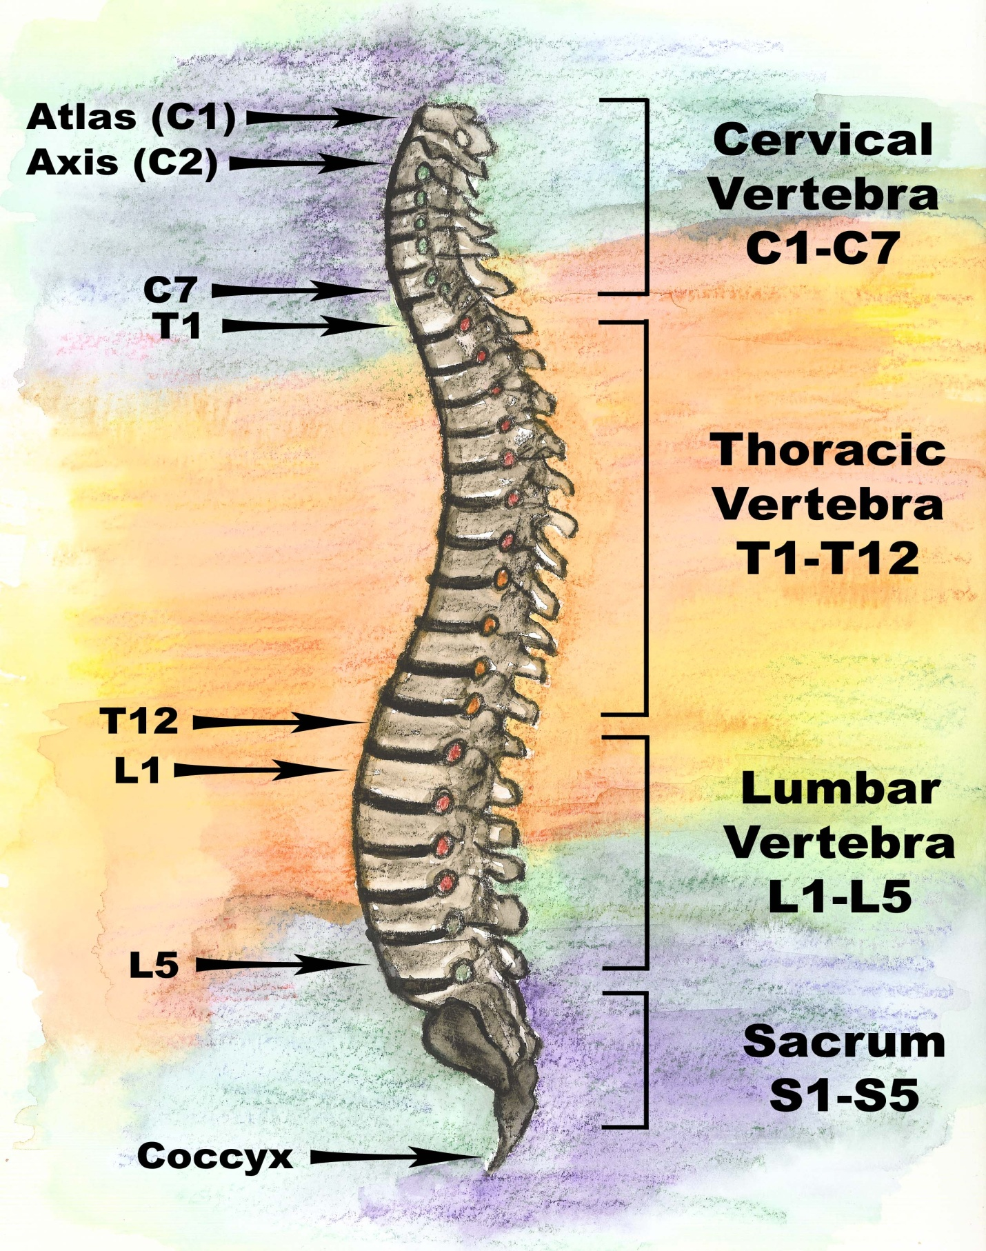
Ascending pathways & Descending pathways

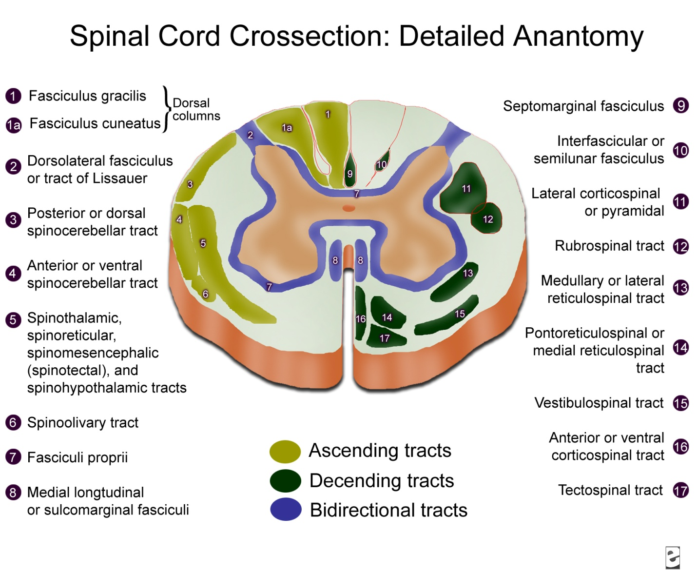
Brainstem: The medulla, pons, and midbrain are collectively called the Brainstem.
Medulla: Contains autonomic centers that regulate breathing and blood pressure as well as centers for swallowing, coughing, and vomiting reflexes.
Pons: participates in regulation of breathing, relays info from cerebral cortex to cerebellum.
Midbrain: participates in control of eye movements.
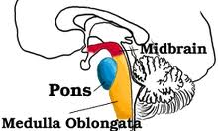

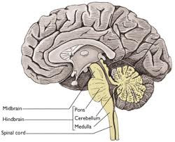

Cerebellum: cerebellum (Latin for little brain) is a region of the brain that plays an important role inmotor control. It may also be involved in some cognitive functions such as attention andlanguage, and in regulating fear and pleasure responses
The cerebellum does not initiate movement, but it contributes to coordination, precision, and accurate timing. It receives input from sensory systems and from other parts of the brain and spinal cord, and integrates these inputs to fine tune motor activity
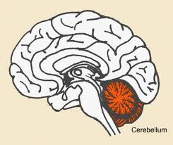

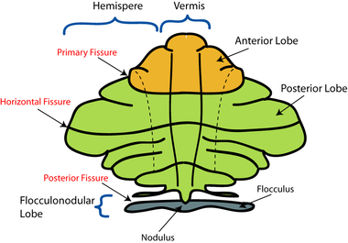

Thalamus and Hypothalamus(Diencephalon):
Thalamus : Processes almost all sensory information.
Hypothalamus: Regulate body temperature, food intake and water balance, controls secretion of the pituitary gland.

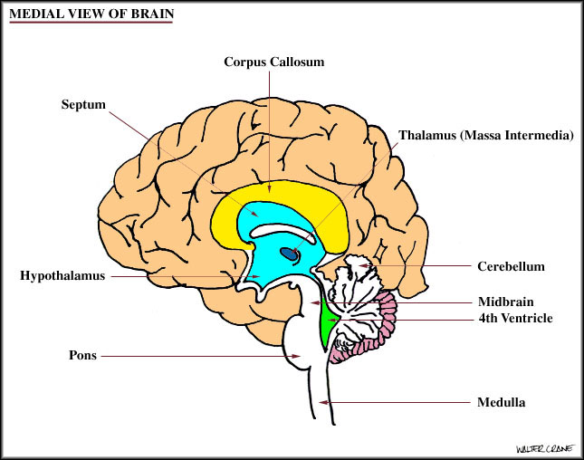
Cerebral hemispheres:
Consists of cerebral cortex and 3 deep nuclei(basal ganglia, hippocampus and amygdale)
Function: perception, higher motor functions, memory and emotion.
Cerebral cortex: consists of 4 lobes.
1)Frontal 2)parietal 3)Temporal 4)Occipital
Sensory and Motor areas of the cortex are designated as
Primary, secondary and tertiary
Association areas.
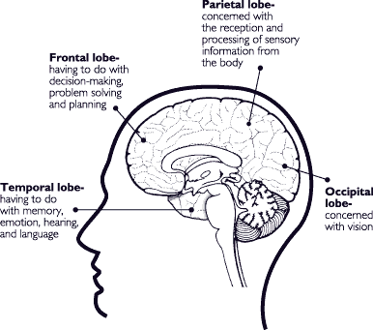
Basal ganglia: consist of caudate nucleus, the putamen and globus pallidus.
Function: assists in regulating movement.

Hippocampus & Amygdala: Part of limbic system
Function: Hippocampus involved in memory and amygdale involves with emotion (eg; effect of emotions on heart rate, pupil size and hypothalamic hormone secretion.

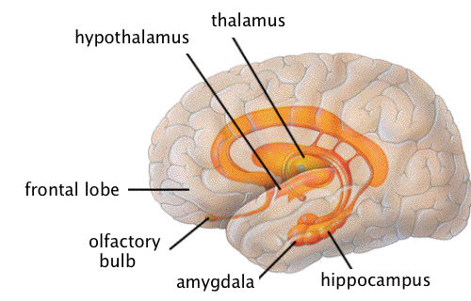

BASAL GANGLIA & INTERCONNECTIONS.
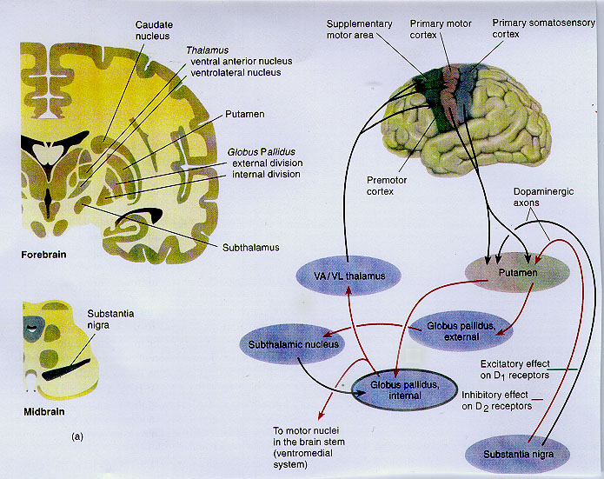

GENERAL FEATURES OF SENSORY AND MOTOR SYSTEMS:
Synaptic Relays:
Consist of different types of neurons including local inter neurons and projection neurons.
Topographic organization: Information is encoded in neural maps

Somatotopic map:
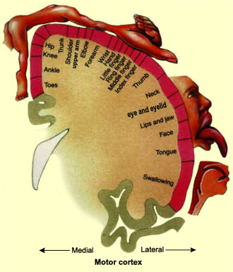
Retinotopic map:
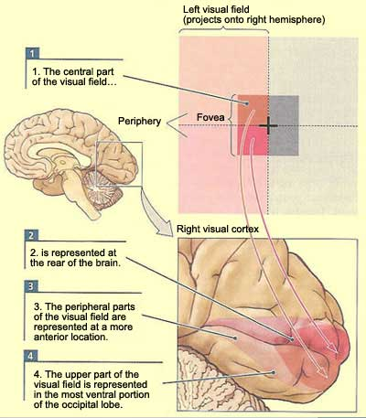
Tonotopic map: 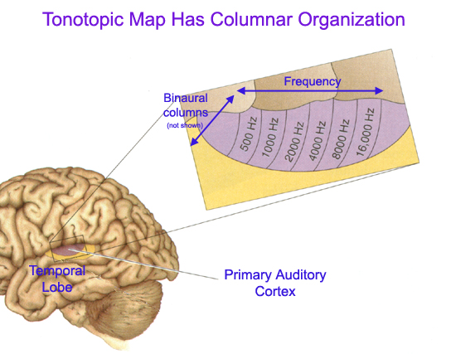
Classification of Nerve fibers: 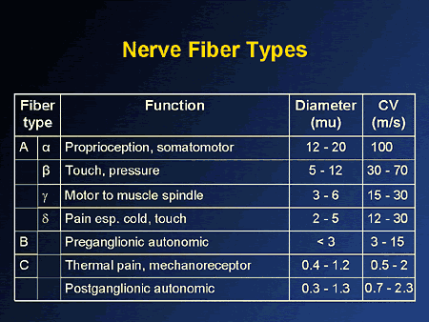
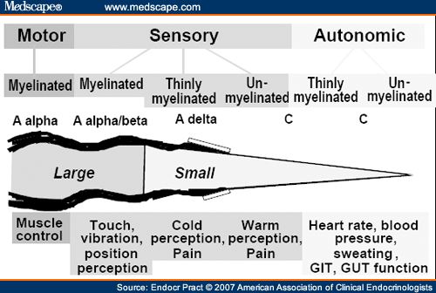
Sensory systems:
Somato-Sensory pathways-
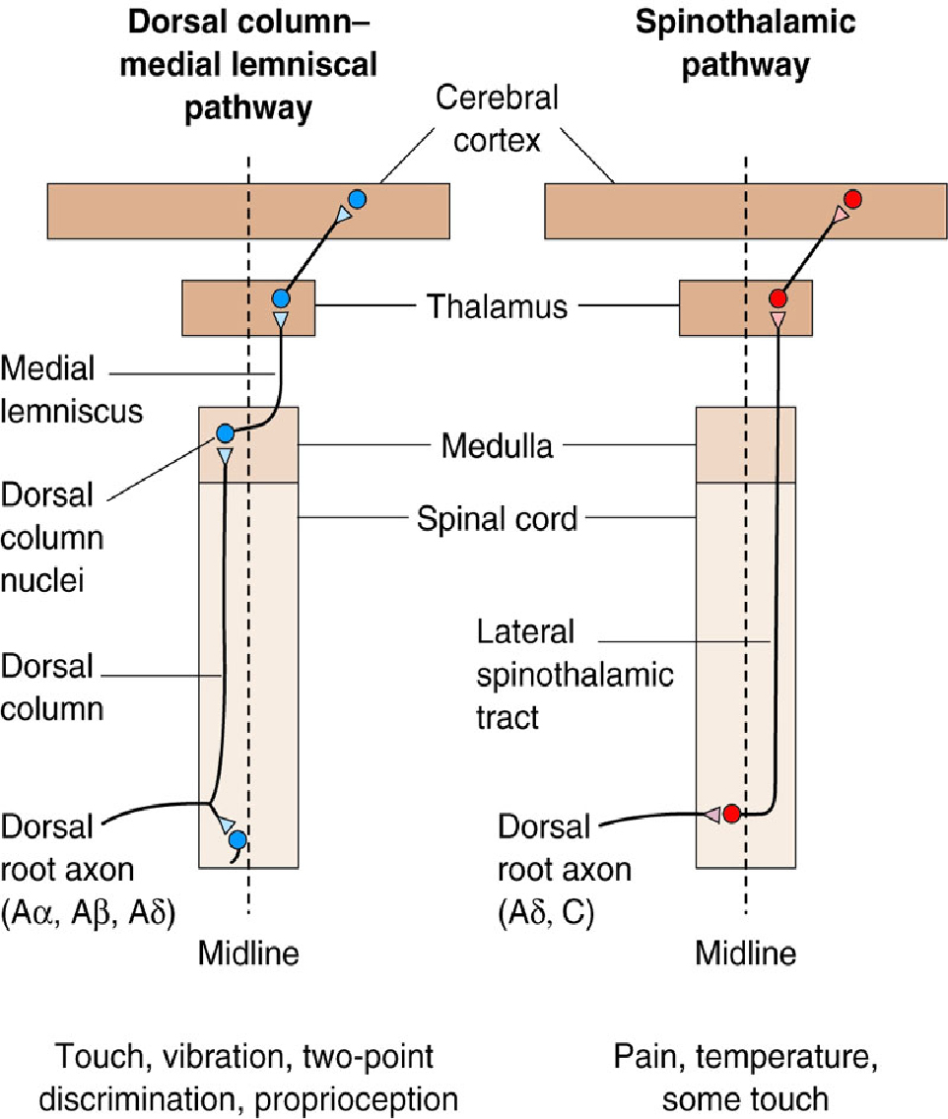
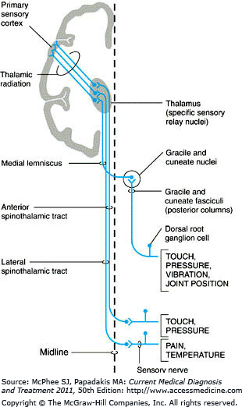
1) Sensory receptors
2) First order sensory afferent neurons
3) Second order sensory afferent neurons
4) Third order sensory afferent neurons
5) Fourth order sensory afferent neurons

Sensory receptors 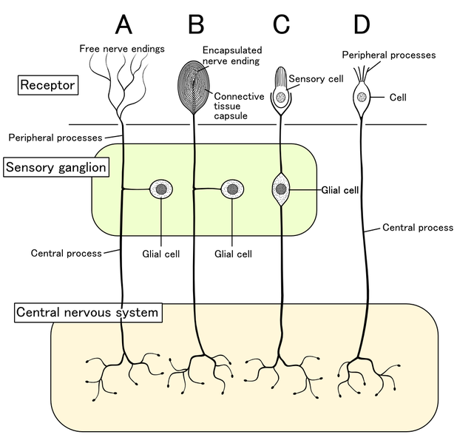
Types of sensory Receptors: 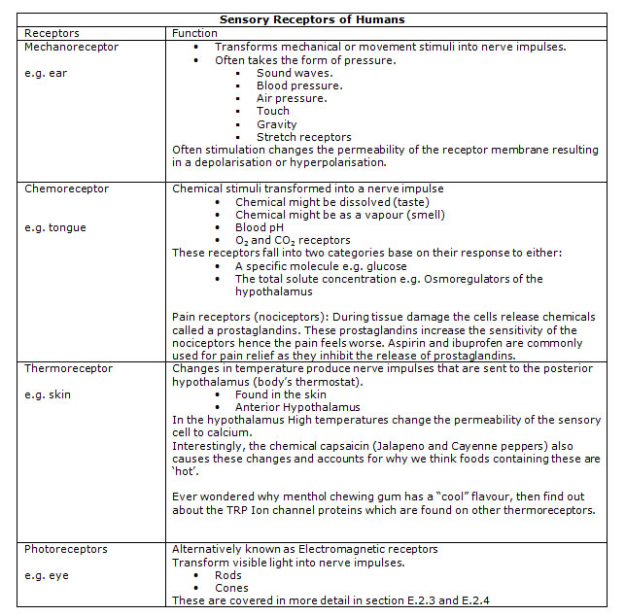
Mechanoreceptors: Activated by pressure
Modality-touch, audition, vestibular
Receptor-Pacinian corpuscle in subcutaneous tissue, Meissners corpuscles in non hairy skin, baroreceptors in carotid sinus, hair cells in organ of corti

By Morphology:

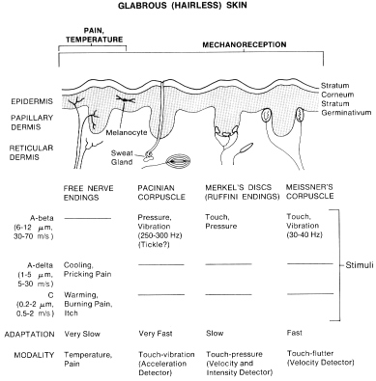
- Ruffini's end organs detect tension deep in the skin.
- Meissner's corpuscles detect changes in texture (vibrations around 50 Hz) and adapt rapidly.
- Pacinian corpuscles detect rapid vibrations (about 200–300 Hz).
- Merkel's discs detect sustained touch and pressure.
- Mechanoreceiving free nerve endings detect touch, pressure and stretching
- Hair follicle receptors are located in hair follicles and sense position changes of hairs.

By rate of adaptation
- Slowly adapting: Slowly adapting mechanoreceptors include Merkel and Ruffini corpuscle end-organs, and some free nerve endings.
  - Slowly adapting type I mechanoreceptors have multiple Merkel corpuscle end-organs.
  - Slowly adapting type II mechanoreceptors have single Ruffini corpuscle end-organs.
- Intermediate adapting: Some free nerve endings are intermediate adapting.
- Rapidly adapting: Rapidly adapting mechanoreceptors include Meissner corpuscle end-organs, Pacinian corpuscle end-organs, hair follicle receptors and some free nerve endings.
  - Rapidly adapting type I mechanoreceptors have multiple Meissner corpuscle end-organs.
  - Rapidly adapting type II mechanoreceptors (usually called Pacinian) have single Pacinian corpuscle end-organs.

Photoreceptors:
Modality- vision
Receptor- rods & cones
Location – retina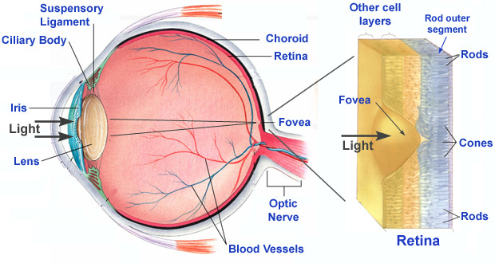
Chemoreceptors:
Modality- Olfaction, Taste, Arterial Po₂, pH of CSF.
Receptor- Olfactory receptor, Taste buds.
Location- Olfactory mucosa, Tongue, Carotid & Aortic bodies, Ventrolateral medulla.
Thermoreceptors:
Modality- Temperature
Receptor- Cold & Warm receptors.
Location- Skin.

Nociceptors:
Modality- Pain and Temperature
Receptor- Thermal & polymodal nociceptors.
Location – Skin.

Sensory Transduction and Receptor potentials
Sensory Transduction is the processes by which an environmental stimulus( eg; pressure, light, chemicals) activates a receptor and is converted into electrical energy.
Current flow then leads to a change in membrane potential, called a receptor potential.(Depolarization or Hyperpolarization).
Receptor potentials are graded in amplitude and amplitude correlate with size of stimulus. 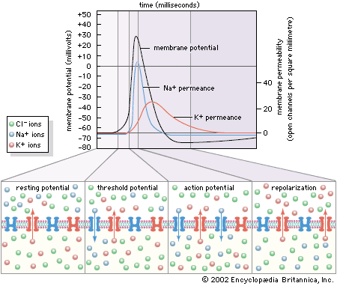
Receptive fields: Defines an area of body that when stimulated results in a change in firing rate of a sensory neuron.
Excitatory or Inhibitory.
Lateral inhibition.
Sensory coding: Sensory neurons are responsible for encoding stimuli in the environment.
The features that can be encoded include sensory modality, spatial location, frequency, intensity, threshold and duration of stimulus.
Adaptation of Sensory receptors: Is observed when a constant stimulus is applied for a period of time.
Tonic receptors.
- Slow or no adaptation
- Continuous signal transmission for duration of stimulus
- Monitoring of parameters that must be continually evaluated, e.g.: baroreceptors
- Encode stimulus intensity and Duration.
Phasic receptors
- Rapid adaptation
- Cease firing if strength of a continuous stimulus remains constant
- Allow body to ignore constant unimportant information, e.g.Smell

