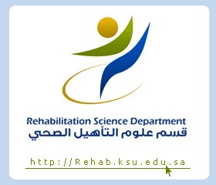
King Saud University
College of Applied Medical Sciences
Department of Rehabilitation Health Sciences

Course Syllabus
2nd Semestrer
1434 H - 2013 G

Course title : Rehabilitation processes (splinting and orthotics).
Course number : RHS 422

Credit hours : (1+1) = 2 hours
Course Instructor: Mrs. Tahani Al Ahmad taalahmad@ksu.edu.sa

Course description
A course covering knowledge of therapeutic techniques and biomechanical principles involved in the application and fabrication of static and dynamic splints.

Objectives

On the completion of this course, the students should be able to:
- Define the principles involved in the therapeutic application of static/dynamic splints.
- Explain the properties of different low temperature, thermoplastic materials.
- Demonstrate the use of patterns, construction and adjustment of the splint, with consideration given to anatomy, biomechanics, goals of the splint, and client needs.
- Demonstrate and document evidence based practice for the application of splints for individuals with musculoskeletal and neurological injuries or illness.
- Take the measurements and make splints for different pathological conditions

Course out line RHS 422 OT program

- Hand anatomy
- Principles of splinting
- Neurological conditions and the role of OT (Hemiplegia)
- Tendon transfers/release in cerebral palsy rehabilitation
- Flexor tendon injuries and rehabilitation
- Extensor tendon rehabilitation
- Hand stiffness
- Management of peripheral nerve injury
- Lower limb orthosis
- Spinal orthoses
- Levels of amputation
- Upper limb and lower limb prosthesis

