Unit I
Conception and Fertilization

Fertilization : it’s the union of ovum (egg) and spermatozoa( sperm) which result in a Zygote.
- where fertilization occur?
in the ampulla's of the fallopian tube following ovulation .
-When?
- days before the next period .
**The term "conception" refers variably to either fertilization or to formation of the conceptus after uterine implantation, and this terminology is controversial.
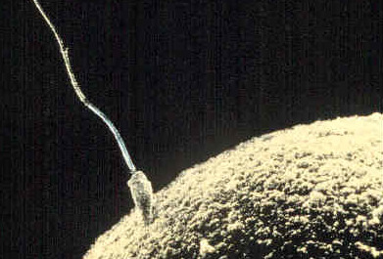

A sperm fertilizing an ovum

**Egg or Ovum is surrounded by an outer matrix called the zona pellucida .outside this matrix are a few layers of follicular cells collectively called the corona radiate .
Request for fertilization:
1. presence of healthy recently ovum , the ovum is fertile for 12 to 24 hours.
2. Presence of enough number of normal, viable, motile and mature sperms, the sperm is fertile for 48 to 72 hours .
3. Normal vagina , cervix, ovaries , fallopian tube and uterus structure specially normal vaginal discharge .
4. Appropriate intercourse time ( around the time of ovulation no more than 24hours before or after ovulation
**The onset of pregnancy marked by implantation of blastocyte into the endometrial.

Steps of Fertilization
- Fertilization occurs when sexual intercourse allows sperm to travel through the female's vagina through the cervix and the uterus to meet the mature egg( corona radiate). Although males can release 200-300 million sperm, it only takes one to penetrate the egg.
- Acrosomal enzymes digest a portion of the zona pellucid.
- Sperm binds to and fused with the eggs's plasma membrane Sperm nucleus enters the egg and fuse to form a new cell (the zygote). This cell contains 46 chromosomes, 23 from each parent cell
** What prevent no more than one sperm from entering the ovum ?
- The egg's plasma membrane changes to prevent other sperm from binding
- Vesicles within the egg release enzymes that cause the Zona Pellucida to become impenetrable and sperm cannot bind
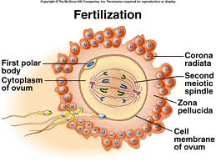

Human development before implementation

-As the zygote travels to the uterus, it divides through rapaid mitotic cell division , but these do not increase the size of the Zygote called cleavage division , forming a cluster of cells (16 cells ) called (the morula) by about 3 days after fertilization.
- The morula develops a hollow cavity and is now known as a blastocyst at 5 days after conception , which will become the embryo. This blastocyst floats freely within the uterine cavity for about 48 hours before attaching itself to a site in the endometrium (uterine lining). The cells in the inside of the blastocyst, called the embryoblast, start forming the embryo. The outer cells, called the trophoblast which secreate the human chorionic gonadotropin (hCG) and it's , start to form the placenta. It continues to be referred to as a pre-embryo.
-About 9 to10 days following fertilization, the blastocyst is completely imbedded into the endometrium, and forms the placenta. Within the cell cover of the blastocyst's cavity, it then develops into a fluid- filled sac covering the embryo, and the yolk sac.
-12 days or so after conception: The blastocyst has started to produce hormones which can be detected in the woman's urine (the human chorionic gonadotropin (hCG))..This hormone will keep the corpus luteum active until the placenta c An produce estrogen and progesterone
-13 or 14 days after conception: A "primitive streak" appears. It will later develop into the fetus' central nervous system.The pre-embryo is now referred to as an embryo. It is a very small cluster of undifferentiated cells at this stage of development.
Cellular differentiation
Embryonic membranes
- Aminion : inner layer
- Chorion: outer layer
- Both membranes form bage of water : aminiotic fluid ( 700-1000 )ml .
- Fetus contributes to amniotic fluid volume through fetal urine
- Umbilical cord: Wharton 's jelly , and contain 2 arteries and 1 vein
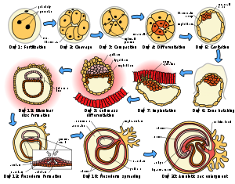

Gestational Period

Pregnancy is dividied into three trimesters :
1st trimester : from fertilization until 14weeks.during this trimester individual start as a zygote ,then morula, blastocyst, and after implementation , is called an embryo.
*embryonic phase of development last from fertilization until 8th weeks of gestation , when it becomes a fetus.
2nd trimester: 15 – 27 weeks
3rd trimester: 28 – 40 weeks
The Stages of fetal development

1.pre-embryonic stage: it's the first 14 days after fertilization .
2. embryonic stage : it's began from 3rd week after conception until 8th weeks .at this time , the embryo is referred to as a fetus.
3. fetal stage: it's begins 8 to 10th weeks after conception and continues until the end of pregnancy . and this time, fetus is fully developed structurally.
Embryonic development – week 2
The cells in the inside of the blastocyst detaches itself and becomes the embryonic disk that will go through gastrulation to become 3 primary germ layers :
- Ecdoderm: the tissue and organs that develop from it are central & peripheral nervous system, sensory epithelium of ear, nose, eye , anal canal , hair , sebaceous and sweaty glands.
- Mesoderm: the tissue and organs that develop from it are bone, cartilage, skeleton, blood and lymph cells, kidney and reproductive organs
- Endoderm: the tissue and organs that develop from it are respiratory tract epithelium, epithelial lining of GI tract ( pharynx, tongue, &thyroid). epithelial lining of bladder.

Embryonic development – week 3
- The nervous system begins to develop
- The posterior neural tube will become the spinal cord and brain
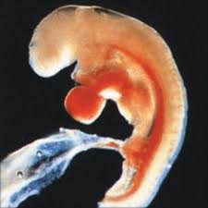
- development of the heart begins
- the size of embryo is a pencil point.
Embryonic development – week 4
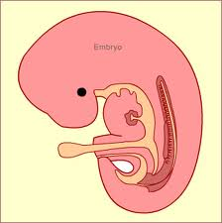
- The embryo is 4-5mmin length
- Chorionic villi form
- Umbilical cord formed
- Foundation for nervous system, genitourinary system, skin, bones, and lung
- Rudiment of eyes, ears, and nose appear
- Buds of legs and arms begin to formed
Embryonic development 5 to 8 weeks

- Head enlarged as a result of brain development
- Sex differentiation begin
- Hands with webs between the fingers have formed at the end of the arm buds
- The face has two eyes on each side of its head.

Fetal Development -9 to 12 weeks

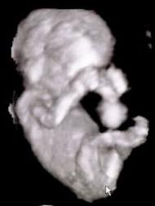
- The fetus average length is 50-87 mm, and weight is 54g
- Finger and toes are distinct
- Placenta is complete
- Can distinguish female from male( 3 month)
- Kidneys start secrete urine

Fetal Development -13to 16 weeks

- Heart beat is present (4 months)
- Lanugo develops
- Lower limbs are well development and coordinated limb movements are present
- Head is erect
- Nasal septum and palate close

Fetal Development -17to 20 weeks
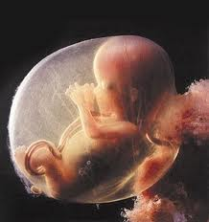
- The fetus weight is about 260-460g
- Fetal movement are felt by women
- Eyebrows and scalp hair are present
- Heart sound are perceptible by auscultation
- Vernix caseosa covers skin
Fetal Development -21to 25 weeks

- Skin appear wrinkled and pink to red
- Eyebrows and fingernail develop
Fetal Development -26to 29 weeks
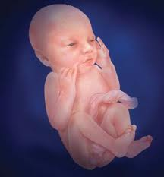
- Skin red
- Weight about 910 to 1,500g
- The fetus often survives if born prematurely
- Rhythmic breathing movement occur

Fetal Development -30to 34 weeks

- Eyelids open
- Steady weight gain occurs(1,70-2.500)g
- Vigorous fetal movement occur
Fetal Development -35to 37 weeks

- Fetus weight is about 2,700-3,400g
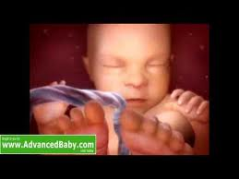
- Face and body have loose wrinkled appearance due to subcutaneous fat deposit
- Amniotic fluid decrease
- Lanugo disappear
Fetal Development -38to full term
- Average fetus weight is about 3,400-3.600g
- Skin is smooth
- Chest is prominent
- Bones of skull are ossified and nearly together
- Testes are in scrotum

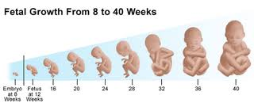
Development of the sex organs

- The sex of an individual is determined at conception (XX is female and XY is male)
- If SRY gene (the sex determining region on the Y chromosome) gene is present ,at ~week 7 the embryo develops into a male
- Development of the male external genitalia is dependent upon dihydrotestosterone which is produced by the testes.
- In the absence of the SRY gene, of the Y chromosome, a female embryo will develop.
The development of the female external genitalia is promoted by the presence of estrogen and other hormones within the maternal system

Embryonic and fetal support structures

1.Corpus luteum: is secrete estrogen and progesterone in the first 2 gestational months before the placenta is fully developed, and these is essential for sustaining the uterine endometrium and preventing menstruation.
2.Decidua:after implementation the endometrium is called decidua and its divided into 3 layer :
- Decidua Basalis
- Decidua Capsularis
- Decidua Vera
Decidua will protect and nourish developing embryo.
3.placenta: it’s begin function at 4th weeks of gestation, by14th week it’s complete, independently functioning organ.
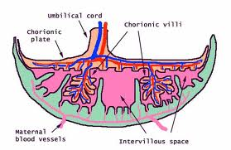
It’s has 2 different surfaces:
a. Fetal surface :
- smooth
-shiny
-cover with amnion,
which reflect on the cord
- the umbilical cord is inserted in its center
B. Maternal surface:

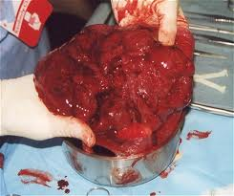
-rough
-spongy
-dull red in color
-composed of 15-20 cotyledons which contain complex vascular system of villi
Chorion membrane that develops from the trophoblast along
with the chorionic villi form the fetal side of the placenta develops into fetal part of placenta. The chorionic villi are projections from the chorion that embed into the decidua basalis and later form the fetal blood vessels of the placenta. its connects the fetal circulation to the placenta composed of both fetal and maternal tissues.
Function of placenta

- Transfer nutrient and oxygen to the fetus
- Remove waste and carbon dioxide by diffusion
- Formation of a barrier ,incomplete, nonselective,alcohol,steroid,narcotics,anesthetics, some antibiotic and some organisms can cross
- The endocrine organ of pregnancy ,it’s produce the following hormones:
a. Estrogen :
- it’s enhance growth of the uterus and breast
- Enhance utero-placental blood flow
- It’s indicates placental function, fetal maturity , and fetal well being.
- Produce from placenta after 12 weeks

B. Progesterone:
-produce from corpus luteum and then from placenta
-relaxes uterine smooth muscle
-promote thickening and increase viscosity of cervical mucus ( mucus plug) to protect fetus against invading bacteria
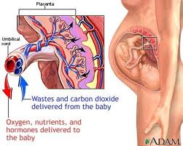
-it’s stimulate growth of glandular breast tissue in preparation for lactation.
-regulate storage of body fat
-it’s maintains uterine lining for implantation

c. Human Chorionic gonadotropin (HCG):
HCG is secrete from trophoblast cell of blastocyst ( early of conception), and then from placenta after 2nd gestational month.
- it’s responsible for maintaining the corpus luteum
- It’s the first indicator of positive pregnancy

d. Human Placental Lactogen OR Human Chorionic Somatomammotropin
- it’s level increase after 20GW
- It’s facilitate glucose transport across placenta and this will promote fetal growth .
- It’s stimulate breast development to prepare for lactation
- It’s stimulate maternal metabolism:
.e. Relaxin Hormone
-released by corpus luteum then placenta
-softens pelvic ligament
-Reduces myometrial tone

4. Membranes and amniotic fluid

A. chorion: outside embryonic membrane
-it’s provide embryo with nourishment and gets rid of wastes
B. yolk sac: contain many of the blood vessels and it’s the site where blood cells first form
C. amnion: innermost membrane
-contain amniotic fluid that cushions and protect the embryo
d. Amniotic fluid
Normal range is from 500-1000ml
Functions of it are the following
- protect the embryo and fetus
-control temperature
-supports symmetrical growth
-prevents adherence to amnion
-allows the embryo and fetus to move within the amniotic cavity
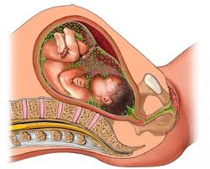

Abnormalities
■ Polyhydramnios or hydramnios refers to excess amount of
amniotic fluid (1,500–2,000 mL). Newborns of mothers who
experienced polyhydramnios have an increased incidence of
chromosomal disorders and gastrointestinal, cardiac, and/or
neural tube disorders.
■ Oligohydramnios refers to a decreased amount of amniotic
fluid (>500 mL at term or 50% reduction of normal amounts),
which is generally related to a decrease in placental function.
Newborns of mothers who experienced oligohydramnios have
an increased incidence of congenital renal problems.

5.Umbilical cord
-At term it is 30-90cm long and 2cm in diameter
-It’s contain 2 artery and 1 vein
■Arteries carry deoxygenated blood.
■ The vein carries oxygenated blood.
-It’s normally inserted in the center of placenta
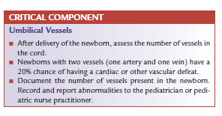
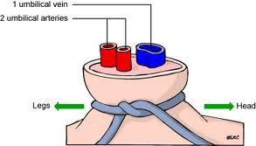
-The cord contains a clear, collagenous substance, like substance called Wharton jelly, which connective tissue that prevents compression of the blood vessels.

