King Saud University

Department of Geology

Instrumental analysis in geology

جهاز الامتصاص الطيفي الذري
Atomic Absorption spectrometer AAS

Saeed shaltoni

Date: 7-5-2009
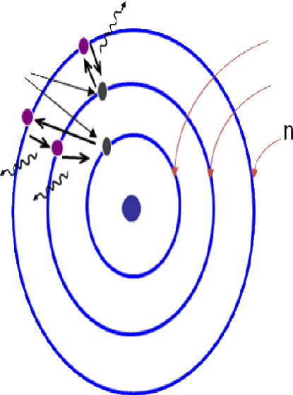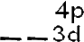
Introduction to spectroscopy

Electron excitation

The excitation can occur at different degrees (see figure 1):

1. low Energy tends to excite the outmost e-’s first

2.when excited with a high Energy (photon of high v) an e- can jump more than one levels
3. Even higher E can tear inner e-’s away from nuclei

Figure 1: The excitation of electrons

An e- at its excited state is not stable and tends to return its ground state

If an e- jumped more than one energy levels(see figure 2) because of absorption of a high E, the process of the e- returning to its ground state may take several steps,
- i.e. to the nearest low energy level first then down to next …

(1) Figure 2: The energy level
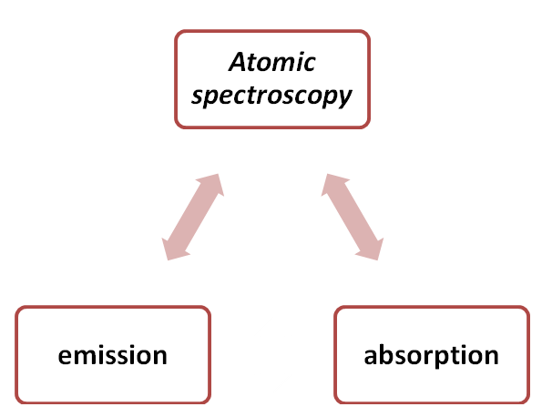 Atomic spectroscopy

The atomic spectroscopy include both the atomic absorption and atomic emission
(see figure 3)

Figure 3: The atomic spectroscopy

Atomic emission
Zero background (noise)(see figure 4)

Figure 4: The atomic emission
Atomic absorption(see figure 5) Bright background (noise) Measure intensity change
More signal than emission
Trace detection

(2) Figure 5: The atomic absorption
Atomic absorption spectrometry

Atomic absorption spectrometry (AAS) is an analytical technique that measures the concentrations of elements. Atomic absorption is so sensitive that it can measure down to parts per billion of a gram (µg dm–3) in a sample. The technique makes use of the wavelengths of light specifically absorbed by an element. They correspond to the energies needed to promote electrons from one energy level to another, higher, energy level.

(AAS) is the appropriate term used when electro-magnetic radiation (EMR) is absorbed or emitted by atoms and measured. All atoms can absorb EMR, and the wavelengths at which EMR is absorbed or emitted is exclusive for a particular
chemical element. AAS is a quantitative method of analysis that is used to analyze

many metals and a few non-metals

It provides accurate quantitative analyses for metals in water, sediments, soils or rocks. (Samples are analyzed in solution form, so solid samples must be leached or dissolved prior to analysis.)

(3)
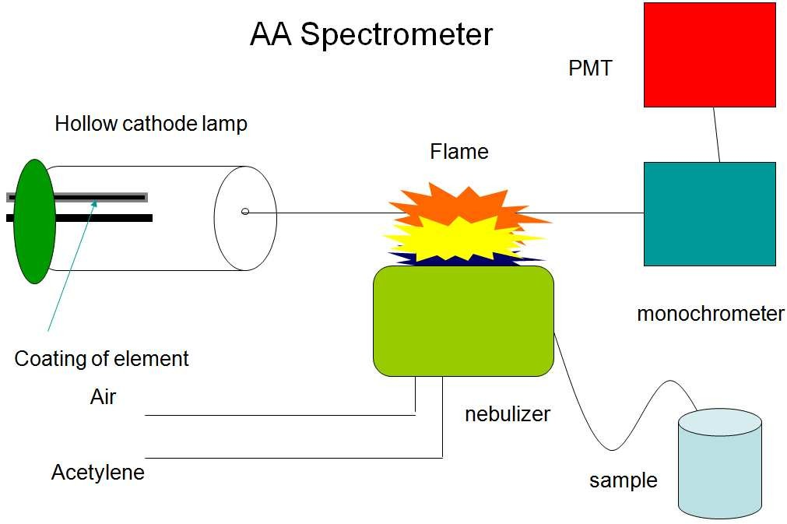 How it works

Atoms of different elements absorb characteristic wavelengths of light. Analyzing a sample to see if it contains a particular element means using light from that element(see figure 6). For example with lead, a lamp containing lead emits light from excited vlead atoms that produce the right mix of wavelengths to be absorbed by any lead va toms from the sample.

Figure 6: The AAS design

In AAS, the sample is atomized – i.e. converted into ground state free atoms in the vapour state – and a beam of electromagnetic radiation emitted from excited lead atoms is passed through the vaporised sample. Some of the radiation is absorbed
by the lead atoms in the sample.

(5)
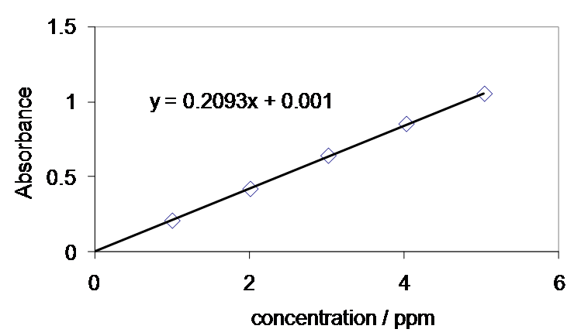 How it works

The greater the number of atoms there is in the vapour, the more radiation is absorbed. The amount of light absorbed is proportional to the number of lead atoms.
A calibration curve (see figure 7)is constructed by running several samples of known lead concentration under the same conditions as the unknown. The amount the standard absorbs is compared with the calibration curve and this enables the calculation of the lead concentration in the unknown sample.

Figure 7: The Calibration curve

Consequently an atomic absorption spectrometer needs the following three components: a light source; a sample cell to produce gaseous atoms; and a means of measuring the specific light absorbed

(6)
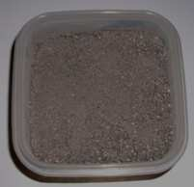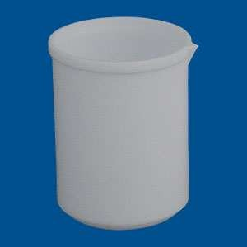 Materials and methods

1. Rock powder (see figure 8)

Figure 8: powdered rock sample

2. Teflon beaker (see figure 9)

Figure 9: Teflon beaker

(7)
Materials and methods

3. Aqua regia(HNO3+HCL)(see figure 10)

4. Autoclave (see figure 11)
Figure 10:Aqua regia bottle
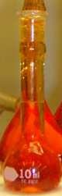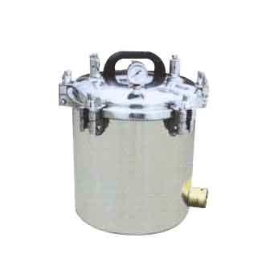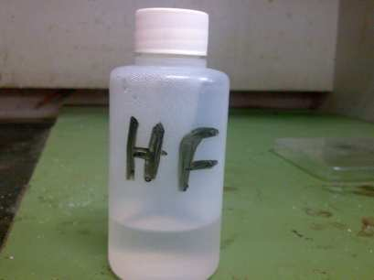

Figure 11:Autoclave
5. Hydrofluoric acid (see figure 12)

Figure 12: Hydrofluoric acid

(8)
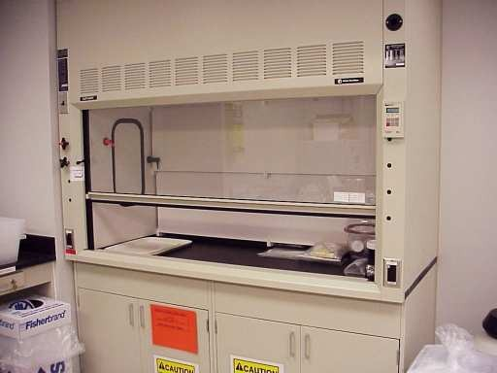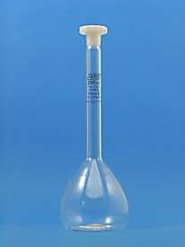 Materials and methods

6. Oven
7. Fume hood (see figure 13)

Figure 13: Fume hood

8. volumetric flask (100 ml)(see figure 14)

Figure 14: 100 ml volumetric flask

(9)
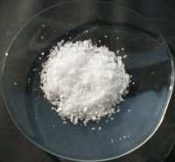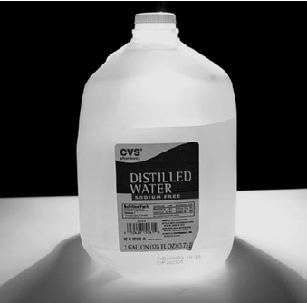 Materials and methods

9. boric acid(see figure 15)

Figure 15:boric acid
10.distelled water (see figure 16)

Figure 16:distelled water

11. Pipette (see figure 17)

Figure 17: pipette with volume 10 ml

(10)
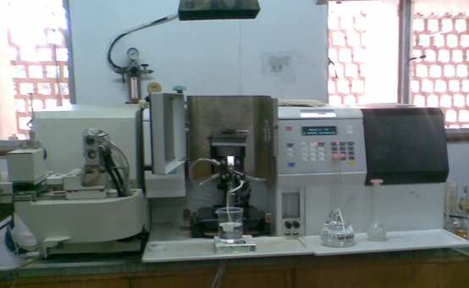 Materials and methods

12. Atomic absorption spectrometer(AAS)(see figure18)

Figure 18:Atomic absorption spectrometer

(11)
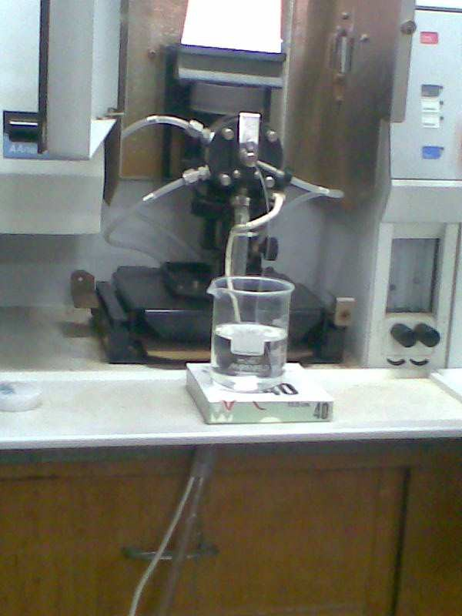 Experimental Procedure

Firstly the sample must be crushed to powder, then 0.2 g of the sample taken and putted in the a Teflon beaker then 5 ml of HF and 5 ml of Aqua regia were added to the beaker and 3 standards were perpetrated .
After that the sample were putting in autoclave to prepare them to put in the oven for 3 hours , then the rock sample will be as a solution.
After the sample was taken to the atomic absorption spectrometer, the nebulizer was putting in the sample (see figure 19)

Figure 19:the nebulizer in the sample

(12)
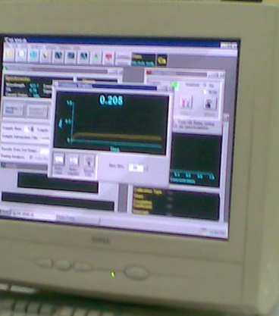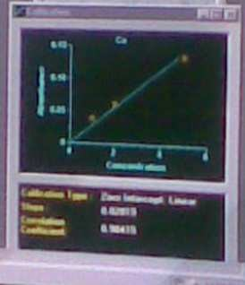 Experimental Procedure

After that we wait for seconds until the absorption reading appear in the screen of computer (see figure 20)

Figure 20:the absorption value at the screen

Then the measurement of the standards the computer will draw the calibration curve (see figure 21)

Figure 21: The calibration curve

After that we the samples that we want to know their concentrations

(13)

