Assignment of Chapter 7
Random-Number Generation
Problem 1:
Assume X0= 13, a = 23, c= 31 and m= 100, use the linear congruential method to generate uniform random values. What is the gap between reparation of a digit (Cycle length).

Problem 2:
Assume X0= 23, a = 17, c= 83 and m= 100, use the linear congruential method to generate uniform random values. What is the gap between reparation of a digit (Cycle length).

Problem 3:
Use Kolmogrov − Smirnorov test to show that the numbers generated in problem 1 can’t be distinguished from uniform random values.

Use the following table in your solution, where α= 0.01

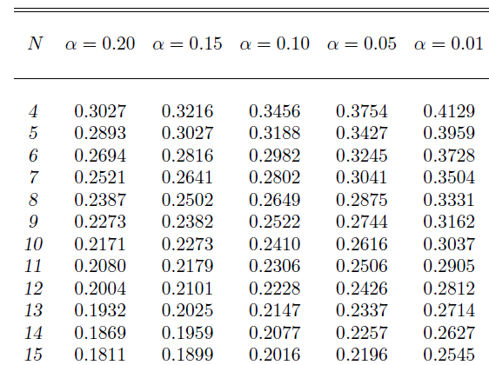

Problem 4:
Use Kolmogrov − Smirnorov test to show that the numbers generated in problem 2 can’t be distinguished from uniform random values.

Use the above table in your solution, where α= 0.01

