Level 4 (CLS 311)
Course Title: Basic Microbiology
Credit Hours: 3 + 1 = 4

DAY | 8-9 | 9-10 | 10-11 | 11-12 | 12-1
SUN
MON | CLS 311[1054]  DrTaghreed/Mrs. Ohoud  Room No G76
TUE | CLS 311[36410]  DrTaghreed/Mrs.Ohoud  Room No S20

Course Description:
This course provides the students with basic theoretical and practical aspects of various groups of microorganisms to include bacteriology, virology, mycology, and parasitology. It also introduces the basic concepts of general microbial control.

CLS 311: Lectures Outline

Weeks Subjects

1. General introduction to Microbiology
Historical background and Classification of
Microorganisms

2. Introduction to Viruses:
Classification, morphology and structure, Replication and
Pathogenicity

3. Introduction to Fungi:
Classification, morphology and structure, Replication and
Pathogenicity

4. Introduction to Parasites:
Classification, General Characteristics of parasites and
Medically important Parasites

5. Introduction to Bacteria:
Classification, Morphology and Structures

6. Mid-term exam

7. Microbial Growth requirements, Bacterial Growth:
Growth curve, Constant and synchronous growth

8. Microbial, Bacterial Metabolism

9. Microbial, Bacterial Genetics

10. Microbial Control:
Principles, Disinfectants, antiseptics, and preservatives
Physical and chemical methods of sterilization

11. Pathogenicity of Infectious Diseases

12. Normal Microbial flora

CLS 311: Laboratory Schedule

Weeks Subjects

- Introduction to Microbiology laboratory techniques and
safety rules

2. Introduction to Microscopy
Types of Microscopes.

3. Examination of Stained Smear and Wet
Preparation.

4. Microscopic examination of Eucaryoticmicrooganisms .

5. Staining of Bacterial Cells ( simple staining )

6. Staining of Bacterial Cells ( differential staining )

7. Preparation and Types of Culture Media

8. Bacterial Culture Techniques
Colonial Morphology

9. Bacterial Count ( Total& Viable )

10. Factors Affecting Microbial Growth

11. Physical and chemical methods used in microbial
control

12. Revision

13. FINAL PRACTICAL EXAMINATION

Assessments:

Mid Term Examination: Written 15
On Tuesday 19/5/1436 – 10/3/2015, 8-9 am
Quiz: Written 5
On Tuesday 25/6/1436 – 14/4/2015, 8-9 am
Mid Term Examination: Practical 20

Final Practical Examination: 20
Final Theoretical Examination: 40

References:

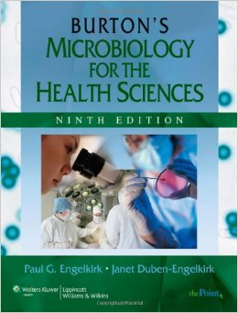

During the lecture: all the electronic devices are not allowed
