Diet and Nutrition Outline

Diet: a special course of food to which people restrict themselves, either to lose weight or for medical reasons.
Nutrition: The process of providing or obtaining the food necessary for health and growth.
- Foods are grouped together because they provide similar amounts of the key nutrients of that food group.
- 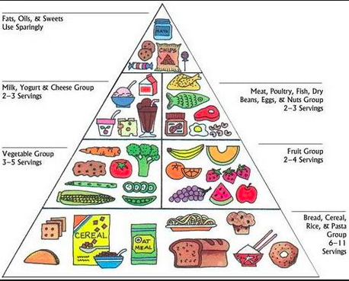

Standards for a Healthy Diet
Various daily food guides have been developed to help healthy people meet the daily requirements of essential nutrients and to facilitate meal planning.
Food group plans emphasize the general types or groups of foods rather than the specific foods, because related foods are similar in composition and often have similar nutrient values.
Nutrition for Older Adults
Include each food group on the Food Pyramid/My Plate
- Grains 5 ounces
- Vegetables 2 cups
- Fruits 1.5 cups
- Milk, yogurt, and cheese 3 cups
- Meat and beans 5 ounces

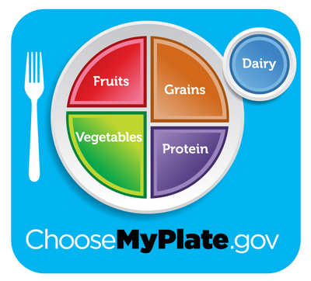

Reduce caloric intake:
Caloric needs generally decrease in older adults often because of decreased activity. Older adults need to consume nutrient-dense foods and avoid foods that are high in calories but have few nutrients.

Reduce fat consumption.
Use leaner cuts of meat, and limit portions to 4 to 6 oz per day. (But be sure intake of meat is sufficient, because older adults often consume inadequate amounts of these foods.) Broil, boil, or bake foods instead of frying them. Use low-fat milk and cheese; limit intake of butter, margarine, and salad dressings.

Reduce consumption of empty calories: Substitute fruit or puddings made with low-fat milk in place of pastry, cookies, and rich desserts.

Reduce sodium consumption for clients who have hypertension or other cardiac problems. Avoid canned soups, ketchup, and mustard. Avoid salted, smoked, cured, and pickled meats (e.g., bacon), poultry, and fish. Do not add salt when cooking foods or at the table.

Ensure adequate calcium intake (at least 800 mg) to prevent bone loss. Milk, cheese, yogurt, cream soups, puddings, and frozen milk products are good sources.

Ensure adequate vitamin D intake:
Vitamin D is essential to maintain calcium homeostasis. Include some milk, because other dairy products are not usually fortified with vitamin D. If milk cannot be tolerated because of a lactose deficiency, provide vitamin supplements.

Ensure adequate iron intake. Iron intake in older people may be compromised by such factors as increased incidence of GI disturbance, chronic diarrhea, regular aspirin use, and possible reduction in meat consumption.
Consume fiber-rich foods:
To prevent constipation and minimize use of laxatives. Because fiber-rich foods provide bulk and a feeling of fullness, they help people control their appetites and lose weight.

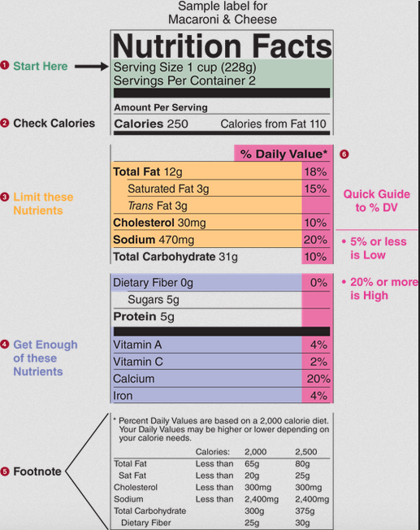
Altered Nutrition

Malnutrition:
- Is commonly defined as the lack of necessary or appropriate food substances, but in practice includes both undernutrition and overnutrition.
- Overnutrition refers to a caloric intake in excess of daily energy requirements, resulting in storage of energy in the form of adipose tissue. As the amount of stored fat increases, the individual becomes overweight or obese.
- A person is said to be overweight when the BMI is between 25 and 29.9 kg/m2 and obese when the BMI is >30 kg/m2 (National Heart, Lung, and Blood Institute, n.d.).
Online Search Question: What is BMI? How to calculate BMI?

Excess body weight increases the stress on body organs and predisposes people to chronic health problems such as hypertension and diabetes mellitus. Obesity that interferes with mobility or breathing is referred to as morbid obesity. Obese individuals may also manifest undernourishment in important nutrients (e.g., essential vitamins or minerals) even though excess calories are ingested.

- Undernutrition refers to an intake of nutrients insufficient to meet daily energy requirements because of inadequate food intake or improper digestion and absorption of food.
- An inadequate food intake may be caused by the inability to acquire and prepare food, inadequate knowledge about essential nutrients and a balanced diet, discomfort during or after eating, dysphagia, anorexia, nausea, vomiting, and so on.
- Improper digestion and absorption of nutrients may be caused by an inadequate production of hormones or enzymes or by medical conditions resulting in inflammation or obstruction of the GI tract.

Inadequate nutrition is associated with marked weight loss, generalized weakness, altered functional abilities, delayed wound healing, increased susceptibility to infection, decreased immunocompetence, impaired pulmonary function, and prolonged length of hospitalization. In response to undernutrition, carbohydrate reserves, stored as liver and muscle glycogen, are mobilized. However, these reserves can only meet energy requirements for a short time (e.g., 24 hours) and then body protein is mobilized.

Protein-calorie malnutrition (PCM), seen in starving children of underdeveloped countries, is now also recognized as a significant problem of clients with long-term deficiencies in caloric intake (e.g., those with cancer and chronic disease). Characteristics of PCM are depressed visceral proteins (e.g., albumin), weight loss, and visible muscle and fat wasting.

- Protein stores in the body are generally divided into two compartments: somatic and visceral. Somatic protein consists largely of skeletal muscle mass
- Visceral protein includes plasma protein, hemoglobin, several clotting factors, hormones, and antibodies.

Components of a Nutritional Assessment
- Anthropometric data
- Height
- Weight
- Ideal body weight
- Usual body weight
- Body mass index
- Components of a Nutritional Assessment
2. Biochemical data
- Hemoglobin
- Serum albumin
- Total lymphocyte count
- Components of a Nutritional Assessment
3. Clinical data
- Skin
- Hair and nails
- Mucous membranes
- Activity level
- Components of a Nutritional Assessment
4. Dietary data
- 24-hour food recall
- Food frequency record
Summary of Risk Factors for Nutritional Problems
Diet History
- Chewing or swallowing difficulties
- Inadequate food budget
- Inadequate food intake
- Inadequate food preparation facilities
- Inadequate food storage facilities
- Intravenous fluids (for 10 or more days)
- Living and eating alone
- Physical disabilities
- Restricted or fad diets
Medical History
- Adolescent pregnancy or closely spaced pregnancies
- Alcohol or substance abuse
- Catabolic or hypermetabolic condition: burns, trauma
- Chronic illness: end-stage renal disease, liver disease, AIDS, pulmonary disease (e.g., COPD), cancer
- Fluid and electrolyte imbalance
- GI problems: anorexia, dysphagia, nausea, vomiting, diarrhea, constipation
- Neurologic or cognitive impairment
- Oral and GI surgery
- Unintentional weight loss or gain of 10% within 6 months
Medication History*
- Antacids
- Antidepressants
- Antihypertensive
- Anti-inflammatory agents
- Antineoplastic agents
- Aspirin
- Digitalis
- Diuretics (thiazides)
- Laxatives
- Potassium chloride
Alternative Feeding Methods
Enteral Nutrition
- Alternative feeding methods that ensure adequate nutrition include enteral (through the GI system) methods. Enteral nutrition (EN), also referred to as total enteral nutrition (TEN), is provided when the client cannot ingest foods or the upper GI tract is impaired and the transport of food to the small intestine is interrupted.
- Enteral feedings are administered through nasogastric and small-bore feeding tubes, or through gastrostomy or jejunostomy tubes.

1. A nasogastric Tube (NGT)
- Is inserted through one of the nostrils, down the nasopharynx, and into the alimentary tract. Traditional firm, large-bore nasogastric tubes are placed into the stomach.

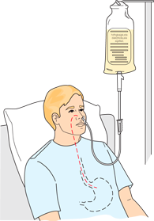
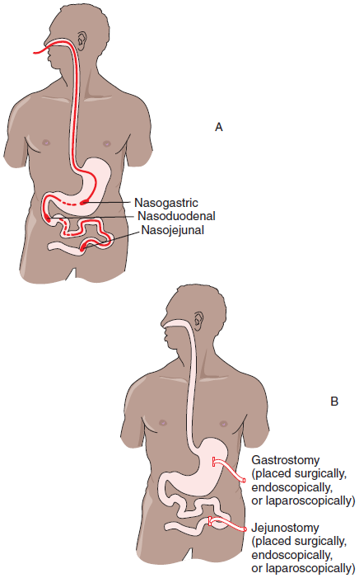

https://www.youtube.com/watch?v=en5ctZInOyA

https://www.youtube.com/watch?v=SneM_Dustsc

2. Parenteral Nutrition
Parenteral nutrition, also referred to as total parenteral nutrition (TPN) or intravenous hyperalimentation, is the IV infusion of dextrose, water, fat, proteins, electrolytes, vitamins, and trace elements. Because TPN solutions are hypertonic (highly concentrated in comparison to the solute concentration of blood), they are injected only into high-flow central veins, where they are diluted by the client’s blood.

TPN is a means of achieving an anabolic state in clients who are unable to maintain a normal nitrogen balance. Such clients may include those with severe malnutrition, severe burns, bowel disease disorders (e.g., ulcerative colitis or enteric fistula), acute renal failure, hepatic failure, metastatic cancer, or major surgeries where nothing may be taken by mouth for more than 5 days.

TPN is not risk free. Infection control is of utmost importance during TPN therapy. The nurse must always observe surgical aseptic technique when changing solutions, tubing, dressings, and filters. Clients are at increased risk of fluid, electrolyte, and glucose imbalances and require frequent evaluation and modification of the TPN mixture.

