Elimination
10.4.2018

- Unration

https://www.youtube.com/watch?v=1NtPjzm1-74.

- Urinary elimination depends on the effective functioning of the upper urinary tract’s kidneys and ureters and the lower urinary tract’s urinary bladder, urethra, and pelvic floor

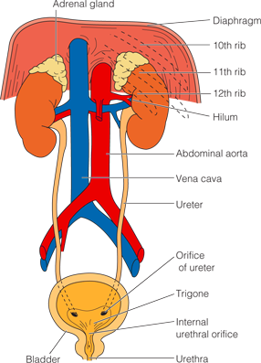

Kidneys
- The paired kidneys are situated on either side of the spinal column, behind the peritoneal cavity.
- They are the primary regulators of fluid and acid–base balance in the body.
- The functional units of the kidneys, the nephrons, filter the blood and remove metabolic wastes.
- In the average adult 1,200 mL of blood, or about 21% of the cardiac output, passes through the kidneys every minute.
- The nephrons of the kidney are composed of six parts: the glomerulus, Bowman’s capsule, proximal convoluted tubule, loop of Henle, distal convoluted tubule, and collecting duct.

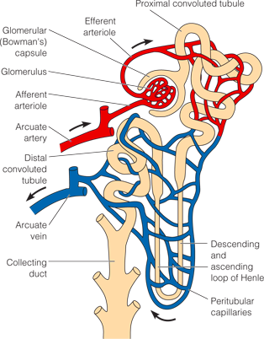

Ureters
- Once the urine is formed in the kidneys, it moves through the collecting ducts into the calyces of the renal pelvis and from there into the ureters.
- At the junction between the ureter and the bladder, a flap like fold of mucous membrane acts as a valve to prevent reflux (backflow) of urine up the ureters.

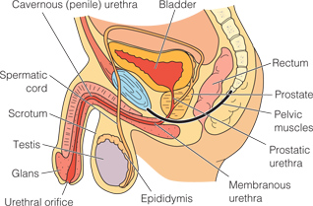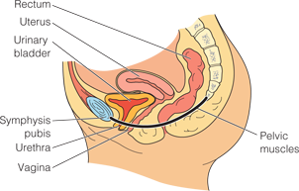

Bladder
- The urinary bladder is a hollow, muscular organ that serves as a reservoir for urine and as the organ of excretion.
- In men, the bladder lies in front of the rectum and above the prostate gland (; in women it lays in front of the uterus and vagina.
- Normal bladder capacity is between 300 and 600 mL of urine.

Urethra
- The urethra extends from the bladder to the urinary meatus (opening).
- In the adult woman, the urethra lies directly behind the symphysis pubis, anterior to the vagina, and is between 3 and 4 cm (1.5 in.) long
- The urethra serves only as a passageway for the elimination of urine.
- The male urethra is approximately 20 cm (8 in.) long and serves as a passageway for semen as well as urine.

Pelvic Floor
- The vagina, urethra, and rectum pass through the pelvic floor, which consists of sheets of muscles and ligaments that provide support to the viscera of the pelvis.
- The internal sphincter muscle situated in the proximal urethra and the bladder neck is composed of smooth muscle under involuntary control. It provides active tension designed to close the urethral lumen.
- The external sphincter muscle is composed of skeletal muscle under voluntary control, allowing the individual to choose when urine is eliminated.
Urination
- Micturition, voiding, and urination all refer to the process of emptying the urinary bladder.
- Urine collects in the bladder until pressure stimulates special sensory nerve endings in the bladder wall called stretch receptors. This occurs when the adult bladder contains between 250 and 450 mL of urine, stimulates these nerves.
- If the time and place are appropriate for urination, the conscious portion of the brain relaxes the external urethral sphincter muscle and urination takes place.

Psychosocial Factors
- For many people, a set of conditions helps stimulate the micturition reflex. These conditions include privacy, normal position, sufficient time, and, occasionally, running water.
- People also may voluntarily suppress urination because of perceived time pressures; for example, nurses often ignore the urge to void until they are able to take a break. This behavior can increase the risk of UTIs.

LIFESPAN CONSIDERATIONS Factors Affecting Voiding
Infants and Children
- Urinary tract infections (UTIs) are the second most common infection in children, after respiratory infections. They are seen more frequently in newborn and young infant boys than girls and are most often due to obstructions or malformations of the urinary system in these children.
- In older infants and children, girls have more UTIs than boys, usually due to contamination of the urethra with stool.
Older Adults
  - Many older men have enlarged prostate glands, which can inhibit complete emptying of the bladder, resulting in urinary retention and urgency that can cause incontinence.
  - After menopause women have decreased estrogen levels, which results in a decrease in perineal tone and support of bladder, vagina, and supporting tissues.
  - Increased stiffness and joint pain, previous joint surgery, and neuromuscular problems can impair mobility, making it difficult to get to the bathroom.
  - Cognitive impairment, such as in dementia, often prevents the person from understanding the need to urinate and the actions needed to perform the activity.
Medications
- Many medications, particularly those affecting the autonomic nervous system, interfere with the normal urination process and may cause retention.
- Diuretics increase urine formation by preventing the reabsorption of water and electrolytes.

Muscle Tone
- Good muscle tone is important to maintain the stretch and contractility muscle so the bladder can fill adequately and empty completely.
- Pelvic muscle tone also contributes to the ability to store and empty urine.

Pathologic Conditions
- Diseases of the kidneys
- Heart and circulatory disorders
- If abnormal amounts of fluid are lost through another route (e.g., vomiting or high fever.
- A urinary stone
- Hypertrophy of the prostate gland

Specific Terms:
Polyuria: Polyuria (or diuresis) refers to the production of abnormally large amounts of urine.
Oliguria: The terms oliguria is low urine output, usually less than 500 mL a day or 30 mL an hour for an adult
Anuria: refers to a lack of urine production.
Hemodialysis, the client’s blood flows through vascular catheters, passes by the dialysis solution in an external machine, and then returns to the client.
Peritoneal dialysis, the dialysis solution is instilled into the abdominal cavity through a catheter, allowed to rest there while the fluid and molecules exchange, and then removed through the catheter.
Frequency: Urinary frequency is voiding at frequent intervals, that is, more than four to six times per day.
Nocturia: is voiding two or more times at night.
Urgency: Urgency is the sudden, strong desire to void. There may or may not be a great deal of urine in the bladder, but the person feels a need to void immediately. (
Dysuria: Dysuria means voiding that is either painful or difficult. It can accompany a stricture of the urethra, urinary infections, and injury to the bladder and urethra.
Enuresis: Enuresis is involuntary urination (Nocturnal enuresis –Diurnal)
Urinary Incontinence: Urinary incontinence (UI), or involuntary leakage of urine or loss of bladder control, is a health symptom, not a disease.
Urinary Retention: When emptying of the bladder is impaired, urine accumulates and the bladder becomes over distended, a condition known as urinary retention.
Assessing Urine
- Amount in 24 hours: (adult) 1,200–1,500 mL
- Color, clarity: Straw, amber Transparent
- Odor: Faint aromatic
- Sterility: No microorganisms present
- pH : 4.5–8
- Glucose: Not present
- Ketone bodies (acetone): Not present
- Blood: Not present

ASSESSMENT
Voiding Pattern
Description of Urine and Any Changes
Urinary Elimination Problems

2. Defecation

https://www.youtube.com/watch?v=9PzANr8VyUg

Elimination of the waste products of digestion from the body is essential to health. The excreted waste products are referred to as feces or stool.
Large Intestine
- The large intestine extends from the (ileocolic) valve, which lies between the small and large intestines, to the anus.
- The colon (large intestine) in the adult is generally about 125 to 150 cm (50 to 60 in.) long.
- It has seven parts: the cecum; ascending, transverse, and descending colons; sigmoid colon; rectum; and anus
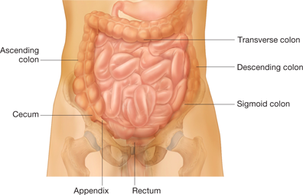

- The colon’s main functions are the absorption of water and nutrients.

- The colon also serves a protective function in that it secretes mucus. This mucus contains large amounts of bicarbonate ions. Mucus serves to protect the wall of the large intestine from trauma and protects the intestinal wall from bacterial activity.

- The rectum has folds that extend vertically. Each of the vertical folds contains a vein and an artery. When the veins become distended, as can occur with repeated pressure, a condition known as hemorrhoids occurs.

- The anal canal is bounded by an internal and an external sphincter muscle. The internal sphincter is under involuntary control, and the external sphincter normally is voluntarily controlled.

Defecation
- Defecation is the expulsion of feces from the anus and rectum. It is also called a bowel movement.
- The frequency of defecation is highly individual, varying from several times per day to two or three times per week.
Characteristics of Normal and Abnormal Feces
- Color; Adult: brown; Infant: yellow
- Consistency: Formed, soft, semisolid, moist
- Amount: Varies with diet
- Odor Aromatic: affected by ingested food and individual’s own bacterial flora

Diet
  - Sufficient bulk (cellulose, fiber) in the diet is necessary to provide fecal volume.
  - It is important to drink plenty of water because fiber works best when it absorbs water.
  - Irregular eating can also impair regular defecation.
  - Spicy foods can produce diarrhea and flatus in some individuals.
  - Excessive sugar can also cause diarrhea.
  - Laxative-producing foods, such as bran, figs, chocolate, and alcohol
  - Constipation-producing foods, such as cheese, pasta, eggs, and lean meat.
Activity
- Activity stimulates peristalsis, thus facilitating the movement of chyme along the colon. Weak abdominal and pelvic muscles are often ineffective in increasing the intra-abdominal pressure during defecation or in controlling defecation.
Psychological Factors
- Some people who are anxious or angry experience increased peristaltic activity and subsequent nausea or diarrhea.
- In contrast, people who are depressed may experience slowed intestinal motility, resulting in constipation.
Medications
- Some drugs have side effects that can interfere with normal elimination. Some cause diarrhea; others, such as large doses of certain tranquilizers and repeated administration of morphine and codeine, cause constipation.
- Iron supplements act more locally on the bowel mucosa and can cause constipation or diarrhea.
- Laxatives are medications that stimulate bowel activity and so assist fecal elimination.
Anesthesia and Surgery
- General anesthetics cause the normal colonic movements to slow by blocking parasympathetic stimulation to the muscles of the colon.
- Surgery that involves direct handling of the intestines can cause temporary cessation of intestinal movement.
Pain
- Clients who experience discomfort when defecating (e.g., following hemorrhoid surgery) often suppress the urge to defecate to avoid the pain. Such clients can experience constipation as a result.

Bowel Diversion Ostomies
An ostomy is an opening for the gastrointestinal, urinary, or respiratory tract onto the skin.
There are many types of intestinal ostomies.
- A gastrostomy is an opening through the abdominal wall into the stomach.
- A jejunostomy opens through the abdominal wall into the jejunum,
- An ileostomy opens into the ileum (small bowel),
- A colostomy opens into the colon (large bowel).

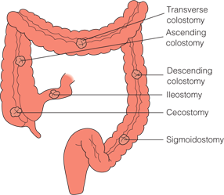
Cleansing Enema
- Hypertonic
- Hypotonic
- Isotonic
- Soapsuds
- Oil (mineral, olive, cottonseed)

https://www.youtube.com/watch?v=VHyu9IyKHVY

