Chapter 7
Random-Number Generation
Example1:
Assume X0= 13, a = 17, c= 37 and m= 100, use the linear congruential method to generate uniform random values. What is the gap between reparation of a digit (Cycle length).

Solution:

No. | R | Normalized
0 | 13 | 0.13
1 | 58 | 0.58
2 | 23 | 0.23
3 | 28 | 0.28
4 | 13 | 0.13

The cycle length is 4

Example2:
Assume X0= 17, a = 11, c= 71 and m= 100, use the linear congruential method to generate uniform random values. What is the gap between reparation of a digit (Cycle length).

Solution:

No. | R | No. | R | No. | R | No. | R | No. | R | No. | R
0 | 17 | 10 | 77 | 20 | 37 | 30 | 97 | 40 | 57 | 50 | 17
1 | 58 | 11 | 18 | 21 | 78 | 31 | 38 | 41 | 98
2 | 9 | 12 | 69 | 22 | 29 | 32 | 89 | 42 | 49
3 | 70 | 13 | 30 | 23 | 90 | 33 | 50 | 43 | 10
4 | 41 | 14 | 1 | 24 | 61 | 34 | 21 | 44 | 81
5 | 22 | 15 | 82 | 25 | 42 | 35 | 2 | 45 | 62
6 | 13 | 16 | 73 | 26 | 33 | 36 | 93 | 46 | 53
7 | 14 | 17 | 74 | 27 | 34 | 37 | 94 | 47 | 54
8 | 25 | 18 | 85 | 28 | 45 | 38 | 5 | 48 | 65
9 | 46 | 19 | 6 | 29 | 66 | 39 | 26 | 49 | 86

The cycle length is 50

Example3:
Use Kolmogrov − Smirnorov test to show that the following generated values can’t be distinguished from uniform random values.

R
0.37
0.78
0.29
0.90
0.61
0.42
0.33
0.34
Use the following table in your solution, where α= 0.1

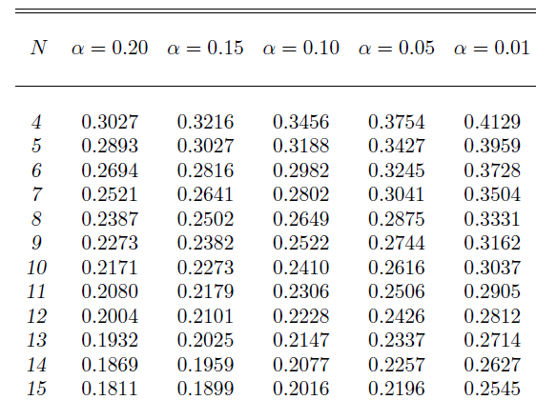

Solution:

- Order generated numbers from smallest to largest
0.29, 0.33, 0.34, 0.37, 0.42, 0.61, 0.78, 0.90

$$R_{i}$$ | 0.29 | 0.33 | 0.34 | 0.37 | 0.42 | 0. 61 | 0.78 | 0.90
$$\frac{i}{N}$$ | 0.125 | 0.25 | 0.375 | 0.5 | 0.625 | 0.75 | 0.875 | 1
$$\frac{i}{N} -R_{i}$$ | -0.165 | -0.08 | 0.035 | 0.13 | 0.215 | 0.14 | 0.095 | 0.10

From the above table, the maximum distance (absolute value) is 0.215 From the given distance values, we find 0.215 < 0.2649 , which means the distribution cannot be distinguished from the uniform distribution.

