EXPLORING FOR COPPER DEPOSITS
Learning Outcomes
- Students will learn what ore deposits are and some important factors in their origin.
- Students will learn about a type of ore deposit known as a porphyry copper deposit.
- Students will plot data from a table onto maps.
- Students will learn to use a geologic map, a soil geochemistry map, and a sediment geochemistry map to help locate a porphyry copper deposit.
- Students will be able to calculate an ore grade and determine whether an ore deposit is economic based on its grade, size, and production costs.
Background
Background for the activity is given in the student handout. Students should know the three major rock classes and their origin and understand the concept of a geologic map.
Material
- Photocopy of the handout
- Red and blue pencil or marker
Procedures
- Students should read the background information in the handout.
- Ask the students to look up the current price per lb. for copper in the commodity section of a newspaper such as the Wall Street Journal or New York Times. (Alternatively, you can provide them the current price. The price at the time this exercise was written was $1.18 per lb.)
- In order to help visualize ore deposits, show students specimens of ore minerals (especially copper minerals such as chalcopyrite, bornite, or azurite) if these are available. Such specimens may be obtained from mineral supply houses or state geologic surveys.
- Students solve the problems in the handout. You may ask the students to show their work for question 9 on a separate sheet.
Results and Discussion
- Ore should occur along the edges of the stocks within the altered zone in Figure 4.
- Students should color in the symbol keys on both the sediment and soil maps.
- Students should use Table 1 to color in the squares and circles on both maps to correspond to the symbol keys.
- One deposit is located within the altered zone on the northwestern margin of the large igneous stock (upstream from stream sediments 3 and 7 and roughly between soil samples B3 and A5). The other is located on the southeastern margin of the same stock (upstream from stream sample 19 between soil samples D6 and C7).
- Cupriferous Creek is flowing east (or east-southeast) at sediment sample 21. The "v's" point to the east.
- The anomaly (stream sample 18) is probably due to pollution from industrial waste, sewage, or a landfill.
- The anomaly southeast of the railroad (sample 32) is probably due to construction contamination from the bridge.
- The anomalies in the southwestern portion of the map (e. g. stream sample 23) are probably associated with vein deposits in the host sandstone. As stated in the handout, these vein deposits are not commonly economical.

Total production cost | = $25/ton x 20 million tons = $500 million
1 % Cu | = 1 tons Cu / 100 tons of ore
tons of Cu | = 1 tons Cu/100 tons of ore x 20 million tons of ore = 0.20 million tons
lbs. of Cu | = 0.20 million tons x 2000 lbs./ ton = 400 million lbs.
- The following assumes a $1.18 per lb. price for copper. The answers will vary depending on the price used by the students.
Gross income = $1.18/lb x 400 million lbs. = $472 million
The gross income ($472 million) is less than the production costs ($500 million). Therefore the deposit will not be profitable.

EXPLORING FOR COPPER

Background
Ores are rocks and minerals that can be mined and sold for a profit. The primary products of ores are metals such as iron, gold, zinc, and copper. These metals are recovered from the ores through special kinds of industrial processes. Such metals occur at low concentrations in all rocks. However, they can be mined only when they occur at high concentrations.
The concentration of a metal in an ore is called its grade. Grade is usually expressed as a weight percentage of the total rock. For example, 1000 kilograms (kg) of iron (Fe) ore that contains 300 kg of iron metal has a grade of 30%:
Grade = (kg metal / kg rock ) x 100
Fe grade = (300 kg Fe/1000 kg ore) x 100 = 30%
Metals occur at much lower grades in most rocks, sediments, and soils. A common way to express these lower concentrations is in terms of parts per million (ppm). If a rock has 1 ppm zinc (Zn), then 1 million grams of the rock (1000 kg) contains 1 gram of Zn. To determine whether a potential ore deposit will be profitable, mining companies must consider a number of factors including: the size of the deposit, its average grade, mining and refining costs, and environmental-related costs. The estimated gross income must be greater than the total costs in order for the deposit to be considered a true ore deposit.
There are many types of ore deposits. They occur in all sorts of sedimentary, igneous, and metamorphic rocks and form in many different ways. However, some key requirements for the formation of most ores include a source for the metals, a mechanism for transporting the metals, and a mechanism for precipitating the ore minerals.
In this exercise, you will learn about a particular kind of ore deposit known as a porphyry copper deposit. Most of the world's copper comes from such deposits located primarily in South America, New Guinea, Indonesia, the United States, and Canada. Copper (Cu) occurs primarily in the mineral chalcopyrite (CuFeS2) within these deposits. The porphyry deposits occur underground on the edges of intrusive igneous bodies known as stocks.
Figure 1 is a cross section of the subsurface that shows how these ore bodies form. Think of this diagram as a picture of a vertical slice of the earth. As a hot igneous stock intrudes into the rock already present, it encounters underground water derived from rainfall. The stock heats this water, and the water begins to move in large circular paths. As the water moves downward, it becomes hotter and leaches copper and other metals from the different rocks it encountered. As the metal-rich water moves back upward, it cools and changes its chemistry, so that chalcopyrite and other ore minerals are precipitated at the edge of the stock. In this model, the immediate sources of the metals are the rocks surrounding the igneous stock, the circulating groundwater is the transporting mechanism, and the cooling and changing composition of the groundwater is the precipitation mechanism.
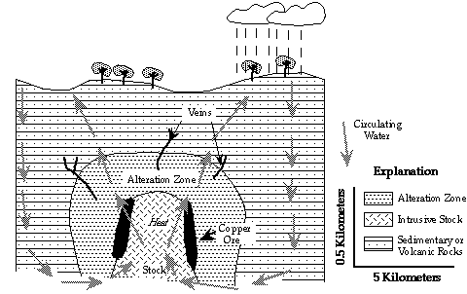
Figure 1. Vertical cross section showing a porphyry copper deposit as it occurs deep within the earth. (Modified from Evans, 1980)
In addition to forming ore deposits, this circulating water can form large bodies of altered rocks surrounding the stocks known as alteration zones. Minor copper mineralization can be formed away from the stocks within thin planar bodies known as veins. However, this mineralization does not usually contain enough copper to be considered ore.
As water and wind erode the surface of the earth, they remove the tops of the igneous stock, alteration zone, and porphyry copper deposit. Figure 2 is a geologic map that shows what these eroded rocks look like from the air. A central stock is surrounded by copper ore bodies, then an alteration zone, and finally unaltered sedimentary and/or volcanic rocks with some minor copper mineralization.
Exploration Techniques
Exploration geologists use a variety of techniques to find such ore deposits. One important technique is geologic mapping. A geologic map such as Figure 2 shows the distribution of the various rocks at the surface of the earth. In the case of porphyry copper deposits, geologists know that such deposits usually form on the outer edges of the igneous stocks and within alteration zones. Once a map such as Figure 2 is constructed, the geologists can focus their exploration activity in these areas.
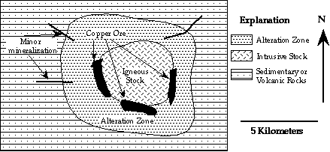
Figure 2. Geologic map showing the aerial view of a porphyry copper deposit
Another common exploration technique is called geochemical exploration. A type of geochemical exploration is gold panning [see another on-line activity called Panning for Gold and Magnetite]. Prospectors and geologists have long used this technique to find gold deposits. A large pan is filled with sediment and water from a stream and swirled around, so that the moving water sorts the grains by their density. Because the gold grains are very dense and easy to recognize, the geologist can quickly isolate these grains. They often count or weigh the grains to determine the approximate gold content of the stream sediments at that particular site. After doing this at many different locations in an area, the geologist makes a map of the gold content of the stream sediments to help find gold deposits.
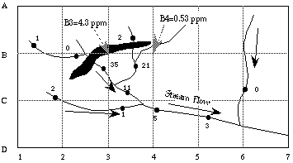
Figure 3. Map showing a stream and sediment survey
Such a map may look like Figure 3. The circles along the streams are locations at which gold (Au) has been panned. The numbers refer to the number of gold grains that were found at these locations. The arrows point in the direction that the stream is flowing (the "v's" formed by the joining streams always point downstream). After studying the map, geologists would predict that gold deposits may occur upstream from the two highest gold values (35 and 21). Unusually high concentrations such as these are termed geochemical anomalies by exploration geologists. The number of grains decreases downstream from these anomalous values. Upstream from the predicted gold deposit, there are few gold grains in the sediments. This is because the stream can only carry the gold grains downstream from the deposit, not upstream.
Geologists also sample stream sediments to explore for porphyry copper deposits. Instead of panning for copper, the geologists take samples of the sediments to a laboratory to determine their copper concentrations. They then make a map similar to Figure 3, but the numbers at each sample location would refer to copper concentrations.
Another commonly used geochemical exploration technique is soil geochemistry. Geologists establish a sampling grid over an area of interest. Figure 3 shows such a grid. It is defined by the letters A through D on the north-south axis, and the numbers 1 through 5 are on the east-west axis. Geologists analyze soil samples at each node of the grid (where the lines cross). They then construct a map showing the concentration of gold at each location. On this map, the highest value of gold (4.3 ppm) occurs at node B3. Node B4 has a lower gold value than B3 (0.53 ppm), but higher than all of the other soil samples in the area. Geologists could use these anomalous values, together with the anomalous stream sediment values to predict that an ore body was present below the soil somewhere in the blackened area.
One difficulty in using sediment and soil geochemistry to explore for ore deposits is the occurrence of anomalies related to human activities. Construction of bridges often produces high concentrations of metals in sediments. Pollution from industry or landfills can impart high metal content to soils, streams, or the atmosphere. Such geochemical anomalies produced by human activities can be confused with anomalies that might indicate the presence of ore deposits.

