- Writ a program that Asks the user to enter his age and print “you are a teenager” if the age is less than 18 and if his age bigger than 18 print “ you are an adult” and if his age is greater than 40 print “ you are old “

Trace the following (what is the out put ) :
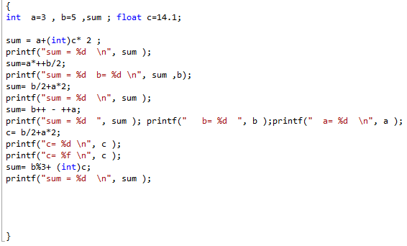
- Where possible, write equivalents for the following statements using compound assignment operators:
  - r = r / 10;
  - z = z * x + 1;
  - q = q + r * m;

- Assume the following:
int j = 6; int k = 10; int n; bool b = false;
Give the value that is assigned, or illegal.
- n = k++; | - n = k++ + ++j; | - n = (k = j) = 5;
- n = (k++); | - n = k+++++j; | - 3 = 4;
- n = ++k; | - n = k = j = 5; | - n = k; n += 1;
- n = 7++; | - n = k = (j = 5);

