_____

In C++, two or more functions can share the same name as long as their parameter declarations are different.
• In this situation, the functions that share the same name are said to be overloaded, and the process is referred to as function overloading
Function overloading is the process of using the same name for two or more
functions.
• The secret to overloading is that each redefinition of the function must use
either-
• different types of parameters
• different number of parameters.
Ambiguity
void f(int x);
void f(int &x); // error
• two functions cannot be overloaded when the only difference is that one takes a
reference parameter and the other takes a normal, call-by-value parameter.

// This program contains an error.
#include <iostream>
using namespace std;

//function prototype
void f(int x);
void f(int &x); // error

int main()
{
int a=10;
f(a); // error, which f()?
return 0;
}
void f(int x)
{cout << "In f(int)\n";}

void f(int &x)
{cout << "In f(int &)\n";}

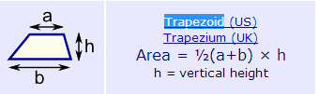
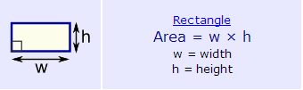
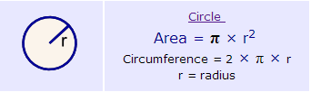
- Write a function AREA to calculate the area of circle, rectangle and Trapezoid using function overloading and PRINT the result .
HINT :
pi = 3.14
void area(int); //circle
void area(int,int); //rectangle
void area(float ,int,int); //trapezoid

const int pi=3.14;
void area(int r); //circle
void area(int,int); //rectangle
void area(float ,int,int); //trapezoid

//circle
void area(int r )
{
cout<<" circle area is : "<< pi*r*r;

}
//rectangle
void area(int h ,int w )
{
cout<<" rectangle area is : "<< h*w;

}
//trapezoid
void area(float h ,int a ,int b )
{
cout<<" trapezoid area is : "<< 1/2*(a+b)*h;

}

