KING SAUD UNIVERSITY
College of Applied and Community Services
CT 1411

Q1: Write a vb.net program that read all names in the file: “Name.txt”. Then write those names separated by commas “ , ”in “result.txt” file.
Hint:
- Both files are created in the project folder.
- Use array to store the names from “Name.txt” file
For Example:

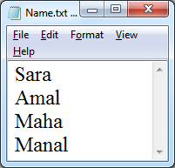

Imports system.io
Module Module1
Sub main()

Dim sr AsNew StreamReader("Name.txt")
Dim Names(100) AsString
Dim name AsString
Dim i = -1

name = sr.ReadLine()
DoUntil name = Nothing
i += 1
Names(i) = name
name = sr.ReadLine()

Loop

Dim count = -1
Dim sw AsNew StreamWriter("result.txt")

ForEach name In Names
sw.Write(name)
count += 1
If count < i Then
sw.Write(",")
EndIf
Next
sr.Close()
sw.Close()
EndSub

EndModule

