KING SAUD UNIVERSITY
College of Applied and Community Services
CT 1411
First Semester 1440-1441

Name: ID: Computer No:
Final Lab

Write a VB.net program that draws the following figure that represent your name and two shapes in XY axes. You should draw using the same format that appears in the figure and the same colors.

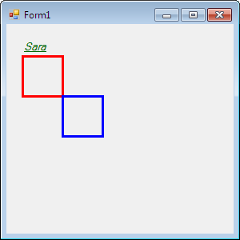

Good Luck
Sara

