HW 1
- (Sales person bonus Calculator) Sales persons in mobile store, which sells mobile phones from different brands, are given monthly bonuses to their salaries based on their ability to sell the store's products. For each sales person, this bonus is calculated based on:
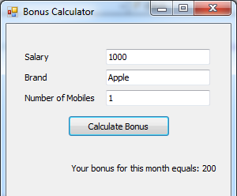
salary. 2) brand of the mobile. 3) number of mobiles he has sold.
Bonus = salary *
(%Percentage of brand's bonus)*Number of Mobiles sold
Brand | (%Percentage of brand's bonus)
Apple | 20%
Samsung | 15%
Blackberry | 10%
Nokia | 5%

- Write a program that calculates the amount of bonus for a sales person [Hint: Use the If Then Else statement].(Multiplication Table Creator) Write a program that reads a number then displays the multiplication table of all numbers equals or less than that number. For example when the user select number 3 the output in the textbox should display multiplication tables of 1, 2, 3. The output should look like the following:
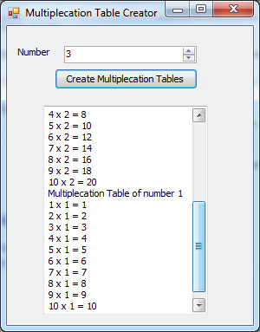
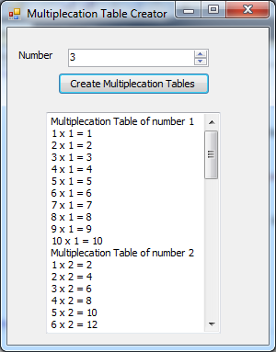
- Write a program which inputs one string and determines whether or not it is a palindrome. A palindrome reads the same backwards and forwards, so 'abba' is a palindrome. Assume that the string contains no spaces or punctuation.

