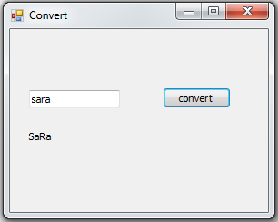
HW 2
Question 1:Write a VB program that takes as input a string and displays the string with every even index of letters capitalized. The processing must be in a subroutine procedure and the result should be displayed in the event procedure (button click).

Question 2:
- Write a program to represent a class Student with information including name, id, total credit hours, and college.
- The class should include a constructor that receives name, id and college for a new student.
- The class should also include methods to add to the total credit hours, in addition to method show to retrieve all information in one string.
- Finally, the class should keep track of the total number of students added.
- Write a client program that creates three students and uses the different methods in the class Student.

Question 1:

With the help of Inheritance define suitable classes for geometrical figures:Square, Rectangle, Oval.
The base class should be figures and contain :
+ width and height
2 methods:
- Show: return the geometrical information
- Calculate area (must overrides): to calculate area for each figure.
Design suitable form to test your classes.
Don’t forget to search for the areas equations for each figure

