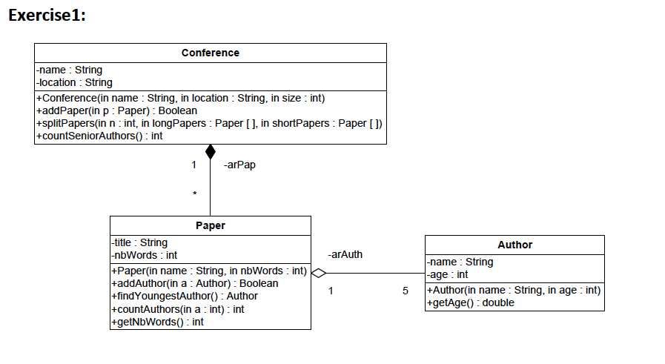
Author class:
Attributes:
- name: the name of the author.
- age: the age of the author.
Methods:
- Author (name: String, age: int): constructor
- getName(): this method returns the name of the author.
- getAge(): this method returns the age of the author.

Paper class:
Attributes:
- title: the title of the paper.
- nbWords: the number of words of the paper.
Methods:
- Paper(title: String, nbWords: int): constructor
- addAuthor (a: Author):this method adds the author a to the paper . It returns true if the author a is successfully added. Otherwise, it returns false.
- findYoungestAuthor():this method returns the youngest author of the paper.
- countAuthors (a: int):this method returns the number of authors having the age greater or equal to a.
- getNbWords ():this method returns the number of words of the paper.

Conference class:
Attributes:
- name: the name of the conference.
- location: the name of the city where the conference is held.
Methods:
- Conference(name: String, location:String): constructor
- addPaper (p: Paper):this method adds the paper p to the conference . It returns true if the paper p is successfully added. Otherwise, it returns false.
- splitPapers(n: int, longPapers: Paper[], shortPapers: Paper[]):this method receives
- two arrays. It inserts the papers having the number of words greater than n into the
- array longPapers. It inserts the papers having the number of words less than n into the array shortPapers.
- countSeniorAuthors ():this method returns the number of authors having the age greater or equal to 50.

QUESTION: Translate into Java code the class Author, Paper, Conference.

