- Write a program that :
ask the user to enter his academic email and check if he enters a valid one
valid email :
- containing @
- length 28
- ending with @student.ksu.edu.sa
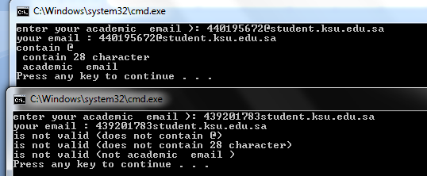

Assume that following variables declarations:
char c;
int x, y ,z ;
double d, e , f ;
char * ptr ="1.27 10.3 9.432";
char s1[100] , s2[100] ;

- Write a C statements to do the following :
- Read a character from the keyboard and store the character in variable c. Do not use scanf.
- Print the value of variable C. Do not use printf.
- Convert the character stored in variable c to an uppercase letter and print it
- Determine whether the value of variable c is a digit.
- Read a line of text into array s1. Do not use scanf.
- Print the line of text stored in array s1. Do not use printf.
- Read three double values into variables d, e and f from the string ptr .
- Copy the string stored in ptr into array s1.

