Lab #2

Q1: The many-to-many relationship between books and authors can be modeled with 3 tables, as shown below. A books table contains data about books (such as title and price); an authors table contains data about the authors (such as name and email). A table called books_authors joins the books and authors tables and captures the many-to-many relationship between books and authors.
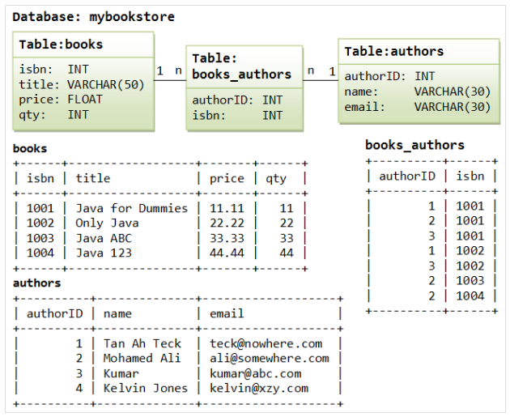

- Using Oracle Do the following:
  - Create table for the above, add all relationships between the relations and add any necessary constraints.
  - Add new column (sex) to authors table.
  - Insert rows to the tables.

