Root Finding by Bisection Method

Bisection Method:
- An implementation of the bisection method in Matlab is given in the textbook (page 75) and is made available to you with minor modification as Matlab function bisect1 saved as file bisect1.m. You can download this file from course website (Or just copy-paste from the code bellow).
- The following script calls the function bisect1 for the example 3.1.1 of the textbook (page73), with f(x) = x⁶- x-1 and values of interval as [a , b] = [1 ,2] and the tolerance of 0.001.
clear all;
close all;
a0 = 1;
b0 = 2;
ep = 0.001;
root=bisect1(a0,b0,ep)

- Type/Download this script in Matlab and save it as a file.
- Run this script and compare your results with Table 3.1 (page 73) of the textbook.
- Verify your results until n = 5 by doing the calculations using your calculator as done in class
- Change the error tolerance (ep) to 0.00001, does your answer change, does number of iteration changes?
- From Matlab help command find the use of “eps” function. Change the error tolerance to machine precision (ep = eps) does your answer change?
- Change the error tolerance to 1e-18, does your answer change, if no, why?
- Carefully study the Matlab code bisect1.m and make sure you understand the algorithm and Matlab commands.
- Implement the steps in home work (HW). You are not supposed to turn in this HW assignment. However, there will be Lab Quiz next week based on this HW assignment.

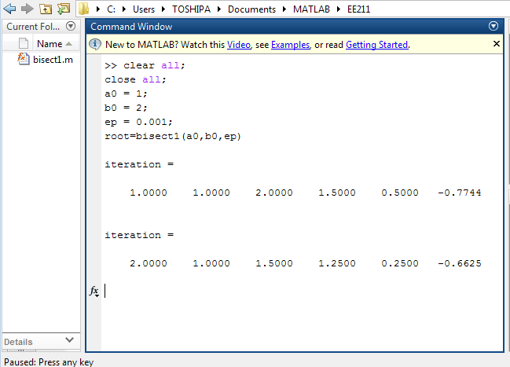

% Lab 06: Root Finding by Bisection Method
% Save this code as “bisect1.m”
function root=bisect1(a0,b0,ep)
%
% function bisect1(a0,b0,ep)
%
% This is the bisection method for solving an equation f(x)=0.
%
% The function f is defined below by the user. The function f is
% to be continuous on the interval [a0,b0], and it is to be of
% opposite signs at a0 and b0. The quantity ep is the error
% tolerance.
% For the given function f(x), an example of a calling sequence
% might be the following:
% root = bisect1(1,2,0.001)
%
%
% The following will print out for each iteration the values of
% count, a, b, c, b-c, f(c)

format short
a = a0; b = b0;
fa = f(a);
fb = f(b);

c = (a+b)/2;
it_count = 0;
while b-c > ep
it_count = it_count + 1;
fc = f(c);
% Internal print of bisection method. Tap the carriage
% return key to continue the computation.

iteration = [it_count a b c b-c fc]
if sign(fb)*sign(fc) <= 0
a = c;
fa = fc;
else
b = c;
fb = fc;
end
c = (a+b)/2;
pause
end

root = c
error_bound = b-c
it_count

%%%%%%%%%%%%%%%%%%%%%%%%%%%%
function value = f(x)
% value = tan(x) - x;
value=exp(-x)-sin(x);
end

end

Homework Lab #07
Question #1
- For the exercise done in the lab, plot the function f(x) = x⁶- x-1 over the interval [a , b] = [1 ,2] in Matlab, verify there is a change of sign at the endpoints for this function, what does this tell you?

- Change the interval [a b] to [-1 2] and again plot the function, what do you observe?

Question #2
Modify the Matlab code to find the root of the functions given in the problem 1 (page 77) of your textbook. Note in each case you must first plot the function to find the interval [a b] which contains only one root

