Polynomial Interpolation using Polyfit

1. Use of Matlab command polyfit ( ) to implement polynomial interpolation and use of polyval ( ) to evaluate the polynomial.

To see what the function polyfit( ) does, type this at Matlab command window:
>> help polyfit

And it gives the following definition:
P = POLYFIT(X,Y,N) finds the coefficients of a polynomial P(X) of degree N that fits the data Y best in a least-squares sense. P is a row vector of length N+1 containing the polynomial coefficients in descending powers, P(1)*X^N + P(2)*X^(N-1) +...+ P(N)*X + P(N+1).

Let’s implement the Example 4.1.1 on page: 119 of the textbook, which implement the linear interpolation for the data points, x= [1, 4], y= [1, 2]. If we simplify the equation (4.2) after substituing the values in the linear interpolation equation given below,
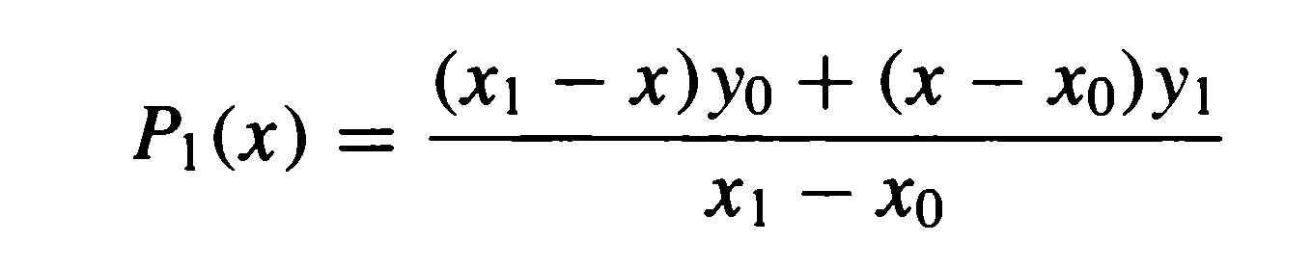
then we get the following polynomial:
P1(x)=0.333x+0.667 ………equation(1)

To determine the above polynomial representation uses the following Matlab code:
>> x= [1, 4], y= [1, 2]
>> p1=polyfit(x,y,1)
p1 = 0.3333 0.6667

This give the coefficient for linear interpolation polynomial (use n=1) as given in equation (1), Suppose we want to evaluate this polynomial as given by equation (1) at x=2, i.e. P₁(2)= 1.3333. We can use the Matlab command polyval ( ) to evaluate the polynomial at any point x. For the p1 coefficient calculated above use the following code to evaluate the above polynomial at x=2.
>> y=polyval(p1,2)
y =1.3333

Consider the Example 4.1.3 on page:121, which determine the quadratic polynomial for the data points x=[ 0 1 2] and y=[-1 -1 7] using

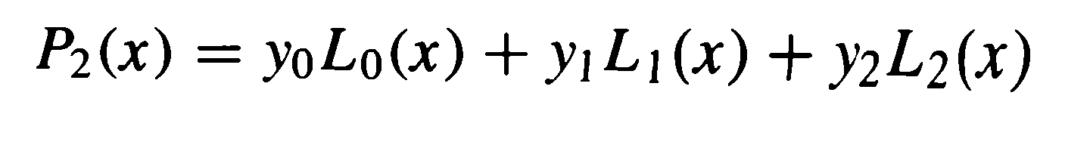

where
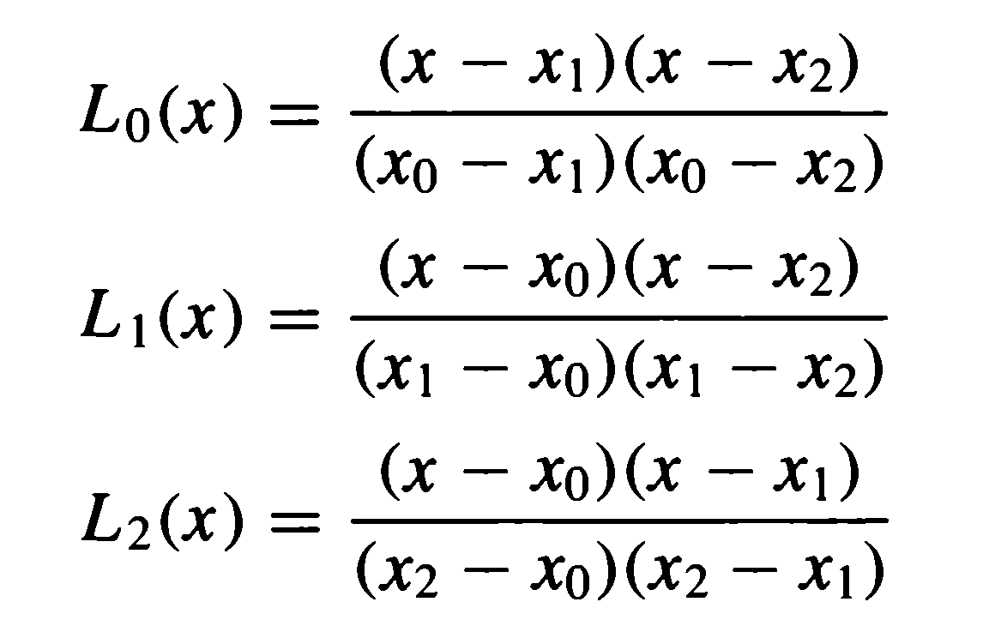
The simplified equation (4.9) is given below:

$P_{2}(x)=4x^{2}-4x-1$ -------- equation(2)

To find the P2(x) representation (in terms of coefficient) use the following code:
>> x=[ 0 1 2] , y=[-1 -1 7]
>> p2=polyfit(x,y,2)
p2 = 4 -4 -1

2. Constructing the Lagrange Interpolating Polynomial using Matlab

1. In order to construct the Lagrange Coefficients for the Lagrange Polynomial in MATLAB, we can use the built-in function poly, which constructs a polynomial with given roots. Enter the following to construct a polynomial with roots 1 and 2 for example:

» poly([1 2])
ans = 1 -3 2

Thus, this is the polynomial (x-1)(x-2) = x² -3x +2 which has roots 1 and 2.

2. Consider the Example 4.1.3, page 121 which construct Lagrange interpolating polynomial of degree two (quadratic) approximating the data points [(0,-1),(1,-1),(2,7)]

Consider the Lagrange basis function L₀(x) given as
$$L_{0}(x)=\frac{\left(x-1\right)(x-2)}{\left(0-1\right)(0-2)}$$

We can see that we need the numerator to be the polynomial with roots x₁ = 1, and x₂ = 2, i.e. (x -1)(x-2) The denominator is the constant (x₀ -x₁)*(x₀-x₂) = (0-1)*(0-2) = 2.
Assuming that we want to store the Lagrange coefficient polynomials in the 3x3 array (matrix) L (with the 1st row being the coefficients for L₀(x), the 2nd row being the coefficients for L₁(x), and the third row being the coefficients for L₂(x) ), we proceed as follows:
>> L(1,:)= poly([1 2])/((0 - 1)*(0 - 2))
L = 0.5000 -1.5000 1.0000
>> L(2,:)= poly([0 2])/((1 - 0)*(1 - 2))
L = 0.5000 -1.5000 1.0000
-1.0000 2.0000 0

>> L(3,:)= poly([0 1])/((2 - 0)*(2 - 1))
L =
0.5000 -1.5000 1.0000
-1.0000 2.0000 0
0.5000 -0.5000 0

The final Lagrange polynomial is: P2(x)= y0*L0 (x)+ y1*L1(x)+y2*L 2(x). We compute the P2(x) as:
>> P = (-1)*L(1,:) + (-1)*L(2,:) + (7)*L(3,:)
P = 4 -4 -1

This has the same coefficient as equation (2) above.
To evaluate the polynomial at 2 we use:
>> polyval(P,2)
ans =7

