Exercise 1
Write a script that finds the smallest of several nonnegative integers. Assume that the first value read, specifies the number of values to be input from the user.

Exercise 2
Write a script that calculates the product of the odd integers from 1 to 15, then outputs HTML5 text that displays the results.

Exercise 3
Write the HTML, CSS and JavaScript code that displays prompt messages asking the user to enter student names and grades (out of 100) and displays the result in a tabular form as follows:
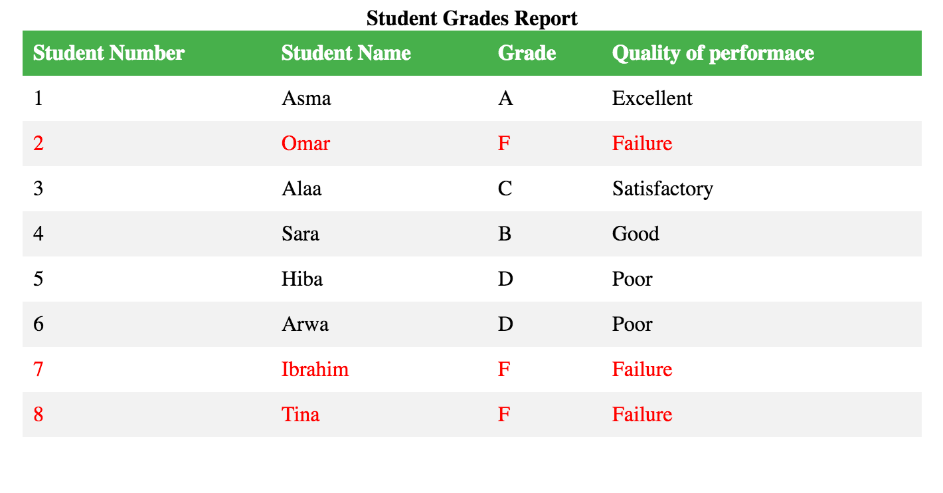
The program should accept any number of students and terminates once the user enters a pre-specified value (e.g., -1). After converting the grades entered by the user to letter grades (i.e., A, B, C, D and F), your code should also determine the quality of performance of each student as follows: A Excellent, BGood, CSatisfactory, DPoor and FFailure. Students whose grades are F should be marked in red too.

