Lab 4: Interpolation using Divided Difference and Newton’s Formula

1. As a starting example we will construct the divided difference table as given in lecture slides for the following data points x=[1 1.1 1.2 1.3 1.4] and y=[0.5403 0.45360 0.36236 0.26750 0.16997]. The divided difference table for these data points is given below:

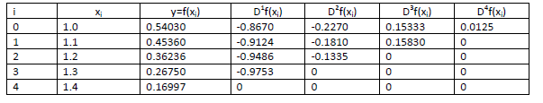

2. In order to construct the Newton polynomial in MATLAB, we would want to first construct the divided difference table. We can do this by storing the values in the rows of a 5 x 5 matrix D.
The first column of D, referenced in MATLAB as D( : ,1), will store the function values at the interpolating points. The second column of D -- D(:, 2) -- will store the first divided differences. The third column of D -- D(:, 3) -- will store the second divided differences. The fourth column of D -- D(:, 4) -- will store the third divided differences. The fifth column of D -- D(:, 5) -- will store the fourth divided difference.
The entries in the matrix D will be:
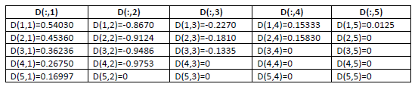

3. Create a 5x5 matrix D initially with all zeros:
>> D = zeros(5,5);

4. Set up the vector X and Y with the x-coordinates of the interpolating values:
>> X=[1 1.1 1.2 1.3 1.4];
>> Y=[0.5403 0.45360 0.36236 0.26750 0.16997];
These entries will be stored as:
For X as:
If you run this on Matlab command window
>>X(3)
ans=1.2
>>X(1:3)
ans = 1 1.1 1.2
And for Y as:

5. Now start computing the divide differences column by column for the matrix D The first column is just the values of the function at the interpolating points, stored in Y:
» D(:,1) = Y;

6. We next work on the second column of D -- starting in first row ( D(1,2) ) and working down to fourth row: >> D(1,2) = (D(2,1)-D(1,1))/(X(2)-X(1));
>> D(2,2) = (D(3,1)-D(2,1))/(X(3)-X(2));
>> D(3,2) = (D(4,1)-D(3,1))/(X(4)-X(3));
>> D(4,2) = (D(5,1)-D(4,1))/(X(5)-X(4));

7. Fill the remaining column by using the following commands:
>> D(1,3) = (D(2,2)-D(1,2))/(X(3)-X(1));
>> D(2,3) = (D(3,2)-D(2,2))/(X(4)-X(2));
>> D(3,3) = (D(4,2)-D(3,2))/(X(5)-X(3));
>> D(1,4) = (D(2,3)-D(1,3))/(X(4)-X(1));
>> D(2,4) = (D(3,3)-D(2,3))/(X(5)-X(2));
>> D(1,5) = (D(2,4)-D(1,4))/(X(5)-X(1));
The final matrix D will have the following form:
>>D
D =
0.5403 -0.8670 -0.2270 0.1533 0.0125
0.4536 -0.9124 -0.1810 0.1583 0
0.3624 -0.9486 -0.1335 0 0
0.2675 -0.9753 0 0 0
0.1700 0 0 0 0

8. Once the ‘D’ Matrix has been created, the Newton polynomials of degrees 1 through 4 which are:
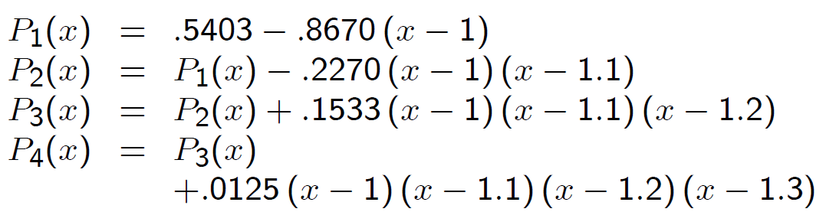
Can be constructed recursively in Matlab as follows:

>> P1 = [0 D(1,1)] + D(1,2)*poly(X(1))
P1 =
-0.8670 1.4073

Similarly, higher polynomials can be constructed

