Lab (5): Numerical Integration: Implementing Trapezoidal Rule in Matlab

- The trapezoidal rule as discussed in class is given as
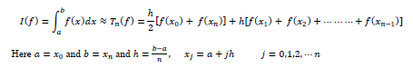

- The following file trapezoidal.m implements the trapezoidal rule in Matlab

%%%%%%%%%%%%%%%%%%%%%%%%%%%%%%%%%%%%%%%%%%%%%%%%%%%%%%%%%%%%%%%%%%%%
function [integral] = trapezoidal(index_f,a,b,n)
% function to calculate the integral using trapezoidal rule
% input parameters:
% index_f: parameter for the integrand
% a: lower limit
% b: upper limit
% n: Number of intervals must be positive integer greater than or equal
% to 1
%
% output parameter: integral
% sum the endpoints
sumend =( f(a,index_f) + f(b,index_f))/2; % f is a function which contains
% multiple integrands
h = (b-a)/n; % size of interval
sum = 0;
if ( n > 1)
for j = 1:1:n-1
xj = a + j*h;
sum = sum + f(xj,index_f);
end
end
integral = h*(sumend + sum);
function f_value = f(x,index)
% this function defines the integrand
switch index
case 1
f_value = exp(-x.^2);
case 2
f_value = 1./(1+x.^2);
end
%%%%%%%%%%%%%%%%%%%%%%%%%%%%%%%%%%%%%%%%%%%%%%%%%%%%%%%%%%%%%%%%%%%%

- Read the m file carefully and make sure you understand all the Matlab commands
- Run this function by writing a script file (e.g. main.m). A sample script file is as follows:

clear all
a = 0;
b = 1;
n = 1;
index_f = 1
integral = trapezoidal(index_f,a,b,n)

- Run this script file to calculate the integral of $I=\int_{0}^{1}{e^{{-x}^{2}}dx ≈0.746824132812427}$ , as given on page 193 of your textbook and fill in the following table

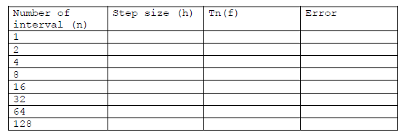

- Modify your script file to generate the table 5.1, page 194 of your textbook. A sample script file is as follows.

clear all
a = 0;
b = 1;
n = 1;
index_f = 1
n1 = [ 2 4 8 16 32 64 128];
for q = 1:length(n1)
n = n1(q);
integral(q) = trapezoidal(index_f,a,b,n);
end
trueval = 0.746824132812427;
err = trueval - integral
y = [n1; err];
fprintf(1,'%6.2f %12.8f\n',y);

- Plot the error versus n, i.e., plot(n1,err,’-o’)
- Repeat the above exercises for the integrals given on page 193 of your textbook.

