COLLEGE OF APPLIED STUDIES AND COMMUNITY SERVICE
CT1411
Lab5

Using Graphics capabilities draw the following diagram.
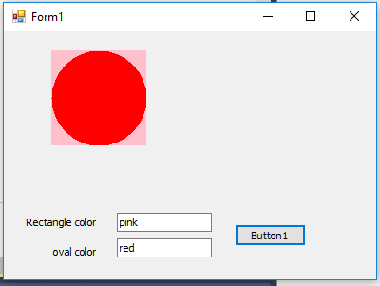
Draw two shapes rectangle and oval with colors specified by the user in text boxes.

