Lab (6): Numerical Integration#2: Implementing Simpson Rule in Matlab

- The Simpson rule as discussed in class is given as

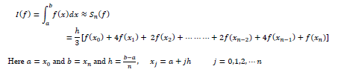

- The following file simpson.m implements the Simpson’s rule in Matlab

function [integral]=simpson(index_f,a,b,n)
%
% function [integral]=simpson(a,b,n0,index_f)
%
% function to calculate the integral using Simpson rule
% input parameters:
% index_f: parameter for the integrand
% a: lower limit
% b: upper limit
% n: Number of intervals must be positive even integer greater than or %
%equal to 2
%
% output parameter:integral
% Initialize for Simpson integration.
sumend = f(a,index_f) + f(b,index_f);
sumodd = 0;
sumeven = 0;
% For case of n=2
if(n == 2)
h = (b-a)/n;
k=1;
sumodd1 = f(a+k*h,index_f);
integral= h*(sumend + 4*sumodd1)/3; %%%% this will calculate the integeral
end
%% For case of n > 2.
if(n > 2)
h = (b-a)/n;
for i=2:2:n-2
sumeven = sumeven + f(a+i*h,index_f);
end
for k=1:2:n-1
sumodd = sumodd + f(a+k*h,index_f);
end
integral= h*(sumend + 4*sumodd + 2*sumeven)/3; %%%% this will caluclate the integeral
end
%
% This defines the integrand.
function f_value = f(x,index)
switch index
case 1
f_value = exp(-x.^2);
case 2
f_value = 1 ./(1+x.^2);
case 3
f_value = 1 ./(2+sin(x));
case 4
f_value = exp(cos(x));
end

- Read the m file carefully and make sure you understand all the Matlab commands
- Run this function by writing a script file (e.g. main.m). A sample script file is as follows:

clear all
a = 0;
b = 1;
n = 2;
index_f = 1
integral = simpson(index_f,a,b,n)

- Run this script file to calculate the integral of $I=\int_{0}^{1}{e^{{-x}^{2}}dx ≈0.746824132812427}$ , as given on page 198 of your textbook and fill in the following table

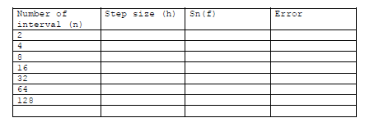

- Modify your script file to generate the table 5.2, page 198 of your textbook. A sample script file is as follows.

clear all
a = 0;
b = 1;
n = 1;
index_f = 1
n1 = [ 2 4 8 16 32 64 128];
for q = 1:length(n1)
n = n1(q);
integral(q) = simpson(index_f,a,b,n);
end
trueval = 0.746824132812427;
err = trueval - integral
y = [n1; err];
fprintf(1,'%6.2f %12.8f\n',y);

- Plot the error versus n, i.e., plot(n1,err,’-o’)
- Repeat the above exercises for the integrals given on page 198 of your textbook. Note you will have to change the simpson.m file to add the new integrand.

