METAMORPHIC ROCK
TEXTURES
Foliated Texture

The mineral constituents of foliated metamorphic rocks are oriented in a parallel or suhparallel arrangement. Foliated metamorphic rocks are generally associated with regional metamorphism. Four kinds of foliated textures arc recognized. In order of increasing metamorphic grade, these are slaty, phyllitic, schistose and gneissic.
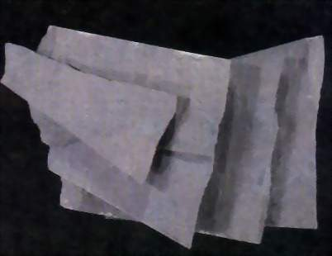
Slaty Texture - This texture is caused by the parallel orientation of microscopic grains. The name for the rock with this texture is slate , and the rock is characterized by a tendency to separate along parallel planes. This feature is a property known as slaty cleavage. (Slaty cleavage or rock cleavage is not to be confused with cleavage in a mineral, which is related to the internal atomic structure of the mineral.)

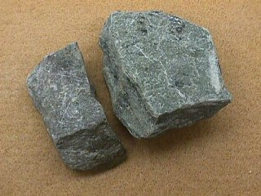
Phyllitic Texture - This texture is formed by the parallel arrangement of platy minerals, usually micas, that are barely macroscopic (visible to the naked eye). The parallelism is often silky, or crenulated. The predominance of micaceous minerals imparts a sheen to the hand specimens. A rock with a phyllitic texture is called a phyllite.

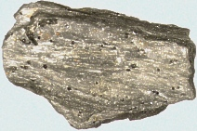
Schistose Texture This is a foliated texture resulting from the suhparallel to parallel orientation of platy minerals such as chlorite or micas. Other common minerals present are quartz and amphiholes. A schistose texture lies between the parallel platy appearance of phyllite and the distinct banding of gneissic texture. The average grain size of the minerals is generally smaller than in a gneiss. A rock with schistose texture is called a schist

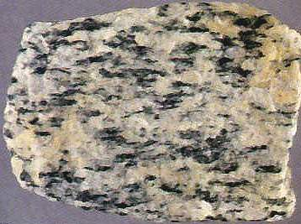
Gneissic Texture This is a coarsely foliated texture in which the minerals have been segregated into discontinuous hands, each of which is dominated by one or two minerals. These bands range in thickness from 1 mm to several centimeters. The individual mineral grains are macroscopic and impart a striped appearance to a hand specimen. Light-colored bands commonly contain quartz and feldspar. and the dark hands are commonly composed of hornblende and hiotite. Accessory minerals are common and are useful in applying specific names to these rocks. A rock with a gneissic texture is called a gneiss.

Nonfoliated Texture

Metamorphic rocks with no visible preferred orientation of mineral grains have a nonfoliated texture. Nonfoliated rocks commonly contain equidimensional grains of a single mineral such as quartz, calcite, or dolomite. Examples of such rocks are
1- quartzite , formed from a quartz sandstone Quartzite and metamorphosed conglomerate can be distinguished from their sedimentary equivalents by the fact that they break across the quartz grains, not around them..

2- marble , formed from a limestone or dolomite. Marble has a crystalline appearance and generally has larger mineral grains than its sedimentary equivalent
3- Hornfels formed from basalt A fine-grained (dense-textured), nonfoliated rock usually of contact metamorphic origin is
4- anthracite coal The metamorphic equivalent of bituminous coal

Examples of Nonfoliated Texture



