- The Cubic (Isometric) System
There are 15 forms, all closed, in the ISOMETRIC CRYSTAL SYSTEM-- more than in any other single system we will examine. You may wish to briefly refer back to the first article in this series, when we built an axial cross. In the isometric system, all 3 crystallographic axes are at right angles to each other and are the same length.
وهناك 13 محور تماثل A=b=c الفا= بيتا =جاما = 90
ثلاث رباعي واربع ثلاثي وسته ثنائي
وهناك 9 مستويات تماثل منها سته مائلة وثلاث محوريه
The axes are renamed a1, a2, and a3. We need to remember that a3 is vertical, a2 is horizontal, and a1 is front to back.
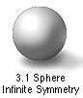
Crystal forms in the isometric system have the highest degree of SYMMETRY, No crystal system even approaches a sphere's degree of symmetry, but the isometric system is often quickly recognizable because some of the forms and combinations of forms somewhat approach sphericity (or, at least, roundness), especially when the faces begin to be curved, due to the high degree of symmetry in the isometric system.
Cube {001}المكعب | Dodecahedron {011}12 وجه | Trapezohedron ا24 رباعي منحرف {hhl} | Hexoctahedron 48 وجه سته في ثمانيه {hkl}
Octahedron ثماني الاوجه {111} | Tetra hexahedron24 وجه اربعه سته اوجه {0kl} | Trisoctahedron v {hll} | 24 وجه ثلاثة ثمانيه اوجه
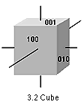
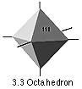
- CUBE-- The cube is composed of 6 square faces at 90 degree angles to each other. Each face intersects one of the crystallographic axes and is parallel to the other two (fig. 3.2). This form, {0012- OCTAHEDRON-- The octahedron is a form composed of 8 equilateral triangles. thus the form notation of {111} (fig. 3.3).
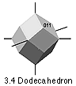
- DODECAHEDRON (AKA Rhombic Dodecahedron) -- This form is composed of 12 rhomb-shaped
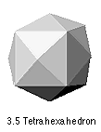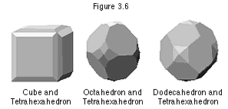
4- TETRAHEXAHEDRON-- This form has 24 isoceles triangular faces.
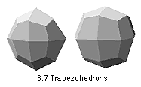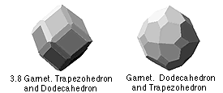
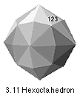
5- TRAPEZOHEDRON (AKA Tetragon-trioctahedron) -- This form has 24 similar trapezium-shaped faces varieties of garnet, where it is often combined with the dodecahedron (fig. 3.8).
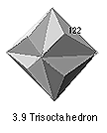
6 - TRISOCTAHEDRON (AKA Trigonal Trisoctahedron ) -- This is another 24-faced form,
7- HEXOCTAHEDRON-- This form has 48 triangular faces,
8 - TETRAHEDRON-- The tetrahedron includes both a positive and negative form with the notation {111} and {1-11}, respectively.

