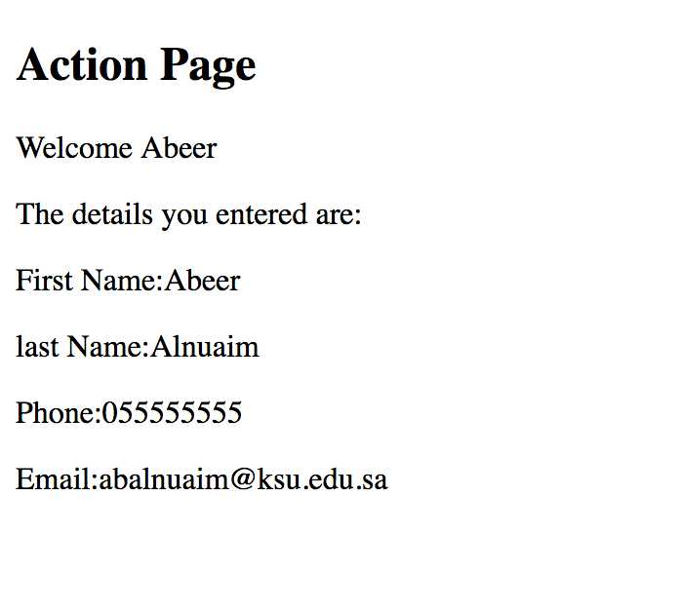
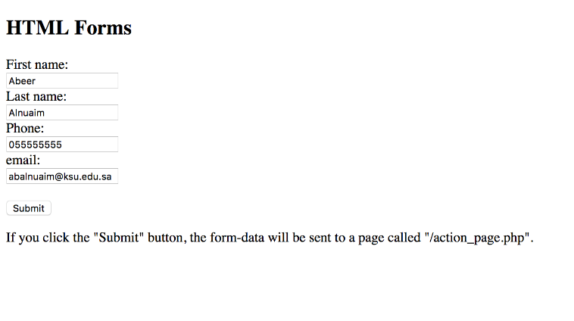
Lab 7

Form HTML code are given to you, Write the php code that produce Action page .
The form code is <!DOCTYPE html>
<html>
<body>
<h2>HTML Forms</h2>
<form method="get" action="action_page.php">
First name:<br>
<input type="text" name="fname" >
<br>
Last name:<br>
<input type="text" name="lname" >
<br>
Phone:<br>
<input type="number" name="phone" >
<br>
email:<br>
<input type="email" name="email" >
<br><br>
<input type="submit" value="Submit">
</form>
<p>If you click the "Submit" button, the form-data will be sent to a page called "/action_page.php".</p>
</body>
</html>

