|  |  |
| --- | --- |
| **King Saudi University**  **Collage of Applied Medical Science** | **Rehabilitation Science Department**  **Electrotherapy-RHS325** |

|  |
| --- |
| LAB ACTIVITY  sheet 3: Identification of Motor Points |

Student name ……………………………………. Student number……………………

Course name………………………………………Course code……………………….

**Objective:**

To be able to locate and identify motor points for specific muscles.

**Materials Needed:**

Electrical stimulation unit with a hand-held electrodes (probe)

**Description of Motor Points**

* A [point](http://www.biology-online.org/dictionary/Point) on the [skin](http://www.biology-online.org/dictionary/Skin) where an [electrical](http://www.biology-online.org/dictionary/Electrical) [stimulus](http://www.biology-online.org/dictionary/Stimulus) will [cause](http://www.biology-online.org/dictionary/Cause) the maximum [contraction](http://www.biology-online.org/dictionary/Contraction) of an underlying [muscle](http://www.biology-online.org/dictionary/Muscle).
* Area of greatest excitability on the surface of the skin overlying superficial muscles that can produce maximum contraction with minimum amount of current intensity.
* Motor point is the region in muscle where a great density of terminal motor end plates is found near the surface.
* The point where the motor nerve enters the muscle.
* Motor point lies at muscles belly between the proximal one third and distal 2/3 of muscle belly or fleshy part of the muscle fibers.

The exact locations of motor points tend to vary from individual to individual, but their approximate locations have been identified in many motor point charts Figure 1-3).

Motor points are not to be confused with trigger points, which are hypersensitive areas that develop secondary to trauma (although they do frequently tend to be found close to each other).

**Procedures:**

1. Attach the dispersive electrode to the thigh or upper arm, depending on the area being examined.
2. Prepare the stimulation unit to the hand-held applicator mode
3. Attach the inactive electrode to the thigh or upper arm, and manually move the hand-held applicator with one hand while controlling the output intensity with the other.
4. Set the stimulation parameters to the following values:

Parameters Settings

Pulse duration: 25 to 50µsec

Pulse frequency: 50pps

Polarity of the active electrode: Negative

Duty cycle: 100%

**Note: Not all parameters will apply to each unit.**

1. Reset the generator’s output intensity to zero, and wet the applicator’s tip with water or gel.
2. Place the applicator tip on the subject’s forearm, and slowly increase the intensity to where a slight muscle contraction is visible (Fig. 4–1).
3. Use the applicator tip to identify the point(s) on the skin that result in strong, isolated contractions of the following muscles:

|  |  |
| --- | --- |
| ***Upper Extremity***   1. Abductor pollicis longus 2. Extensor digiti minimi 3. Extensor indicis 4. Flexor carpi radialis 5. Flexor carpi ulnaris | ***Lower Extremity***   1. Abductor digiti minimi 2. Extensor hallucis longus 3. Extensor digitorum brevis 4. Plantaris 5. Tibialis anterior |

1. The intensity of the stimulation may need to be adjusted as the applicator is moved over the skin. Most applicators have an intensity adjustment knob located on them.

***Note: Reduce the intensity to zero before applying or removing the applicator from the subject’s skin.***

1. Using the labeling key, mark the location of each motor point identified on the accompanying charts.

**Sheet for Motor Points-Upper limb**

[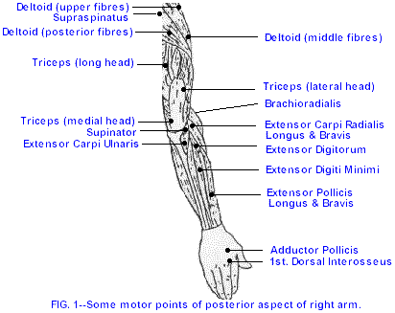](http://www.google.com.sa/url?sa=i&rct=j&q=motor+points+for+electrical+stimulation&source=images&cd=&cad=rja&docid=pFQOmauWKUMpGM&tbnid=QsaSxS0dT6-zsM:&ved=0CAUQjRw&url=http://www.istop.org/papers/tenniselbow.htm&ei=Y3IbUevjFs-5hAe5xICABA&psig=AFQjCNGq9_C8kVd5GEzWEnEnaDY7nzP9Og&ust=1360839606019547)

[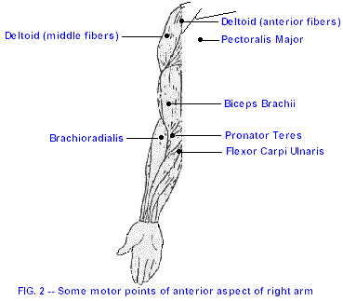](http://www.google.com.sa/url?sa=i&rct=j&q=motor+points+for+electrical+stimulation&source=images&cd=&cad=rja&docid=pFQOmauWKUMpGM&tbnid=vgH_fKiVJ5vPcM:&ved=0CAUQjRw&url=http://www.istop.org/papers/tenniselbow.htm&ei=jHIbUe_WGJGHhQeJxYCgDw&psig=AFQjCNGq9_C8kVd5GEzWEnEnaDY7nzP9Og&ust=1360839606019547)

**Sheet for Motor Points-lower limb**



**Sheet for Motor Points-Face**

[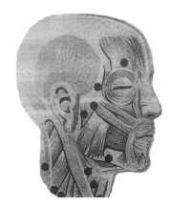](http://www.google.com.sa/url?sa=i&rct=j&q=motor+points+for+electrical+stimulation+face&source=images&cd=&cad=rja&docid=YJTRVlRbdOSQfM&tbnid=bBjMnXw6TaGQHM:&ved=0CAUQjRw&url=http://www.newline.ie/business_zone/business_zone/terms.html&ei=FnMbUYCMIMmLhQfxkoE4&psig=AFQjCNHxHscwSu3lmN8MmmJAgl-uiKVO-g&ust=1360839825834926)

**Activity Questions**

1. Compare your findings with those of your subject. Do the motor points approximate those on the chart?
2. What would explain any differences? If you are using a unit where a polarity change is possible, try the following: Change the polarity from negative to positive. Move to an identified motor point and increase the intensity until a similar contraction is elicited. Did the required intensity change from your initial trial?
3. Is it possible to obtain a muscle contraction if electrode placement is not over a motor point? Why or why not?