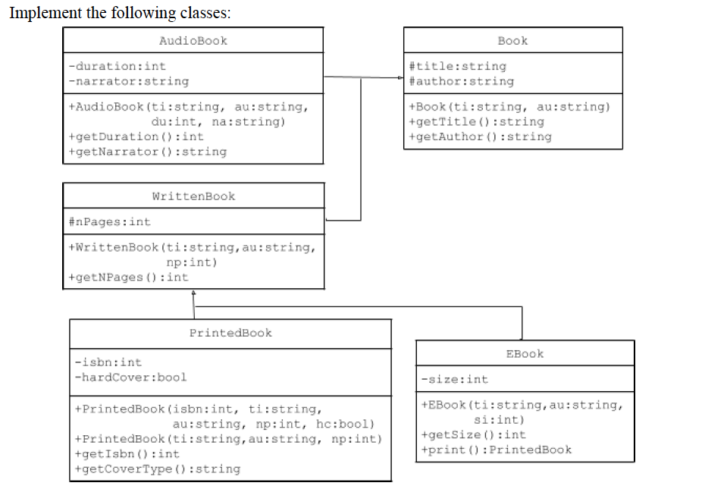

Class Book
■ title and author: represent the title of the book and its author
■ Book(ti:string, au:string): a constructor that initializes title and author respectively
Class AudioBook
■ duration: length of the audio clip in minutes
■ narrator: name of the person whose voice is recorded
■ AudioBook(ti:string, au:string, du:int, na:string): initializes title, author, duration and narrator respectively
Class WrittenBook
■ count of the pages of the book
■ WrittenBook(ti:string, au:string, np:int): initializes title, author and nPages respectively
Class PrintedBook
■ isbn: stores the international standard book number
■ hardCover: it true if the book has a hardcover and false if it has paperback cover
■ PrintedBook(isbn:int, ti:string, au:string, np:int, hc:bool): a constructor that initializes isbn,title, author, nPages and hardCover respectively
■ PrintedBook(ti:string, au:string, np:int): a constructor that initializes title, author and nPages to the passed arguments respectively, and initializes isbn to 0 and hardCover to false.

Class EBook
■ size: storage size of the ebook file in MBs
■ EBook(ti:string, au:string, si:int): initializes title, author and size respectively
■ print(): returns an object of type PrintedBook that has that same title, author and nPages as the current EBook

