Lab3: ABO Blood Grouping & Rh Groups

Method:
- 2 one-diameter circles were drawn on each slide and marked as shown in the figure, control, Anti-A, Anti-B and Anti-AB
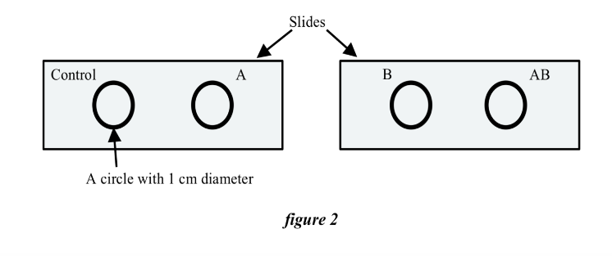
D

- The tip of the finger was punctured.
- Drop one drop of blood was dropped in each slide.
- one drop of anti-A antibody in circle A, of anti-B antibody in circle B and of anti- AB antibody in circle AB. (no drop in the control).
- The blood and antigen were mixed with different toothpick thoroughly. The results were observed after 10 sec.

Results:
Antibody | Observation
Control
Anti-A
Anti-B
Anti-D

