***[BCH 322]***

***The Effect of Enzyme Concentration on the Rate of an Enzyme Catalyzed Reaction***

***Method:***

1. Label 7 test tubes (A, B, C, D, E, F, and G) and blank.
2. Follow the following addition protocol to all the tubes:

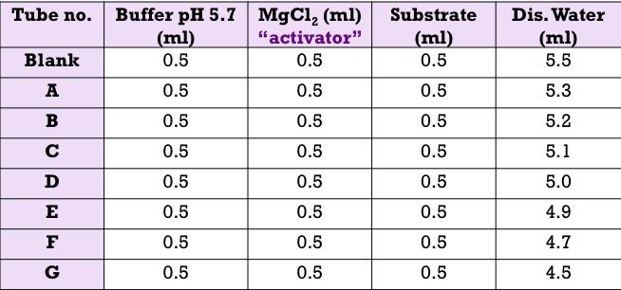

1. Place all the tubes in a test rack situated in a water bath maintained at 37 ºC and let the temperature equilibrate for 5 minutes.
2. Start the reaction by adding different volumes of the enzyme and stop it by adding 0.5 ml KOH as in the following table:

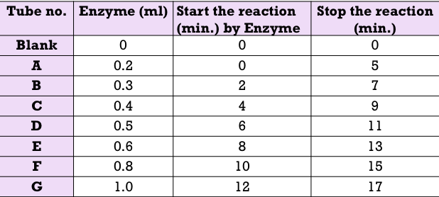

1. After all the reactions have been terminated, determine the absorbance at 405 nm for each sample.



**Results:**

