Visceral and Ocular Larva Migrans

Clinical Manifestations
Two distinct patterns of larva migrans infection are recognized: visceral larva migrans and ocular larva migrans. These clinical syndromes result from the systemic migration of the larval forms of animal helminthic parasites. Toxocara species, the common roundworms of dogs and cats, are the usual cause. The disease affects mainly children.
The classic visceral larva migrans syndrome usually occurs in preschool children with a history of pica (dirt-eating). Patients who have severe infections often present with eosinophilia, fever, and marked hepatomegaly which may persist for months; there may be associated respiratory symptoms with wheezing and coughing. Pruritic rashes and chronic urticaria may occur. Neurologic involvement may cause seizures. Death has been associated with myocarditis, encephalitis, and respiratory syndromes.
The ocular form of the disease usually occurs in children who are between school age and young adulthood. Ocular invasion by the larva may produce retinal granulomas or endophthalmalitis, leukokoria (white pupillary reflex), decreased visual acuity, strabismus and eye pain. The syndrome may resemble retinoblastoma; misdiagnosis has resulted in unnecessary enucleation of the involved eye. The host usually is asymptomatic until ocular involvement becomes apparent. Patients with ocular disease rarely have a history of pica. It has been suggested that ocular larva migrans is associated with fewer larvae than visceral larva migrans. This view is generally supported by the finding of higher serum antibody titers in patients with visceral than with ocular disease. Rarely, the two forms of the disease coexist, presumably related to massive infection. Infections not involving the eye that are caused by few parasites may be asymptomatic and hence not recognized.

Structure
Toxocara canis is the most common cause of visceral and ocular larva migrans. Mature Toxocara canis worms live in the small intestine of the dog, their natural host. They have an average life span of about 4 months. The female is 5 to 18 cm. long and the male, 4 to 10 cm. A single female may produce 200,000 eggs per day. A heavily infected dog can pass millions of eggs per day in feces. The egg is about 85 μm × 75 μm with a light brown, thick shell. Under appropriate soil conditions, the egg embryonates and develops to the infective stage. The infective larva is approximately 400 μm × 20 μm and resembles the adult.

Multiplication and Life Cycle
When infective eggs of Toxocara canis are ingested by a dog, the larvae hatch in the small intestine, invade the intestinal mucosa, and undergo an extraintestinal migratory phase. In older dogs, many larvae remain trapped in body tissues. In puppies, most of the larvae migrate through the bronchioles to the trachea and pharynx, where they are swallowed and complete maturation to the adult form in the intestine. Eggs are shed in the feces and develop into an infective stage in the soil (Fig. 1).
Most puppies are infected prenatally with Toxocara canis. Presumably, hormonal changes during gestation facilitate transplacental migration of larvae from maternal tissues. Puppies may also be infected by the transmammary route or by ingestion of embryonated eggs.
Pathogenesis
Humans contract Toxocara infections by ingesting embryonated eggs. The larvae hatch in the small intestine, invade the mucosa, and enter the portal system. Some are trapped in the liver, but others proceed to the lungs and into the systemic circulatory system where they may disseminate to virtually any organ (Fig. 2)). The parasite cannot complete its life cycle in humans as it does in the animal host. Developmental arrest occurs in the larval stage. The larvae persist in tissue, where they evoke a granulomatous reaction and eventually die. The clinical manifestations depend on the amount of tissue damage caused by the invading larvae and on the associated immune-mediated inflammatory response.
(Fig. 1)

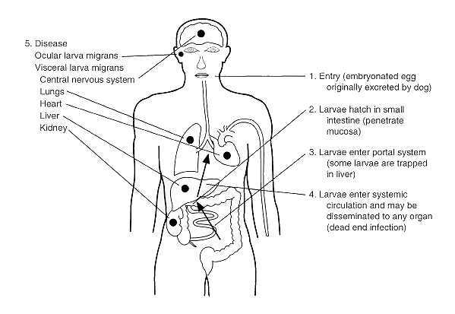
Fig. 2: Pathogenesis of visceral larva migrans caused by Toxocara canis

Host Defenses
Visceral larva migrans is associated with marked hematologic and immunologic host response, in contrast to the ocular disease, in which, presumably, the small number of parasites cause less host reaction. Serum Toxocara antibody titers usually are elevated to diagnostic levels in both syndromes. Leukocytosis with eosinophilia (usually in excess of 30 percent) occurs in visceral disease. Peripheral leukocyte counts exceeding 100,000/mm³; are seen. Hypergammaglobulinemia
is common, and IgE is markedly elevated. In addition to antibodies specific for larvae and their secretory-excretory products, a number of nonspecific antibodies may be produced, including rheumatoid factor and elevated antibody titers to human A and B blood group substances.
Epidemiology
Most young puppies and approximately 20 percent of adult dogs are actively infected with Toxocara canis. Puppies between 3 weeks and 3 months of age excrete large numbers of eggs and constitute the greatest hazard to the environment. Backyards, children's sandboxes, public parks, and beaches accessible to dogs are often contaminated with Toxocara ova, which may remain infective for years. These areas are potential exposure sites for young children or others who accidentally ingest the infective eggs. Children who habitually eat dirt are at particular risk. Direct contact with pets is not a factor in infection because of the incubation period required before the eggs are infective.
Diagnosis
The diagnosis of visceral larva migrans is usually suggested by the clinical findings of visceral involvement in association with hypergammaglobulinemia, leukocytosis, and eosinophilia. Liver biopsy may be diagnostic, although the larvae are difficult to find even in the presence of eosinophilic granulomas (Figures 3 and 4). Elevated titers of antibodies against the A and B isohemagglutinins Toxocara antigens support the diagnosis. The enzyme-linked immunoabsorbent assay (ELISA) using larva-specific antigen has proven a reliable serologic test. It is especially useful in evaluating ocular infections, which characteristically do not exhibit the peripheral eosinophilia and other evident host responses of visceral disease.
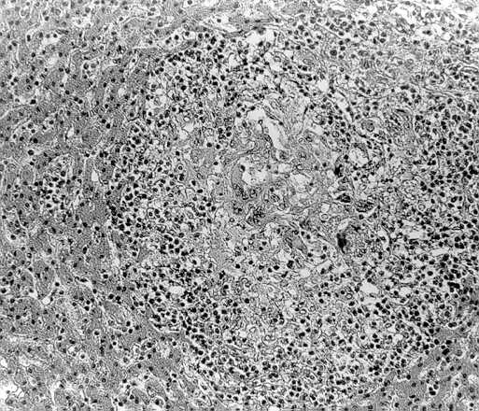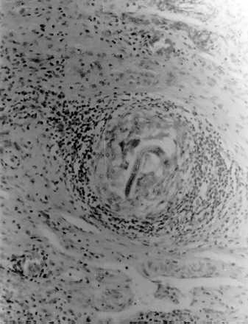
Figures 3&4: Liver biopsy from child with visceral larva migrans caused by Toxocara (x200)

Control
Prevention of human infection centers on the appropriate treatment of Toxocara infections in dogs and cats and on sanitary disposal of pet feces. Public education on the necessity of these preventive measures is needed. Many responsible pet owners are unaware of the health hazards imposed on human by animal roundworm infections. Once the soil has become contaminated, infective eggs persist indefinitely.
There is no treatment of proven efficacy for disease caused by Toxocara species in humans. The anthelminthic drugs diethylcarbamazine and albendazole have been reported to be beneficial in some cases. Corticosteroids have been used to decrease the inflammatory response in ocular infections and in severe respiratory or cardiac disease.

Samuel Baron MD
Professor, Department of Microbiology and Immunology, Professor, Department of Internal Medicine, and Associate Dean for Research Development and Planning, University of Texas Medical Branch at Galveston, Galveston, Texas
- Rhonda C. Peake
- Deborah A. James
- Mardelle Susman
- Carol Ann Kennedy
- Mary Jo Durson Singleton
- Steve Schuenke
Fourth Edition, 1996 The University of Texas Medical Branch at Galveston

