Csc1203- Tutorial 3

Q1.Map the EER model of the following databases . Show all integrity types(Clarify your answer by underline the Primary key, and dotted line the Foreign Key.(

- Library
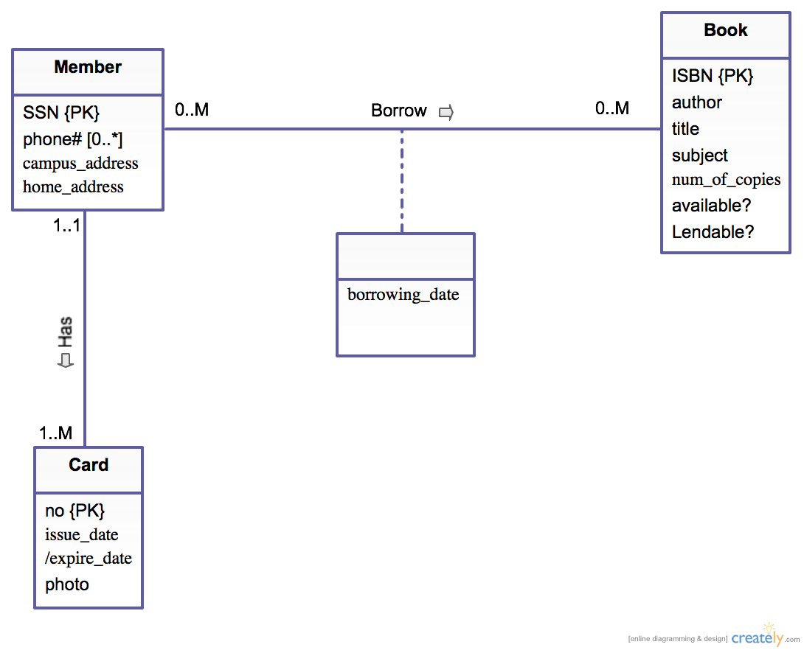

Book (ISBN, author, title, num_of_copies, available, lendable)
Member (SSN, city, street, zip)
M_Phone (SSN, phonenumber)
Borrowing (ISBN, SSN, borrowing_date)
Card (no, issue_date, photo, SSN)

- Retail Company Database

Employee(SIN, Mobile#, DOB, Fname, Lname, Branch#)
Sub-Emp(SIN, Insured_Flag, Manager_Flag, Policy#, Premium, Amount, Profit_shares)
Branch (Branch#, Address, Budget, SIN)
Dependant(SIN, Dependent_Name, Age, Relationship)

