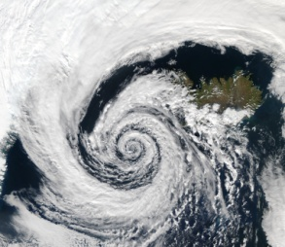  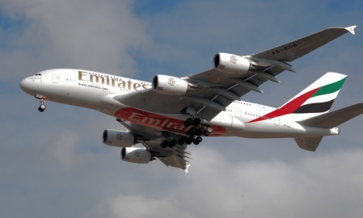

Mechanical Engineering Department

**ME322 Mechanical Laboratories (1) - Thermo-Fluid**

**MIDTERM EXAM**

|  |  |
| --- | --- |
| **Date(s): 6 Apr 2015G / 17 Jumada Al-Akhir 1436H**  **Day: Monday**  **Time: 7-9pm** | **Professor(s):**  **Dr. Jamel Orfi**  **Dr. Zeyad Al-Mutairi**  **Dr. A. Al-Witry** |

|  |  |  |  |  |
| --- | --- | --- | --- | --- |
| **Student Info** | |  | **Exam Information** | |
| **Name (English)** | **SAMPLE SOLUTION SHEET** | **Total Marks** | **20** |
| **Name (Arabic)** | **SAMPLE SOLUTION SHEET** | **Number of Questions** | **3** |
| **Number** | **SAMPLE SOLUTION SHEET** | **Available Time** | **2 Hours** |

**EXAM RULES:**

1) Please **place your Identity Card on the desk in front of you** for identity confirmation.

2) All **mobile phones have to be switched off and put away from the student**.

3) This is a **CLOSED BOOK** Exam. All necessary charts provided.

4) **Only Non-Programmable Calculators Allowed**.

5) **Please Beware: Strong Anti-Cheating Policies Apply...**

6) Once the exam time is finished, please hand-over your exam paper when asked for so without delay or it may not be received.

7) Answer in the answer book provided.

|  |  |
| --- | --- |
| **Marks** | |
| **Q1** | **6** |
| **Q2** | **6** |
| **Q3** | **8** |
| **Total** | **20** |
| **Professor's**  **Signature** | **ALW** |

|  |  |  |
| --- | --- | --- |
| **For Official Use Only** | | |
|  | | |
|  | | |
|  | | |
|  | | |
|  | | |
| **#** | **Questions** |
| **1** | Calculate the volumetric and mass flowrates of oil flowing inside a 2" diameter pipe at 0.25m/s?  Oil density is 850kg/m3. |

**Q1]** The system sketched below illustrates water discharge from a large reservoir to atmosphere through a smooth pipe. At a certain time the height of water in the tank is 26 m and gives a flow rate of 16x10-3 m3/s. For the system below find: [Total Marks 6]

1. Identify the types of losses in the system?
2. Calculate the head loss through the 3.8 cm pipe?
3. Estimate the entrance coefficient?

Note: for laminar flow the friction coefficient f = 64/Re, for turbulent flow in smooth pipe f = 0.316/Re0.25. Assume any other necessary missing information.







**Q2]** [Total Marks 6]

The measurement of thermal conductivity uses a device, described schematically in Figure 1 and involves the measurement of both the heat flux and temperature difference. The difficulty of the measurement is always associated with the heat flux measurement done directly (for example, by measuring the electrical power going into the heater or the heat flux of a cooling liquid such as water).

1. Consider the following case where the thermal conductivity of a certain material is measured using this device. Water is used as coolant with a volumetric flow rate of 130 mL/min. The heated water exits at a temperature of 56 oC while the tap water temperature is at 23 oC. The temperatures of the sample T1 and T2 (see figure 1) are 120 oC and 70 oC respectively. The diameter D and the length ΔL of the sample are 2 inches and 5 inches.

Find the thermal conductivity of this material. *[Marks 2]*

 

**Figure 1** **Figure 2**

Figure 2 describes another method, which is a widely used method for thermal conductivity testing. Its principle lies with passing the heat flux through a known material (reference with a thermal conductivity Kr) and an unknown sample (with a thermal conductivity Ks) and comparing the respective thermal gradients, which will be inversely proportional to their thermal conductivities.

1. Show that the thermal conductivity of the sample Ks can be obtained using the following relation:

$K_{s}=K_{r}(\frac{{∆T}_{1}+{∆T}_{2}}{2{∆T}_{s}})$*[Marks 1.5]*

Where ΔT1 refers to the temperature difference on the sides of the reference near the heater. ΔT2 refers to the temperature difference on the sides of the reference near the coolant. ΔTs is the temperature difference on the sides of the sample.

1. A series of measurements gave the following data: ΔT1 = 70 oC, ΔTs= 40 oC; ΔT2 = 70 oC; L=5 cm; D=2 cm; If the reference thermal conductivity Kr is 220 W/mK,

evaluate the thermal conductivity of the sample. *[Marks 1]*

1. Give two main advantages of using this method (shown in figure 2) compared to the conventional method (figure 1). *[Marks 1.5]*

**SOLUTION of Q2:**

1. The heat flux through the sample can be expressed as: Q=KAΔT/ΔX = mCpΔTw

The thermal conductivity is:

K= mCpΔTw/(AΔT/ΔX) where m, the mass flow rate = ρ(ΔV/Δt); V and t are volume and time.

K= (1000*(130/60)*10-6*4180*(56-23))/(2.0258*10-3*(120-70)/((5*2.54)/100)) = 374.73 W/mK.

1. The heat flux through the reference and the sample is:

Q/A= Ks*ΔTs/L= Kr*((ΔT1+ΔT2)/2)/L

Thus, Ks= Kr*((ΔT1+ΔT2)/2ΔTs)

1. Ks= Kr*((ΔT1+ΔT2)/2ΔTs) = 220*(70+70)/(2*40)=385 W/mK
2. Some advantages of using method 2:

* No measurements of heat flux
* Just measurements of temperature
* Few measurements are needed
* Reduced heat losses

**Q3]** A wind-tunnel experiment into the forces acting on a NACA0009 aerofoil at constant air speed revealed the following results.[Total Marks 8]

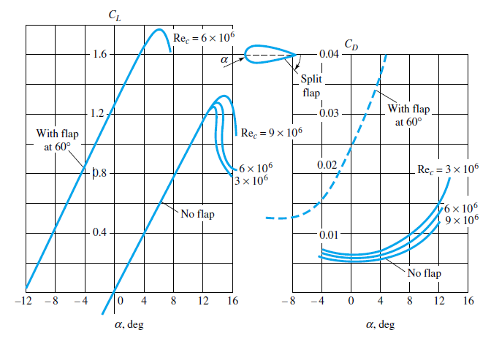

The tested airofoil projected area= 0.025m2. Ambient air temperature and pressure are 20oC and 1atm consecutively. Use the ReC= 3x106 line in all your solutions.

1) What is the value of the stall angle for this airfoil? [0.5 Mark]

2) What is the AOA to obtain the safest maximum L/D ratio obtainable from this airofoil for use in the design of a real full-scale wing? **Tip:** You might be better off to use a sketch in solving this one! [1 Mark]

3)At the optimum AOA for maximum L/D (earlier branch), find the needed aircraft thrust and maximum allowable weight for cruising at 900km/hr using a similar shaped full-scale wing of a projected area of 30m2?. Operating temperature and pressure are -20oC and -0.3barg. [3.5 Mark]

4) Give a detailed discussion and analyses of what would happen if the wings flaps were deployed using numbers extensively?. Comment on the good and bad points about using this aerofoil profile for this airplane's wing. [3 Marks]

**SOLUTION Q3:**

1) Stall AOA= 6o for this wing.

2) The maximum L/D can be found by investigating the CL and CD values versus AOA:

|  |  |  |  |
| --- | --- | --- | --- |
| **AOA** | **CL** | **CD** | **L/D** |
| 0 | 0 | 0.0063 | 0.00 |
| 2 | 0.2 | 0.0065 | 30.77 |
| 4 | 0.4 | 0.007 | 57.14 |
| 6 | 0.6 | 0.00825 | 72.73 |
| 8 | 0.78 | 0.00975 | 80.00 |
| 12 | 1.15 | 0.015 | 76.67 |
| 14 | 1.32 | 0.0225 | 58.67 |

**The maximum L/D here is near 80. However, this can not be used due to it being past the stall conditions.**

Since stall happens for this wing around 14o AOA, the maximum safe AOA obtainable from this NACA0009 airfoil is at an AOA=8o giving a maximum L/D of 80 which is an excellent value and far away from stall conditions by about 6 degrees.

3) At cruising, **Lift = Wmax** and **Tneed = Drag**.

W = L = CL (0.5*ρa*V2)*Ap and T = D = CD (0.5*ρa*V2)*Ap

From (2) above, maximum L/D occurs at an AOA of 8o and **CL = 0.78** and **CD=0.00975.**

Also: P = ρ R T Then; ρa = P/RT = ((1-0.3)*100000)/(287*(273-20)) **ρa = 0.964 kg/m3**

Va = 900km/hr Then **Va= 250 m/s**

Maximum Weight = L = 0.78*(0.5*0.964*2502)*30 = **704925 N**

Needed Thrust = D = 0.00975*(0.5*0.964*2502)*30= **8811.5625 N**

4) If the flaps were deployed, the available lift will increase but so will the impending drag. At an AOA of 4o, the lift will be increased by more than 400% while the drag will increase by 360%.

The stall angle will be also lowered from 14o to 6o only meaning that we can no longer use the 8o AOA in the design of the full-scale wing. Even if we used a 4o AOA for wing's inclination, this could cause a critical flight regime once the flaps are used and be un-safe for the aircraft with it being so close to stall conditions. Since all wings use flaps for take-off and landing, this situation has to be taken in the overall decision to use this airfoil shape or not in the design of the full-scale wing.

The wing will, therefore, need to be re-designed or an alternative NACA wing profile be used.

Other non-symmetrical airfoils should be capable of giving higher lift and even better L/D ratio. Even if stall occurred with these alternative wings, various flow straighteners and flow control surfaces may be added to prevent