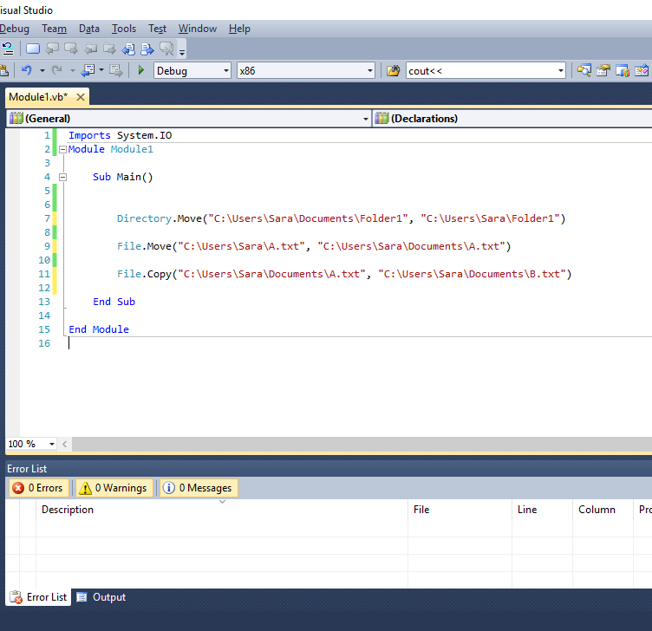

Imports System.IO
Module Module1

Sub Main()

Directory.Move("C:\Users\Sara\Documents\Folder1", "C:\Users\Sara\Folder1")

File.Move("C:\Users\Sara\A.txt", "C:\Users\Sara\Documents\A.txt")

File.Copy("C:\Users\Sara\Documents\A.txt", "C:\Users\Sara\Documents\B.txt")

End Sub

End Module

