- Open excel sheet and write the fallowing data
- Save the document with your name in the desktop

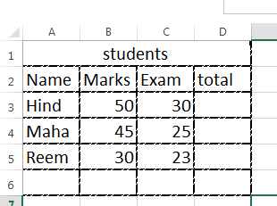

- Merge the first Rows and write student
- Add pink shading into whole cells in rows 2
- Adjust the width of the columns
- Insert green color into all borders
- Change the font size 14
- Adjust all words in the table to the center
- Into total cell we will make the formulas
- Sum the marks and exams
- Into 3E name the cell result (marks + exam /2)
- Into 6D find out the Max of the total
- Into 6B find out the Min of the marks
- Into 6C find out the average of the exam
- Change the name of the sheet to student
- Add another sheet with name school 99
- Add your name as a header and 2017 as footer
- Insert the column chart (about name and total only )
- Add main title student’s results
- Add main title student’s results Axis Title primary horizontal [school99]
- Add main title student’s results Axis Title (primary vertical [2017]

