Discrete Probability Distributions
The first: Binomial Probability Distribution

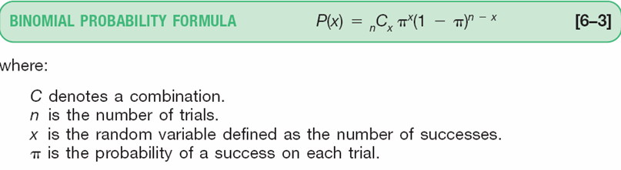
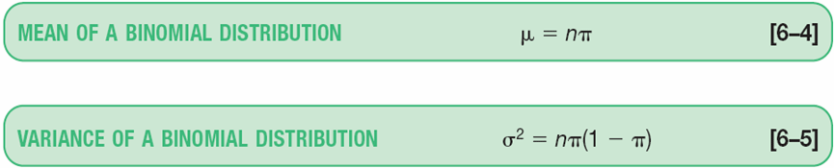

Example:
Use the following to answer questions 1-9:
David's gasoline station offers 4 cents off per gallon if the customer pays in cash and does not use a credit card. Past evidence indicates that 40% of all customers pay in cash. During a one-hour period five customers buy gasoline at this station.

1. What is the probability that exactly two customers will pay in cash?
2. What is the probability that exactly four customers will pay in cash?
3. What is the probability that at least three customers will pay in cash?
4. What is the probability that a maximum of two customers will pay in cash?
5. What is the probability that no customers will pay in cash?
6. What is the probability that more than one and less than four customers will pay in cash?
7. What is the expected number of customers pay in cash?
8. What is the variance of the number of customers pay in cash?
9. what is the standard deviation of the number of customers pay in cash?

The second:
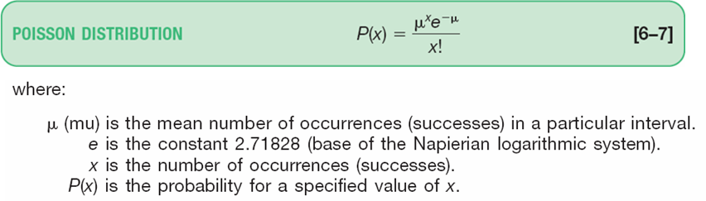
Poisson Probability Distribution
The Poisson distribution can be described mathematically using the formula:
- The mean and the variance of the Poisson distribution are equal $=μ=nπ$

Example:
Use the following to answer questions 1-7:
A statistics professor receives an average of five e-mail messages per day from students. Assume the number of messages approximates a Poisson distribution.
1. What is the probability that on a randomly selected day she will have no messages?
2. What is the probability that on a randomly selected day she will have five messages?
3. What is the probability that on a randomly selected day she will have two messages?
4. What is the probability that on a randomly selected day she will have a maximum of two messages?
5. What is the probability that on a randomly selected day she will have at least two messages?
6. What is the expected number of messages received per day?
7. What is the variance of the number of messages received on the day expected?

Continuous Probability Distributions
Normal Distribution

1. For the normal distribution, the mean plus and minus 1.96 standard deviations will include about what percent of the observations?
2. For a standard normal distribution, what is the probability that z is greater than 1.75?
3. What is the area under the normal curve between z = 0.0 and z = 1.79?
4. What is the area under the normal curve between z = –1.0 and z = –2.0?
5. What is the area under the normal curve between z = 0.0 and z = 2.0?
6. The mean amount spent by a family of four on food per month is $500 with a standard deviation of $75. Assuming that the food costs are normally distributed, what is the probability that a family spends less than $410 per month?
7. What is the proportion of the total area under the normal curve within plus and minus two standard deviations of the mean?

8. A new extended-life light bulb has an average service life of 750 hours, with a standard deviation of 50 hours. If the service life of these light bulbs approximates a normal distribution, about what percent of the distribution will be between 600 hours and 900 hours?

9. The mean score of a college entrance test is 500; the standard deviation is 75. The scores are normally distributed. What percent of the students scored below 320?

10. A study of a company's practice regarding the payment of invoices revealed that an invoice was paid an average of 20 days after it was received. The standard deviation equaled five days. Assuming that the distribution is normal, what percent of the invoices were paid within 15 days of receipt?

11. The mean of a normal distribution is 400 pounds. The standard deviation is 10 pounds. What is the area between 415 pounds and the mean of 400 pounds?

12. The weekly mean income of a group of executives is $1000 and the standard deviation of this group is $100. The distribution is normal. What percent of the executives have an income of $925 or less?

13. The weight of cans of fruit is normally distributed with a mean of 1,000 grams and a standard deviation of 50 grams. What percent of the cans weigh 860 grams or less?
14. The mean amount of gasoline and services charged by Key Refining Company credit customers is $70 per month. The distribution of amounts spent is approximately normal with a standard deviation of $10. What is the probability of selecting a credit card customer at random and finding the customer charged between $70 and $83?

15. The distribution of the annual incomes of a group of middle management employees approximated a normal distribution with a mean of $37,200 and a standard deviation of $800. About 68 percent of the incomes lie between what two incomes? ($36400 and $38000)

16. A large manufacturing firm tests job applicants who recently graduated from college. The test scores are normally distributed with a mean of 500 and a standard deviation of 50. Management is considering placing a new hire in an upper level management position if the person scores in the upper 6 percent of the distribution. What is the lowest score a college graduate must earn to qualify for a responsible position? ( z=1.56, x=578)

17. The mean of a normal probability distribution is 500 and the standard deviation is 10. About 95 percent of the observations lie between what two values? (480 and 520)

18. Suppose a tire manufacturer wants to set a mileage guarantee on its new XB 70 tire. Tests revealed that the tire's mileage is normally distributed with a mean of 47,900 miles and a standard deviation of 2,050 miles. The manufacturer wants to set the guaranteed mileage so that no more than 5 percent of the tires will have to be replaced. What guaranteed mileage should the manufacturer announce? (44,528)

19. The mean amount of gasoline and services charged by Key Refining Company credit customers is $70 per month. The distribution of amounts spent is approximately normal with a standard deviation of $10. What is the probability of selecting a credit card customer at random and finding the customer charged between $70 and $83? (0.4032)

20. Management is considering adopting a bonus system to increase production. One suggestion is to pay a bonus on the highest 5 percent of production based on past experience. Past records indicate that, on the average, 4,000 units of a small assembly are produced during a week. The distribution of the weekly production is approximately normally distributed with a standard deviation of 60 units. If the bonus is paid on the upper 5 percent of production, the bonus will be paid on how many units or more? (4099)

Area between 0 and z
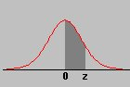
 | 0.00 | 0.01 | 0.02 | 0.03 | 0.04 | 0.05 | 0.06 | 0.07 | 0.08 | 0.09
0.0 | 0.0000 | 0.0040 | 0.0080 | 0.0120 | 0.0160 | 0.0199 | 0.0239 | 0.0279 | 0.0319 | 0.0359
0.1 | 0.0398 | 0.0438 | 0.0478 | 0.0517 | 0.0557 | 0.0596 | 0.0636 | 0.0675 | 0.0714 | 0.0753
0.2 | 0.0793 | 0.0832 | 0.0871 | 0.0910 | 0.0948 | 0.0987 | 0.1026 | 0.1064 | 0.1103 | 0.1141
0.3 | 0.1179 | 0.1217 | 0.1255 | 0.1293 | 0.1331 | 0.1368 | 0.1406 | 0.1443 | 0.1480 | 0.1517
0.4 | 0.1554 | 0.1591 | 0.1628 | 0.1664 | 0.1700 | 0.1736 | 0.1772 | 0.1808 | 0.1844 | 0.1879
0.5 | 0.1915 | 0.1950 | 0.1985 | 0.2019 | 0.2054 | 0.2088 | 0.2123 | 0.2157 | 0.2190 | 0.2224
0.6 | 0.2257 | 0.2291 | 0.2324 | 0.2357 | 0.2389 | 0.2422 | 0.2454 | 0.2486 | 0.2517 | 0.2549
0.7 | 0.2580 | 0.2611 | 0.2642 | 0.2673 | 0.2704 | 0.2734 | 0.2764 | 0.2794 | 0.2823 | 0.2852
0.8 | 0.2881 | 0.2910 | 0.2939 | 0.2967 | 0.2995 | 0.3023 | 0.3051 | 0.3078 | 0.3106 | 0.3133
0.9 | 0.3159 | 0.3186 | 0.3212 | 0.3238 | 0.3264 | 0.3289 | 0.3315 | 0.3340 | 0.3365 | 0.3389
1.0 | 0.3413 | 0.3438 | 0.3461 | 0.3485 | 0.3508 | 0.3531 | 0.3554 | 0.3577 | 0.3599 | 0.3621
1.1 | 0.3643 | 0.3665 | 0.3686 | 0.3708 | 0.3729 | 0.3749 | 0.3770 | 0.3790 | 0.3810 | 0.3830
1.2 | 0.3849 | 0.3869 | 0.3888 | 0.3907 | 0.3925 | 0.3944 | 0.3962 | 0.3980 | 0.3997 | 0.4015
1.3 | 0.4032 | 0.4049 | 0.4066 | 0.4082 | 0.4099 | 0.4115 | 0.4131 | 0.4147 | 0.4162 | 0.4177
1.4 | 0.4192 | 0.4207 | 0.4222 | 0.4236 | 0.4251 | 0.4265 | 0.4279 | 0.4292 | 0.4306 | 0.4319
1.5 | 0.4332 | 0.4345 | 0.4357 | 0.4370 | 0.4382 | 0.4394 | 0.4406 | 0.4418 | 0.4429 | 0.4441
1.6 | 0.4452 | 0.4463 | 0.4474 | 0.4484 | 0.4495 | 0.4505 | 0.4515 | 0.4525 | 0.4535 | 0.4545
1.7 | 0.4554 | 0.4564 | 0.4573 | 0.4582 | 0.4591 | 0.4599 | 0.4608 | 0.4616 | 0.4625 | 0.4633
1.8 | 0.4641 | 0.4649 | 0.4656 | 0.4664 | 0.4671 | 0.4678 | 0.4686 | 0.4693 | 0.4699 | 0.4706
1.9 | 0.4713 | 0.4719 | 0.4726 | 0.4732 | 0.4738 | 0.4744 | 0.4750 | 0.4756 | 0.4761 | 0.4767
2.0 | 0.4772 | 0.4778 | 0.4783 | 0.4788 | 0.4793 | 0.4798 | 0.4803 | 0.4808 | 0.4812 | 0.4817
2.1 | 0.4821 | 0.4826 | 0.4830 | 0.4834 | 0.4838 | 0.4842 | 0.4846 | 0.4850 | 0.4854 | 0.4857
2.2 | 0.4861 | 0.4864 | 0.4868 | 0.4871 | 0.4875 | 0.4878 | 0.4881 | 0.4884 | 0.4887 | 0.4890
2.3 | 0.4893 | 0.4896 | 0.4898 | 0.4901 | 0.4904 | 0.4906 | 0.4909 | 0.4911 | 0.4913 | 0.4916
2.4 | 0.4918 | 0.4920 | 0.4922 | 0.4925 | 0.4927 | 0.4929 | 0.4931 | 0.4932 | 0.4934 | 0.4936
2.5 | 0.4938 | 0.4940 | 0.4941 | 0.4943 | 0.4945 | 0.4946 | 0.4948 | 0.4949 | 0.4951 | 0.4952
2.6 | 0.4953 | 0.4955 | 0.4956 | 0.4957 | 0.4959 | 0.4960 | 0.4961 | 0.4962 | 0.4963 | 0.4964
2.7 | 0.4965 | 0.4966 | 0.4967 | 0.4968 | 0.4969 | 0.4970 | 0.4971 | 0.4972 | 0.4973 | 0.4974
2.8 | 0.4974 | 0.4975 | 0.4976 | 0.4977 | 0.4977 | 0.4978 | 0.4979 | 0.4979 | 0.4980 | 0.4981
2.9 | 0.4981 | 0.4982 | 0.4982 | 0.4983 | 0.4984 | 0.4984 | 0.4985 | 0.4985 | 0.4986 | 0.4986
3.0 | 0.4987 | 0.4987 | 0.4987 | 0.4988 | 0.4988 | 0.4989 | 0.4989 | 0.4989 | 0.4990 | 0.4990

